1-17 on first exam
18. | How did the Crusades change the social structure of Europe?
 | A. They freed the serfs from monarchal control.
 | B. They decreased the influence of the clergy.
 | C. They weakened the power of the noble class.
 | D. They encouraged religious diversity throughout Europe.

19. | Use the list below to answer the question.  • Aztecs created chinampas.  • Incas built step terraces.  • Medieval peasants cleared forests and drained  swamps.  What was the primary purpose of all of the activities listed in the list?
 | A. to increase farmable land
 | B. to guard from enemy attacks
 | C. to make trade with foreigners easier
 | D. to protect inhabitants from severe weather

20. | How did the Great Schism in the Western Church affect medieval society?
 | A. It led to the decline of feudalism.
 | B. It weakened the influence of the Church.
 | C. It advanced the Church’s claims to secular power.
 | D. It decreased the power of royal monarchies.

21. | Which document recognized the rights of the nobility in England?
 | A. The Mayflower Compact
 | B. The Magna Carta
 | C. Articles of Confederation
 | D. The Declaration of Independence

22. | What is a characteristic of the philosophy of the divine right of kings?
 | A. Monarchs are subject to the authority of parliament.
 | B. The clergy make government decisions.
 | C. Parliamentary representatives share power.
 | D. The monarch derives authority from a deity.

23. | Use the information in the chart to answer the question.  King Louis XIV of France  • Believed in divine right  • Declared “I am the state”  • Removed power from the nobles  • Increased the power of appointed officials  • Canceled the Edict of Nantes  Which political system did King Louis XIV support?
 | A. direct democracy
 | B. state socialism
 | C. absolute monarchy
 | D. constitutional republic

24. | Which period best completes this diagram?
 | A. The Protestant Reformation
 | B. The Era of Good Feelings
 | C. The Industrial Revolution
 | D. The Gilded Age

25. | What was one major effect of the invention of the printing press?
 | A. It helped Catholic leaders increase power.
 | B. It helped facilitate the spread of religious ideas.
 | C. It helped popularize reforms in the Catholic Church.
 | D. It helped introduce new leadership roles in the church.

26. | Which statement best explains how Marco Polo influenced European voyages of exploration to the Americas?
 | A. His innovations in navigation allowed European ships to make more distant trips.
 | B. His descriptions of the Americas convinced Europeans to establish settlements there.
 | C. His accounts of the wealth in China motivated Europeans to seek trade routes to Asia.
 | D. His religious ideas inspired Europeans to spread Christianity farther around the world.

27. | Which Protestant reformer preached the idea of predestination?
 | A. Martin Luther
 | B. John Wesley
 | C. Henry VIII
 | D. John Calvin

28. | How did the bubonic plague most change the social structure of Europe in the Middle Ages?
 | A. The shortage of labor empowered the peasant class.
 | B. The rise of nationalism increased the influence of the nobility.
 | C. The decline in demand ensured the success of the merchants.
 | D. The increased demand for labor strengthened feudalism.

29. | Which factor was most responsible for the dramatic decline in the Native American population between 1492 and 1650?
 | A. war
 | B. disease
 | C. famine
 | D. slavery

30. | Use the maps to answer the question.  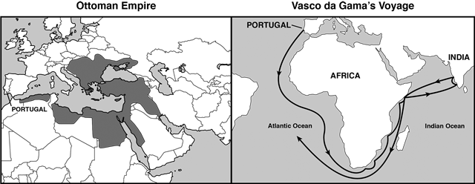  How did the Ottoman Empire influence Portugal to find a sea route to India?
 | A. by controlling access to direct overland trade routes to Asia
 | B. by providing Europeans with advanced navigational technology
 | C. by creating accurate maps of the Atlantic and Indian Oceans
 | D. by forbidding Asian countries from developing merchant fleets

