World History Benchmark #1
Student
Class
Date

1. | Which relationship illustrates how the Neolithic Revolution affected ancient Egypt?
 | A. sedentary lifestyle → fewer technical skills
 | B. increased agricultural productivity → division of labor
 | C. smaller labor force → more religious leaders
 | D. increased hunting → development of government

2. | Which ancient civilizations were located in Mesopotamia?
 | A. Angles, Saxons, and Jutes
 | B. Olmec, Mayan, and Aztec
 | C. Latins, Etruscans, and Romans
 | D. Sumerians, Babylonians, and Assyrians

3. | Use the diagram below to answer the question.  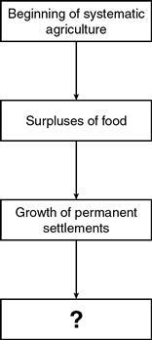  Which phrase best completes this diagram?
 | A. Introduction of religious beliefs
 | B. Destruction of river civilizations
 | C. Establishment of social hierarchies
 | D. Disappearance of tribal societies

4. | Use the diagram below to answer the question.  During which period did this transition occur?
 | A. Paleolithic Era
 | B. Neolithic Era
 | C. Bronze Age
 | D. Iron Age

5. | Which title best completes this diagram?
 | A. Results of Chinese Cultural Influence
 | B. Concepts Developed in Ancient Mesopotamia
 | C. Features of Greek and Roman Government
 | D. Results of Aztec and Mayan Political Influence

6. | Use the list below to answer the question.  Ancient Indian Social Structure  • Brahman (priestly) class  • Kshatriya (warrior/noble) class  • Vaishya (commoner/herdsmen/tradesman) class  • Shudra (peasant/servant) class  What is the best classification for this social structure?
 | A. ethnic groups
 | B. religious sects
 | C. feudal system
 | D. caste system

7. | The ancient Greek city-state of Athens influenced later cultures by
 | A. adopting a monotheistic religion.
 | B. developing a written language.
 | C. constructing a system of canals.
 | D. establishing a democratic government.

8. | How did the Jewish Ten Commandments affect the development of a legal code?
 | A. The Commandments emphasized the importance of ethical behavior.
 | B. The Commandments established a structure of government.
 | C. The Commandments helped enforce the authority of secular leaders.
 | D. The Commandments confirmed the need for social equality.

9. | Use the information in the chart to answer the question.  Civilization Achievement  Babylonia Hammurabi’s Code  Ancient Greece Draco’s Code  Byzantine Empire Justinian’s Code  How did codifying laws benefit all three societies?
 | A. by promoting equality and prohibiting discrimination
 | B. by creating an early form of representative government
 | C. by establishing a clear system of rules and consequences
 | D. by ensuring power was distributed between branches of government

10. | Where was the center of the Inca empire located?
 | A. in the Andes Mountains
 | B. in the Amazon Forest
 | C. on the Yucatan Peninsula
 | D. along the Rio Grande River

11. | What was the purpose of the Great Wall built during the Qin Dynasty?
 | A. to prevent subjects from fleeing Qin rule
 | B. to control commerce on the Silk Road
 | C. to mark the border across the Gobi Desert
 | D. to stop attacks by northern nomads

12. | This map illustrates the origin and spread of which major religion?
 | A. Buddhism
 | B. Christianity
 | C. Hinduism
 | D. Islam

13. | Which characteristic do Buddhism and Hinduism share?
 | A. a rigid social system
 | B. the belief in a single deity
 | C. a faith in divine salvation
 | D. the concept of karma

14. | Use the list below to answer the question.  • Christianity  • Islam  • Judaism  What do these religions have in common?
 | A. They originated in the Arabian Peninsula.
 | B. They observe the Five Pillars.
 | C. They began during the Roman Empire.
 | D. They are monotheistic faiths.

15. | This chart represents a historical aspect of which belief system?
 | A. the structure of religious authority in Judaism
 | B. a series of cultural groups recognized in Buddhism
 | C. the political order prescribed by Islam
 | D. a social hierarchy based on Hinduism

16. | Use the information in the list to answer the question.  Social Classes in Ancient Rome  • Patrician  • Plebian  • Slave  How were patricians different from other social classes in Ancient Rome?
 | A. Patricians had the poorest living conditions.
 | B. Patricians were prohibited from becoming citizens.
 | C. Patricians came from a different country and belonged to a different culture.
 | D. Patricians owned most of the land and held most of the political positions.

17. | Use the excerpt below to answer the question.  196. If a man put out the eye of another man, his eye shall be put out.  197. If he break another man’s bone, his bone shall be broken.  198. If he put out the eye of a freed man, or break the bone of a freed man, he shall pay one gold mina [a fine].  199. If he put out the eye of a man’s slave, or break the bone of a man’s slave, he shall pay one-half of its value.  —Hammurabi’s Code, Babylonia, c.1772 B.C.  Based on this excerpt, which of these conditions existed in Babylonia?
 | A. social class inequality
 | B. racial discrimination
 | C. due process of law
 | D. religious freedom

18. | Use the list below to answer the question.  Selected Major Greek Thinkers  • Archimedes  • Euclid  • Thales  These individuals all made major contributions to knowledge in which area?
 | A. foundations of mathematics
 | B. principles of social structure
 | C. democratic institutions
 | D. theories of psychology

19. | Use the pictures below to answer the question.  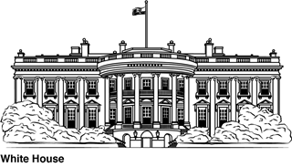  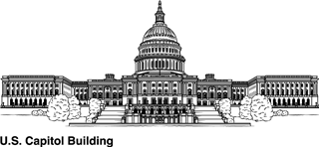  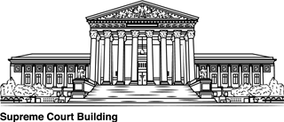  Which civilizations had the greatest influence on the architecture of these buildings in Washington, D.C.?
 | A. Ghana and Mali
 | B. Aztec and Inca
 | C. Ancient India and Ancient China
 | D. Ancient Greece and Ancient Rome

20. | Which ancient civilization most influenced the development of a democratic form of government in the United States?
 | A. India
 | B. China
 | C. Egypt
 | D. Greece

