Source 1: 1938 at the Halifax County Courthouse in northeastern North Carolina.
Photo by John Vachon/ Farm Security Administration

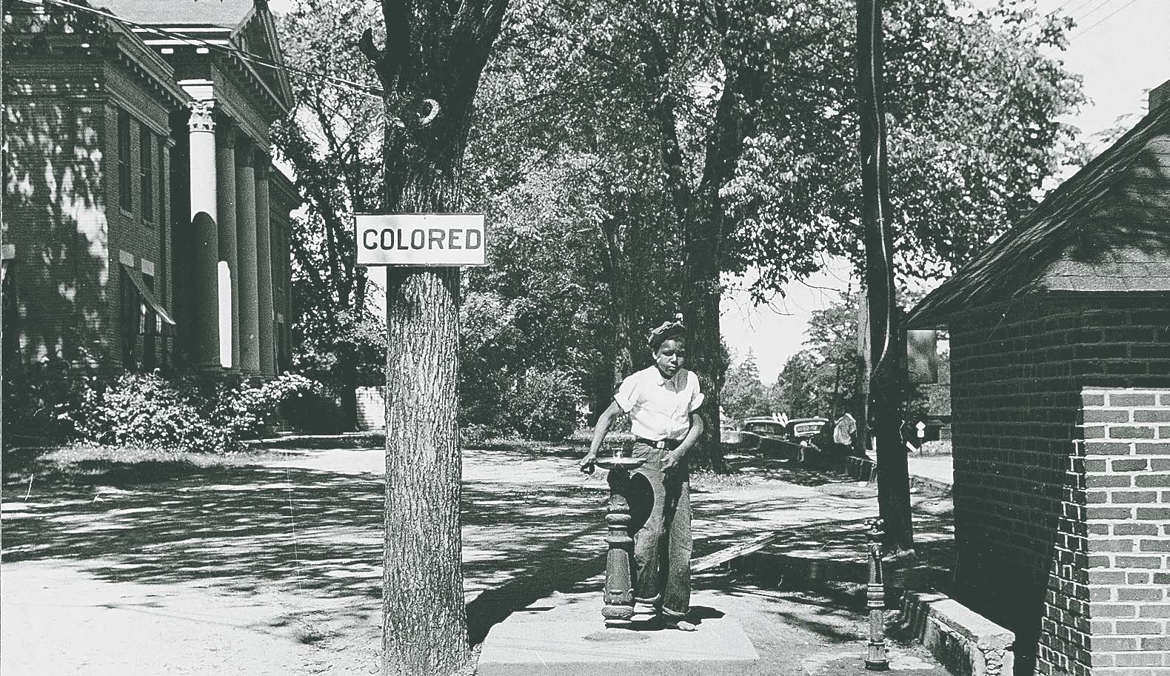
Source 2: Racial Segregation Ordinances, Birmingham, Alabama, May, 1951:

SEC. 597 Negroes and White Persons Not To Play Together
It shall be unlawful for a Negro and a white person to play together or in company with each other in any game of cards, dice, dominoes, checkers, baseball, softball, football, basketball or similar games.
Any person, who being the owner, proprietor or keeper or superintendent of any tavern, inn, restaurant, ballfield, stadium or other public house or public place, or the clerk, servant or employee of such owner, proprietor, keeper, or superintendent, knowingly permits a Negro and a white person to play together or in company with each other, at any game with a baseball, softball, basketball or other ball, in his house or on his premises or in a house or on premises under his charge, supervision or control, shall, on conviction, be punished as provided in Section 4.
Approved Sept. 19, 1950 A true copy, Eunice S. Hewes, City Clerk Post-Herald, Sept 21, 1950
Source 3: Martin Luther King Jr. Speech, “The Power Of Nonviolence”, June 4, 1957

From the very beginning there was a philosophy undergirding the Montgomery boycott, the philosophy of nonviolent resistance. There was always the problem of getting this method over because it didn’t make sense to most of the people in the beginning. We had to use our mass meetings to explain nonviolence to a community of people who had never heard of the philosophy and in many instances were not sympathetic with it. We had meetings twice a week on Mondays and on Thursdays, and we had an institute on nonviolence and social change. We had to make it clear that nonviolent resistance is not a method of cowardice. It does resist. It is not a method of stagnant passivity and deadening complacency. The nonviolent resister is just as opposed to the evil that he is standing against as the violent resistor but he resists without violence. This method is nonaggressive physically but strongly aggressive spiritually.
NOT TO HUMILIATE BUT TO WIN OVER
Another thing that we had to get over was the fact that the nonviolent resister does not seek to humiliate or defeat the opponent but to win his friendship and understanding. This was always a cry that we had to set before people that our aim is not to defeat the white community, not to humiliate the white community, but to win the friendship of all of the persons who had perpetrated this system in the past. The end of violence or the aftermath of violence is bitterness. The aftermath of nonviolence is reconciliation and the creation of a beloved community. A boycott is never an end within itself. It is merely a means to awaken a sense of shame within the oppressor but the end is reconciliation, the end is redemption.
Then we had to make it clear also that the nonviolent resister seeks to attack the evil system rather than individuals who happen to be caught up in the system. And this is why I say from time to time that the struggle in the South is not so much the tension between white people and Negro people. The struggle is rather between justice and injustice, between the forces of light and the forces of darkness. And if there is a victory it will not be a victory merely for fifty thousand Negroes. But it will be a victory for justice, a victory for good will, a victory for democracy.
Another basic thing we had to get over is that nonviolent resistance is also an internal matter. It not only avoids external violence or external physical violence but also internal violence of spirit. And so at the center of our movement stood the philosophy of love. The attitude that the only way to ultimately change humanity and make for the society that we all long for is to keep love at the center of our lives. Now people used to ask me from the beginning what do you mean by love and how is it that you can tell us to love those persons who seek to defeat us and those persons who stand against us; how can you love such persons? And I had to make it clear all along that love in its highest sense is not a sentimental sort of thing, not even an affectionate sort of thing.

Source 4: Two Quotes from Malcolm X

Quoted in George Breitman, ed. The Last Year of Malcolm: The Evolution of a Revolutionary, NY: Pathfinder Press, INC, 1970, pages 106-107

“Since self-preservation is the first law of nature, we assert the Afro-American’s right of self-defense. The Constitution of the USA clearly affirms the right of every American citizen to bear arms. And as Americans, we will not give up a single guarantee under the Constitution.
The history of unpublished violence against our people clearly indicates that we must be prepared to defend ourselves or we will continue to be a defenseless people at the mercy of a ruthless and violent racist mob.
We assert in those areas where the government is either unable or unwilling to protect the lives and property of our people, that our people are within their rights to protect themselves by whatever means necessary. A man with a rifle or a club can only be stopped by a person who defends himself with a rifle or club.
Tactics based solely on morality can only succeed when you are dealing with basically moral people or a moral system. A man or system which opposes a man because of his color is not moral. It is the duty of every African American community throughout this country to protect its people against mass murders, bombers, lynchers, brutalizers, and exploiters.”

II. “On Black people and war” Speech by Malcolm X, November 10, 1963

“If violence is wrong in America, violence is wrong abroad. If it is wrong to be violent defending black women and black children and black babies and black men, then it is wrong for America to draft us, and make us violent abroad in defense of her. And if it is right for America to draft us, and teach us how to be violent in defense of her, then it is right for you and me to do whatever is necessary to defend our own people right here in this country.” ~~~~Malcolm X
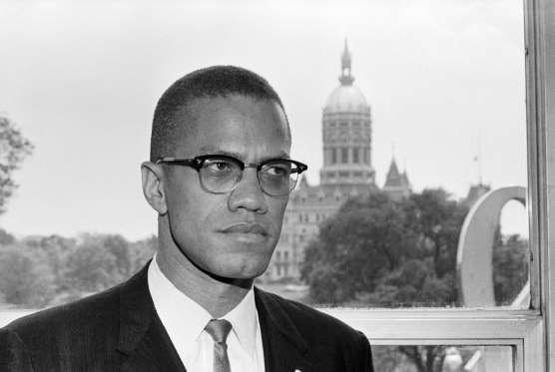
Source 5: MOHANDAS K. GANDHI'S SPEECH (EXCERPTS) TO THE ALL-INDIA CONGRESS, Bombay, August 7, 1942
There are people who have hatred in their hearts for the British. I have heard of people saying that they are disgusted [filled with dislike] with them. The common people's mind does not differentiate [see a difference] between a Britisher and the imperialist form of their government. To them both are the same…
I know full well that the British will have to give us our freedom when we have made sufficient [enough] sacrifices and proven our strength. We must remove the hatred for the British from our hearts. At least, in my heart there is no such hatred. As a matter of fact, I am a greater friend of the British now than I ever was.…
At the time when I am about to launch the biggest front in my life, there can be no hatred for the British in my heart. The thought that, because they are in difficulties, I should give them a push is totally absent from my mind. It has never been there. It may be that, in a moment of anger, they might do things that might provoke [cause anger in] you. Nevertheless, you should not resort to violence; that would put non-violence to shame. …
Non-violence is a matchless weapon, which can help every one. I know we have not done much by way of non-violence and therefore, if such changes come about, I will take it that it is the result of our labors during the last twenty-two years and that God has helped us to achieve it.
…I want you to adopt non-violence as a matter of policy. With me it is a creed [belief], but so far as you are concerned I want you to accept it as policy. As disciplined soldiers you must accept it in toto [completely], and stick to it when you join the struggle.

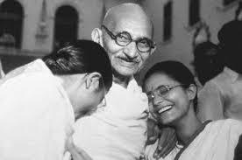

Source 6: Two quotes from Robert F. Williams.

Robert F. Williams before the NAACP 1960 – taken from Timothy B. Tyson, Radio Free Dixie: Robert F. Williams and the Roots of Black Power (1999) Page 198.

Background: Robert Franklin Williams (1925-1996) was an African-American leader who became famous for advocating “armed self-defense” and inspiring groups such as the Black Panthers. Source: http://www.northcarolinahistory.org/encyclopedia/186/entry/

“Tom Paine, Washington, Jefferson, and Patrick Henry were all honorable men who are supposed to represent the true spirit of America. These noble men advocated violence as a vehicle of liberation. They are not considered wild-eyed, bloodthirsty fanatics by a long shot.” ~~~Robert F. Williams
Taken from Timothy B. Tyson, Radio Free Dixie: Robert F. Williams and the Roots of Black Power (1999) Page 214
“When Hitler’s tyranny threatened the world, we did not hear very much about immoral it is to meet violence with violence.” ~~~Robert F. Williams

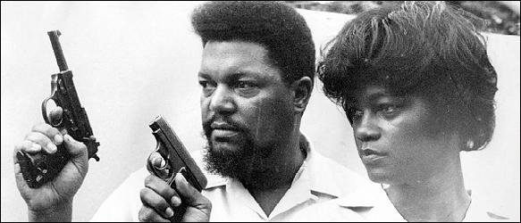
Robert F. Williams

Source 7: Martin Luther King Jr., from his book Strength to Love, 1963
“Darkness cannot drive out darkness; only light can do that. Hate cannot drive out hate; only love can do that. Hate multiplies hate, violence multiplies violence, and toughness multiplies toughness in a descending spiral of destruction....
The chain reaction of evil -- hate begetting hate, wars producing more wars --must be broken, or we shall be plunged into the dark abyss of annihilation.”
~~~~~~Dr. Martin Luther King, Jr.

Source 8: Image from Civil Rights Movement Protest; Birmingham, 1963

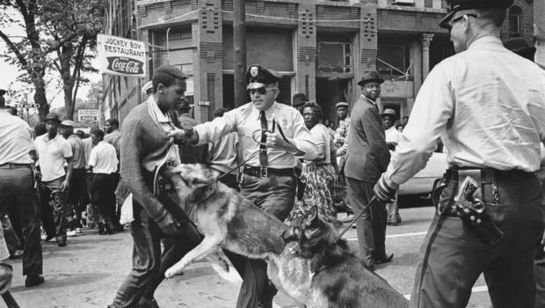

Source 9: Ida B. Wells Southern Horrors: Lynch Law in All Its Phases (1892)

“The lesson this teaches and which every Afro American should ponder well, is that a Winchester rifle should have a place of honor in every black home, and it should be used for that protection which the law refuses to give. When the white man who is always the aggressor knows he runs as great a risk of biting the dust every time his Afro-American victim does, he will have greater respect for Afro-American life. The more the Afro-American yields and cringes and begs, the more he has to do so, the more he is insulted, outraged and lynched.” ~~~~Ida B. Wells

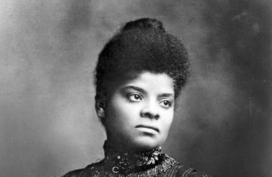

Source 10: Speech by Lyndon B. Johnson
Remarks upon Signing the Civil Rights Bill (July 2, 1964)

My fellow Americans:
I am about to sign into law the Civil Rights Act of 1964. I want to take this occasion to talk to you about what that law means to every American.
One hundred and eighty-eight years ago this week a small band of valiant men began a long struggle for freedom. They pledged their lives, their fortunes, and their sacred honor not only to found a nation, but to forge an ideal of freedom—not only for political independence, but for personal liberty—not only to eliminate foreign rule, but to establish the rule of justice in the affairs of men.
That struggle was a turning point in our history. Today in far corners of distant continents, the ideals of those American patriots still shape the struggles of men who hunger for freedom. This is a proud triumph. Yet those who founded our country knew that freedom would be secure only if each generation fought to renew and enlarge its meaning. From the minutemen at Concord to the soldiers in Viet-Nam, each generation has been equal to that trust.
Americans of every race and color have died in battle to protect our freedom. Americans of every race and color have worked to build a nation of widening opportunities. Now our generation of Americans has been called on to continue the unending search for justice within our own borders.
We believe that all men are created equal. Yet many are denied equal treatment.
We believe that all men have certain unalienable rights. Yet many Americans do not enjoy those rights.
We believe that all men are entitled to the blessings of liberty. Yet millions are being deprived of those blessings—not because of their own failures, but because of the color of their skin.
The reasons are deeply embedded in history and tradition and the nature of man. We can understand—without rancor or hatred—how this all happened.
But it cannot continue. Our Constitution, the foundation of our Republic, forbids it. The principles of our freedom forbid it. Morality forbids it. And the law I will sign tonight forbids it.
That law is the product of months of the most careful debate and discussion. It was proposed more than one year ago by our late and beloved President John F. Kennedy. It received the bipartisan support of more than two-thirds of the Members of both the House and the Senate. An overwhelming majority of Republicans as well as Democrats voted for it.
It has received the thoughtful support of tens of thousands of civic and religious leaders in all parts of this Nation. And it is supported by the great majority of the American people.The purpose of the law is simple:
It does not restrict the freedom of any American, so long as he respects the rights of others.
It does not give special treatment to any citizen.
It does say the only limit to a man's hope for happiness, and for the future of his children, shall be his own ability.
It does say that there are those who are equal before God shall now also be equal in the polling booths, in the classrooms, in the factories, and in hotels, restaurants, movie theaters, and other places that provide service to the public.
I am taking steps to implement the law under my constitutional obligation to "take care that the laws are faithfully executed."

