“What kind of peace do we seek? Not a [peace] enforced on the world by American weapons of war . . . not merely a peace for Americans but peace for all men and women . . . For, in the final analysis, our most basic common link is that we all inhabit this small planet. We all breathe the same air. We all cherish our children’s future. And we are all mortal.”
—John F. Kennedy, June 10, 1963

- Study the passage and answer the question. Which of the following was based on the ideals Kennedy expressed in this speech?
a. the Peace Corps
b. the Bay of Pigs invasion
c. the strategy of containment
d. the Great Society

“The Great Society rests on abundance and liberty for all. It demands an end to poverty and racial injustice, to which we are totally committed in our time. But that is just the beginning. The Great Society is a place where every child can find knowledge to enrich his mind and to enlarge his talents. It is a place where leisure is a welcome chance to build and reflect, not a feared cause of boredom and restlessness. It is a place where the city of man serves not only the needs of the body and the demands of commerce but the desire for beauty and the hunger for community.”
—Lyndon Johnson, May 22, 1964

2. Which of the following goals was central to Johnson’s vision of the Great Society?
a. equal opportunity for education
b. flexible response
c. suburban community development
d. world peace

“Our prosperity rests on the basic [beliefs] that the work of free individuals makes a nation—and it is the job of Government to help them do the best they can . . . that our greatest resource is the health and skills and knowledge of our people . . . that older Americans . . . are entitled to live out their lives in dignity . . . that individual farmers and individual workers have a right to some protection against those forces which might deprive them of a decent income from the fruits of their labor.”
—Lyndon Johnson, May 1964

3. According to Johnson, the primary role of government is to
a. protect older Americans. c. support individual effort.
b. provide a decent income. d. conserve resources.

“Kindly, Move Over A Little, Gentlemen”
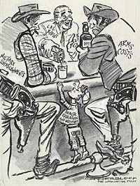

4. Which statement regarding Lyndon B. Johnson’s presidency is best supported by the information in this cartoon?
- Domestic programs had been the main priority in previous budgets.
- Domestic programs were eliminated during the 1960s.
- Military spending had negatively affected domestic programs.
- Military spending was completely eliminated to fund domestic programs.

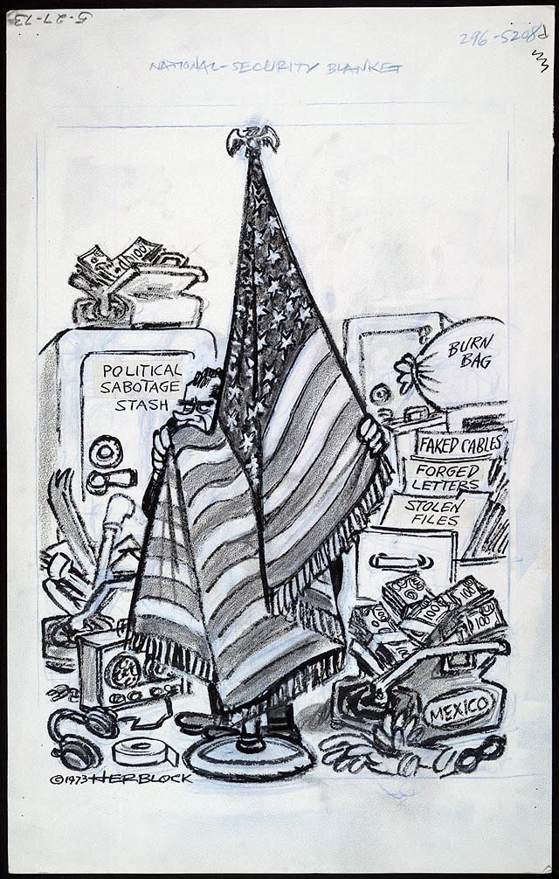

5. Which action by President Richard Nixon is the focus of this cartoon?
- recalling diplomats from Mexico
- supporting tax decreases and budget cuts
- attempting to hide evidence from investigators
- making concessions to the Soviet Union

6. The outcome of the events illustrated in the cartoon resulted in the
- expansion of the Vietnam War into Cambodia
- resignation of President Richard Nixon
- growing support for environmental protection legislation
- visit to Communist China by President Richard Nixon

. . . Believing this as I do, I have concluded that I should not permit the Presidency to become involved in the partisan divisions that are developing in this political year. With America’s sons in the fields far away, with America’s future under challenge right here at home, with our hopes and the world’s hopes for peace in the balance every day, I do not believe that I should devote an hour or a day of my time to any personal partisan causes or to any duties other than the awesome duties of this office—the Presidency of your country. . . .
— President Lyndon B. Johnson, Address to the Nation, March 31, 1968

7. What was one problem facing President Lyndon B. Johnson at the time this speech was delivered?
- Americans had experienced several judicial scandals.
- His participation in peace talks threatened the war effort.
- Opposition to the Vietnam War was becoming more widespread.
- Great Society programs forced a reduction in military spending.

“Somalis Are Still Hungry and at War Despite Efforts of United States Troops”
“United States Troops Help Reinstate Haitian President”
“United States and NATO Allies Use Air Strikes To Slow Ethnic Cleansing in Bosnia”

8. These 1990s headlines illustrate the efforts of the United States to
- support independence movements
- act as an international peacekeeper
- prevent the spread of communism
- protect United States business investments

“No voting qualification or prerequisite to voting, or standard, practice, or procedure shall be imposed or applied by any State or political subdivision to deny or abridge the right of any citizen of the United States to vote on account of race or color.”
— Section 2, Voting Rights Act of 1965

9. The specific goal stated in this section of the Voting Rights Act of 1965 was to
- expand the use of property qualifications
- establish voter qualifications such as literacy tests
- stop fraudulent voting in large cities
- remove barriers to voting based on racial background

“Hoover and Smith Campaign on Radio”
“Kennedy Passes Nixon in Polls After Televised Debate”
“Obama Raises Record Donations Using the Internet”

10. Which statement about the use of media in political campaigns is illustrated by these headlines?
- Media bias does not affect the ability of political leaders to communicate with voters.
- Political leaders adapt to new forms of media to communicate with voters.
- Electronic media are an ineffective way for political leaders to communicate with voters.
- Endorsements by the media have the greatest influence on voters.

CLARK M. CLIFFORD
815 Connecticut Avenue
Washington, D.C. 20006
May 17, 1965

The President The White House

Dear Mr. President:
…I believe our ground forces in South Vietnam should be kept to a minimum, consistent with the protection of our installations and property in that country. My concern is that a substantial buildup of U.S. ground troops would be construed by the Communists, and by the world, as a determination on our part to win the war on the ground. This could be a quagmire. It could turn into an open end commitment on our part that would take more and more ground troops, without a realistic hope of ultimate victory. I do not think the situation is comparable to Korea. The political posture of the parties involved, and the physical conditions, including terrain, are entirely different. …

Respectfully yours, Clark

11. What advice about United States involvement in Vietnam is President Lyndon B. Johnson being given in this letter?
- Escalation of the Vietnam War is necessary to stop communist expansion.
- Increasing the United States military commitment to Vietnam would be a mistake.
- Victory in the Vietnam War will be assured if the president continues his policies.
- Military success in Vietnam is improving the president’s chances for reelection.

…Capitalism, demonstrably the greatest of the constructed economic systems, has in the past decade clearly proved its advantages over the alternative systems. The information highway will magnify those advantages. It will allow those who produce goods to see, a lot more efficiently than ever before, what buyers want, and will allow potential consumers to buy those goods more efficiently. Adam Smith would be pleased. More important, consumers everywhere will enjoy the benefits.
— Bill Gates, 1995

12. Which statement most accurately expresses the main idea of this passage?
- Information technology will make it easier to buy and sell goods.
- Information technology will make capitalism obsolete.
- Government must regulate the information technology industry.
- The costs of information technology will outweigh its benefits.

“Iran Starts Uranium Enrichment Program”
“North Korea Conducts Underground Atomic Tests”
“Pakistan Accused of Selling Atomic Secrets to Libya”

13. These headlines are most closely related to United States national security concerns over the
- proliferation of nuclear weapons
- construction of nuclear power plants
- effectiveness of the nuclear test ban treaty
- enforcement of the Strategic Arms Limitation Treaty

• Freedom of expression was limited under John Adams.
• Japanese Americans were interned during World War II.
• The George W. Bush and Barack Obama administrations held suspected terrorists in military prisons without trial.

14. All of these actions taken by the federal government show that
- rights guaranteed by the Constitution have seldom changed
- discrimination against minority groups usually decreases during periods of war
- civil liberties are often restricted in time of war or national crisis
- human rights violations have often been the cause of United States wars

“We conclude that, in the field of public education, the doctrine of ‘separate but equal’ has no place. Separate educational facilities are inherently unequal. Therefore, we hold that the plaintiffs and others similarly situated for whom the actions have been brought are, by reason of the segregation complained of, deprived of the equal protection of the laws guaranteed by the Fourteenth Amendment….”

15. This Supreme Court decision is based on the idea that segregation in education is likely to
- deny individuals equal opportunities to make social and economic progress
- interfere with the right to privacy in public schools
- create excessive burdens on school transportation systems
- result in high tax increases to support separate school systems

I am asked frequently how Special Olympics was born. It really began in the late 1950s and early ’60s, when I traveled through the United States to visit several institutions for people with intellectual disabilities. The conditions in those days were terrible. There was no special education, no physical activity and certainly no opportunity to play sports. My visits left an indelible mark for life—I knew I had found an area of enormous need where I could focus my life’s work and energy….
— Eunice Kennedy Shriver, founder of Special Olympics

16. Based on this passage, the Special Olympics provides people with disabilities the opportunity to
- obtain job training
- receive an education
- participate in competitive athletics
- live in community institutions

“… There is one sign the Soviets can make that would be unmistakable, that would advance dramatically the cause of freedom and peace. General Secretary Gorbachev, if you seek peace, if you seek prosperity for the Soviet Union and Eastern Europe, if you seek liberalization: Come here to this gate! Mr. Gorbachev, open this gate! Mr. Gorbachev, tear down this wall!…”
— President Ronald Reagan, June 12, 1987

17. President Reagan was calling for the end of the
- nuclear arms race
- Soviet invasion of Afghanistan
- division of Berlin, Germany
- Warsaw Pact

“Convention Meets at Seneca Falls”
“19th Amendment Ratified”
“Betty Friedan Organizes National Organization for Women”

18. Which statement about women in the United States is best illustrated by these headlines?
- The role of women in society has remained unchanged since colonial times.
- The struggle for women’s rights has spanned many decades.
- The earnings of women today are equal to those of men.
- The movement for women’s rights has lacked leadership.

• Theodore Roosevelt mediates adoption of the Treaty of Portsmouth.
• Richard Nixon visits China.
• Bill Clinton supports peace accords in Northern Ireland.

19. These actions are examples of various presidents acting as
- chief diplomat b. head of party c. chief legislator d. commander in chief

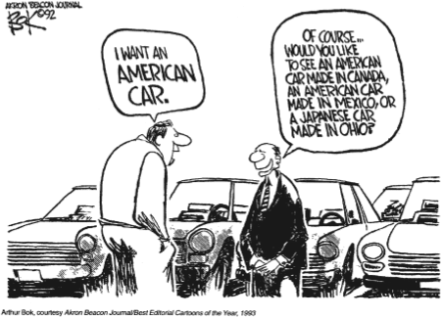

20. Which economic issue is the cartoonist addressing?
- globalization b. high tariffs
c. transportation costs d. quality of American cars

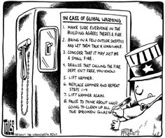

21. Which statement best supports the cartoonist’s view in 2007 about global warming?
- The federal government has been slow to take action on global warming.
- Most people support efforts to address global warming.
- Dealing with global warming is too expensive.
- Global warming is damaging the ozone layer.

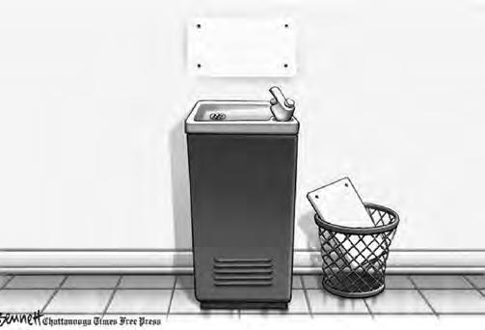

22. According to the cartoonist, one important result of the election of President Barack Obama in 2008 was that
- public facilities in the South were finally integrated
- the executive branch of government gained power over the legislative branch
- a racial barrier in government had been broken
- racial discrimination was legally eliminated in the United States

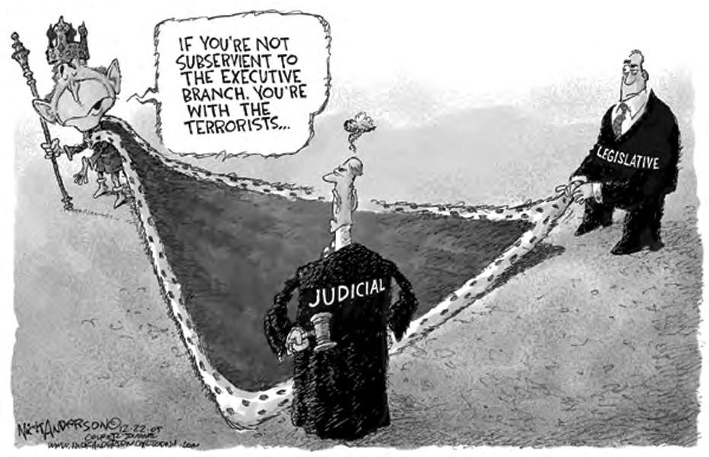

23. This cartoon illustrates that actions taken during times of crisis have sometimes led to concerns about the functioning of
- federalism b. salutary neglect
c. checks and balances d. bicameral legislatures

Answers
- A
- A
- C
- C
- C
- B
- C
- B
- D
- B
- B
- A
- A
- C
- A
- C
- C
- B
- A
- A
- A
- C
- C

