Unit 5-6 Primary Source Questions

Name: _______________________________________________ Date: ______________________

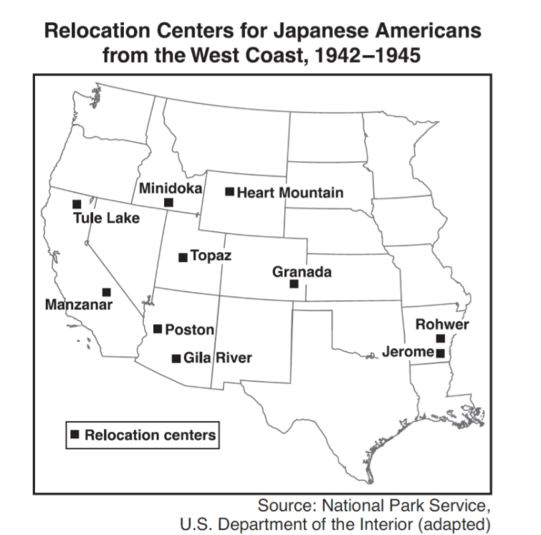
- The relocation camps shown on the map were mainly a reaction to the

A) Japanese military attack on Pearl Harbor
B) capture of Japanese war prisoners
C) need to train Japanese Americans for military service
D) attacks by Japanese Americans on United States military bases

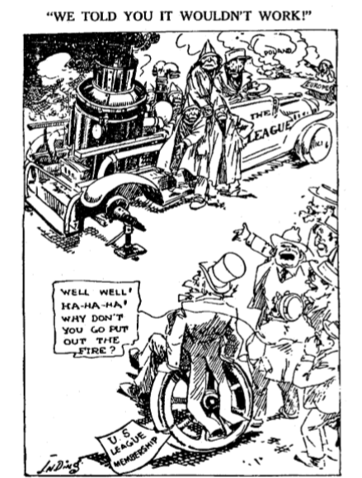

2. The situation portrayed in the cartoon helped lead the United States to adopt which policy in the period after World War II?

A) neutrality B) support of the formation of the United Nations
C) isolationism D) military aid to Poland and other Eastern European nations

Along the eastern coast of the United States, where the numbers of Americans of Japanese ancestry is comparatively small, no concentration of camps have been established. From a military point of view, the only dangers on this coast is from Germany and Italy...But the American government has not taken such high-handed action against Germans and Italians - and their American-born descendants - on the East Coast, as has been taken against Japanese and their American-born descendants on the West Coast. Germans and Italians are “white.” Color seems to be the only possible reasons why thousands of American citizens of Japanese ancestry are in concentration camps. Anyway, there are no Italian-American, or German-American citizens in such camps.
-Harry Paxton Howard, “Americans in Concentration Camps”,
The Crisis official magazine of the NAACP, September 1942

3. According to Howard, why are Japanese-Americans but not German or Italian Americans in concentration camps?
- Deeper hatred of Japanese after Pearl Harbor Attack
- There are much fewer German & Italian Americans than Japanese Americans
- Racism against Japanese Americans
- There was less land for concentration camps on the urbanized east coast

Executive Order 9066
Whereas the successful prosecution of the war requires every possible protection against espionage and against sabotage to national-defense material, national-defense premises, and national-defense utilities by virtue of the authority vested in me as President of the United States, and Commander in Chief of the Army and Navy, I hereby authorize and direct the Secretary of War, and the Military Commanders . . . whenever he deems such action necessary or desirable, to prescribe military areas in such places . . . may determine, from which any or all persons may be excluded, and with respect to which, the right of any person to enter, remain in, or leave shall be subject to whatever restrictions the Secretary of War may impose. The Secretary of War is hereby authorized to provide for residents of any such area who are excluded . . . transportation, food, shelter, and other accommodations as may be necessary.
-Franklin Roosevelt, 1942

4. Which statement is consistent with the eventual response to Executive Order 9066?

- federal government increased taxes to pay for the relocation and deportation of Japanese Americans to the Japanese mainland.
- Federal legislation was signed to apologize to Japanese Americans for internment and $1.6 billion were disbursed as reparations.
- Japanese Americans were given hiring preferences for federal jobs.
- Japanese Americans were granted priority in graduate school admissions.

We uphold the exclusion order...In doing so, we are not unmindful of the hardships imposed on it by a large group of American citizens...But hardships are a part of war, and war is a aggregation (sum) of hardships...Citizenship has its responsibilities, as well as its privileges, and, in time of war, the burden is always heavier. Compulsory (mandatory) exclusion of large groups of citizens from their homes, except under circumstances of direct emergency and peril, is inconsistent with our basic governmental institutions. But when, under conditions of modern warfare, our shores are threatened by hostile forces, the power to protect must be commensurate (in proportion) with the threatened danger...To cast this case into the outlines of racial prejudice, without reference to the real military dangers which were presented, merely confuses the issue.
-Chief Justice Hugo Black, Korematsu v United States, 1944

5. According to Chief Justice Black, why were Japanese-Americans put into concentration camps?
- The military threat of Japanese invasion B) Because they were not of European descent
C) Because of their proven activity as spies and rebels against the United States
D) Because they were not citizens and therefore not protected by the Constitution

“Yesterday, December 7, 1941—a date which will live in infamy—the United States of America was suddenly and deliberately attacked by naval and air forces of the Empire of Japan. . . .”
—President Franklin D. Roosevelt, Address to Congress, December 8, 1941

6. In this statement, President Roosevelt was addressing Congress about the:

A) sinking of merchant ships in the Atlantic Ocean B) D-Day invasion of France
C) bombing of Pearl Harbor D) air raids on the Panama Canal

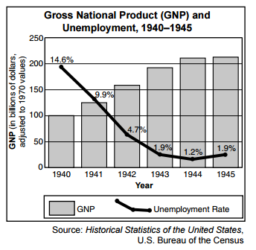

7. Which conclusion about the United States economy during World War II is most clearly supported by the information in the graph?

A) Organized labor conducted frequent strikes during the war years
B) The war led to improved economic conditions
C) The Gross National Product (GNP) steadily declined during the war years
D) Unemployment increased throughout the war

The Servicemen′s Readjustment Act (commonly known as the G.I. Bill) was signed and implemented in 1944 in the final years of World War II. An important aspect of the act was the extension of education to military veterans: Any person who served in the active military or naval forces on or after September 16, 1940, and prior to the termination of hostilities in the present war, shall be entitled to vocational rehabilitation . . . or to education or training.
-Servicemen′s Readjustment Act of 1944

8. Which describes the large-scale impact of the Servicemen’s Readjustment Act after WWII?
- It increased the incentive to enlist in the military and increased the likelihood of engaging in war.
- It increased the number of veterans entering universities and improved the education of the workforce.
- It created financial problems for universities as student-veterans did not pay for their educations.
- It decreased the power of the anti-war movement as the benefits of war were publicized.

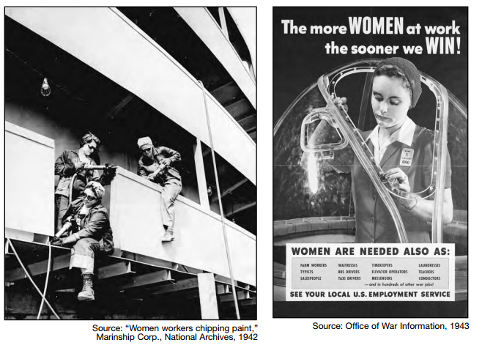

9. Photographs and posters showing scenes similar to these were used by the federal government to

- Support the goal of equal pay for equal work
- Discourage women from taking jobs from men with families
- Recruit women to fill wartime manufacturing jobs
- Encourage women to accept combat roles

The very existence of the Greek state is today threatened by the terrorist activities of several thousand armed men, led by Communists, who defy the government’s authority...Greece must have assistance if it is to become a self-supporting and self-respecting democracy. The United States must supply this assistance...No other nation is willing and able to provide the necessary support for a democratic Greek government. One of the primary objectives of the foreign policy of the United States is the creation of conditions in which we and other nations will be able to work out a way of life free from coercion….If Greece should fall under the control of an armed minority, the effect upon its neighbor, Turkey, would be immediate and serious. Confusion and disorder might well spread throughout the entire Middle East ...should we fail to aid Greece and Turkey in this fateful hour, the effect will be far reaching to the West as well as the East.
-Truman Doctrine Speech delivered by Harry Truman to Congress March 1947

10. Why would no other nations be “willing and able” to provide aid to Greece in 1947?
- Continued anger and resentment over Greece’s role in WWI & WWII
- Most other global leaders were still recovering from WWII themselves
- Greece’s strong fascist and communist leanings made most countries unwilling to give them aid
- European nations were still suffering from the Great Depression and could not financially support any other nations

11. The idea Truman explains, that just 1 country falling to Communism would have an impact all around the world, would be the foundation for which theory that dominated US foreign policy by the Vietnam Era?

- Theory of Relativity B) Frontier Theory
C) Domino Theory D) Detente

The foreign policy of the United States, which reflects the imperialist tendencies of the American monopolistic capital, is characterized in the post war period by striving for world supremacy. This is the real meaning of the many statements by President Truman and other representatives of American ruling circles; that the United States has the right to lead the world. All the forces of American diplomacy - the army, the air force, the navy, industry, and science - are enlisted in the service of this foreign policy.
Soviet Ambassador Nikolai Novikov in telegram to Soviet Leadership September 1946

12. What does Ambassador Novikov believe is the motivation for US foreign policy?

- World Peace B) Attaining a capitalist empire
C) The elimination of Communism D) Control of weapons and space technology

13. What American belief or philosophy predominant in the 19th century would give support to Novikov’s claims of American motives and justification?

- Nativism B) Manifest Destiny C) Progressivism D) Populism

Speaker A: "We must provide arms to the legitimate governments of Greece and Turkey if they are to defeat Soviet-sponsored subversion."
Speaker B: "The first priority is to help rebuild the postwar economies of European countries so that democratic governments can survive."
Speaker C: "Our main goal is to create a system of collective security agreements to deal with any military threats."
Speaker D: "We must continue to build both our nuclear and our conventional arsenals if we are to have any hope of world peace."

14. The central concern of all the speakers is
- the containment of communism
- the defeat of the Axis Powers in World War II
- a ban on the proliferation of nuclear weapons
- the support of United Nations peacekeeping efforts

Answers
            - A
            - B
            - C
            - B
            - A
            - C
            - B
            - B
            - C
            - B
            - C
            - B
            - B
            - A

