Unit 3-4: Passage Questions

Name: ___________________________________________________ Date: _____________________

"History will vindicate the position taken by the United States in the war with Spain....If, however, a contest undertaken for the sake of humanity degenerates into a war of conquest, we...have added hypocrisy to greed…Shall we contemplate a scheme for the colonization of the Orient merely because our ships won a remarkable victory in the harbor of Manila?...Our guns destroyed a Spanish fleet, but can they destroy that self-evident truth, that governments derive their just powers not from superior force, but from the consent of the governed?"

-Wm. Jennings Bryan, Presidential Candidate of the Democratic Party, 1896 and 1900, June 14, 1898

1. According to Bryan, the US role in the Spanish American War will be remembered as good and just as long as what does not happen?

- The Spanish do not simply move on the take over other parts of Latin America
- A war that was started to aid Cuban independence from a brutal dictatorship, ends up becoming a war for US territorial gain
- That it becomes a pattern that the United States intervenes for humanitarian purposes
- A war that was started to gain territory for the United States, ends up becoming a war for Cuban Independence

2. “Hawaiian Planters Urge American Annexation”
“U.S. and Germany Negotiate for Control of the Samoan Islands”
“U.S. Gains Control of Wake Island and Guam”

Which conclusion can best be drawn from these headlines?

(a) The Anti-Imperialist League strongly influenced Congress.
(b) Respect for native cultures motivated United States foreign policy.
(c) United States territorial expansion increased in the Pacific Ocean.
(d) Construction of a railroad to Alaska was a major policy goal.

3. “There’s no chance of progress and reform in an administration in which war plays the principal part. .”
— President-elect Woodrow Wilson, 1913

In this statement, President-elect Wilson was expressing the belief that
(a) the United States should enter World War I immediately
(b) reform movements are strengthened by war
(c) the nation will require a change in leadership if it goes to war
(d) the Progressive movement would be best served by continued peace

The people of the United States are drawn from many nations, and chiefly from the nations now at war. It is natural and inevitable that some will wish one nation, others another, to succeed in the momentous struggle. Such divisions among us would be fatal to our peace of mind and might seriously stand in the way of our duty as the one great nation at peace, the one nation ready to play a part of mediator and counselor of peace. The United States must be neutral in fact, as well as in name, during these days that are to try men’s souls. We must be impartial in thought as well as action.
-Woodrow Wilson speech to Congress August 1914

4. Wilson’s 1914 speech is a great example of the American policy of

- Isolationism (b) Assimilation
(c) Capitalism (d) Self-Determination

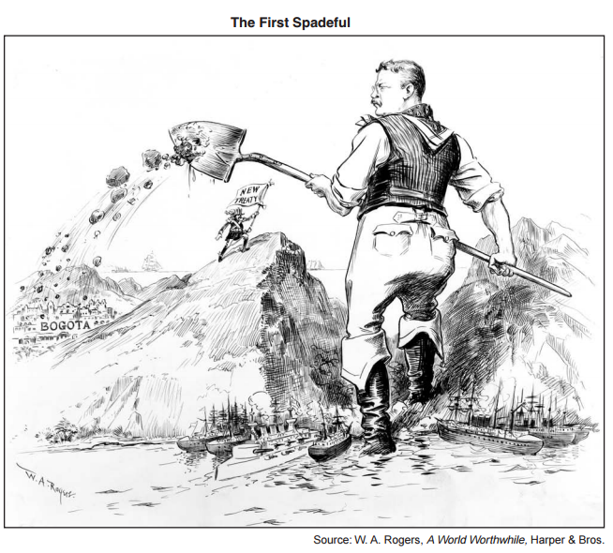

5. The cartoon illustrates the actions of President Theodore Roosevelt in

(a) securing the land to build the Panama Canal
(b) leading troops in the Spanish-American War
(c) ending the war between Russia and Japan
(d) improving diplomatic relations with Latin American nations

6. Critics of the actions shown in this cartoon claimed President Theodore Roosevelt was

(a) causing environmental damage
(b) requiring massive tax increases
(c) following a policy of imperialism
(d) producing major trade deficits with China

“To talk of Columbia as a responsible power to be dealt with as we would deal with Holland or Belgium or Switzerland or Denmark is a mere absurdity. The analogy is with a group of Sicilian or Calabrian bandits…You could no more make an agreement with the Columbian rulers than you could nail currant jelly to a wall…I did my best to get them to act straight. Then I determined that I would do what ought to be done without regard to them.”
-Private letter from President Roosevelt to his former Secretary of State, John Hay

7. In the opening lines of the quote, the tone of Roosevelt toward the Latin American nation of Columbia is consistent with which ideas of ethnic, racial, and national hierarchies in the world?

- Popular Sovereignty and Rule of Law
- Nativism and Socialism
- Social Darwinism and White Man’s Burden
- Social Gospel and Gospel of Wealth

“To draw this country into the horrors of the present war in Europe, to force the youth of our land into the…bloody trenches of war-crazy nations, would be a crime of the magnitude which defies description…No specious (misleading) or plausible …pleas about a “war for democracy” can cloud the issue. Democracy cannot be shot into a nation. It must come spontaneously and purely from within…You are responsible. You must do your share to maintain, support, and uphold the rights of the people of this country. In this world crisis where do you stand? Are you with the forces of liberty and light or war and darkness?”
-Charles Schenck in 1918 pamphlet “Assert Your Rights”

8. What argument for the war do both Debs and Schenck believe to be disingenuous, hypocritical, or manipulative?

- American Defense (b) Freedom of the Seas
(c) Protect innocent people, like the Belgians & refugees (d) Make the world safe for Democracy

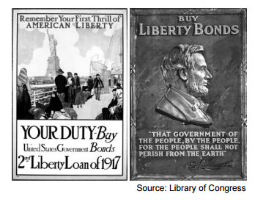

9. The United States government published these World War I posters to encourage Americans to

(a) increase military enlistments (b) reduce the use of consumer goods
(c) invest in the war effort (d) conserve scarce resources for the military

Whoever, when the United States is at war, shall willfully utter, print, write, or publish any disloyal, profane, scurrilous, or abusive language about the form of government of the United States or the Constitution of the United States, or the military or naval forces of the United States, or the flag of the United States, or the uniform of the Army or Navy of the United States…or shall willfully utter, print, write, or publish any language intended to incite, provoke, or encourage resistance to the United States…shall be punished by fine of not more than $10,000 or the imprisonment of not more than 20 years or both.
-Excerpt of the Sedition Act of 1918

The character of every act depends upon the circumstances in which it is done. The most stringent protection of free speech would not protect a man in falsely shouting “Fire!” in a theater and causing a panic…The question in every case is whether the words used are in such circumstances and and are of such a nature as to create a clear and present danger that they will bring about the substantive evils that Congress has a right to prevent…When a nation is at war many things that might be said in a time of peace are such a hindrance to its effort that their utterance will not be endured so long as men fight and that no court could regard them as protected by any constitutional right.
-Supreme Court opinion by Justice Oliver Wendell Holmes Jr March 1919 in Schenck v US case

10. The Sedition Act & Justice Holmes opinion both offer exceptions to what basic American liberty?

- Freedom of speech
- Freedom of religion
(c) Right to bear arms
(d) Right to due process

11. Both passages argue what gives the government the right to limit that liberty?

- Personal security
- Protection of property
(c) National security
(d) National supremacy clause

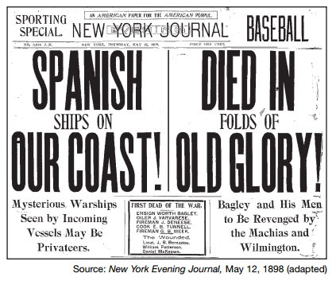

12. These 1898 headlines are best understood as an example of

(a) political advertising (b) yellow journalism
(c) public opinion polling (d) isolationist policies

13. The purpose of these headlines was to build public support for

(a) efforts to defend the Panama Canal (b) the annexation of Cuba
(c) an end to the policy of imperialism (d) the war against Spain

We intend to begin on the first of February unrestricted submarine warfare. We shall endeavor in spite of this to keep the United States of America neutral. In the event of this not succeeding, we make Mexico a proposal or alliance on the following basis: make war together, make peace together, generous financial support and an understanding on our part that Mexico is to reconquer the lost territory in Texas, New Mexico, and Arizona.…
— Zimmerman telegram, 1917

14. The disclosure of this document contributed to

(a) a declaration of war against Mexico (b) the entry of the United States into World War I
(c) the passage of the Treaty of Versailles (d) a restriction on immigration from Latin America

“I can never be anything else but an American, and I must think of the United States first. I have never had but one allegiance – I cannot divide it now. I have loved but one flag and I cannot share that devotion and give affection to the mongrel (mutt, cross-breed) banner invented for a league. Internationalism to me is repulsive. The United States is the world’s best hope, but if you fetter her in the interests and quarrels of other nations, if you tangle her in the intrigues of Europe, you will destroy her power for good and endanger her very existence. Leave her to march freely through the centuries to come as in the years that have gone…Our first ideal is our country. Our ideal is to make her ever stronger and better and finer, because in that way alone can she be of the greatest service to the world’s peace and the welfare of mankind.”
-Henry Cabot Lodge speech 1919

15. Lodge would best exemplify which concept of US history?

- Socialism (b) Pacifism
(c) Isolationism (d) Expansionism

16. Which heading best completes the partial outline below?

I. _________________________________
A. The United States claims the Hawaiian Islands.
B. Puerto Rico becomes a United States territory.
C. The United States fights an insurrection in the Philippine Islands.
D. The United States Senate ratified the Panama Canal treaty.

(a) Rise of American Imperialism (b) Causes of World War I
(c) Enforcement of the Monroe Doctrine (d) Trade Expansion in East Asia

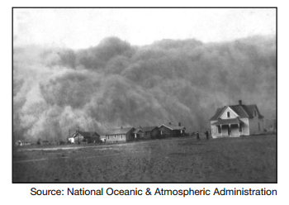

17. The conditions shown in the photograph were mainly the result of
- government subsidies to increase crop production
- migrations from farms to cities
- poor farming methods and sustained drought
- reduced tariffs on farm machinery and crops

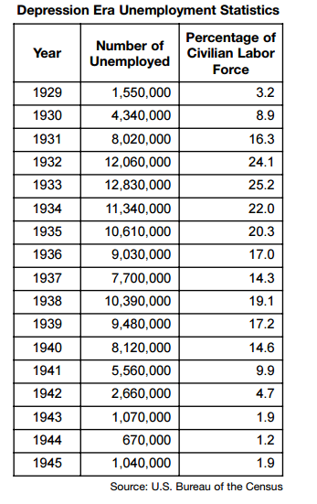

18. Which conclusion is most clearly supported by the information in the chart?

- President Herbert Hoover’s economic policies expanded job opportunities
- The United States unemployment rate reached its highest level in 1938
- President Franklin D. Roosevelt’s New Deal programs failed to address the unemployment crisis
- World War II ended the high unemployment rates of the Great Depression.

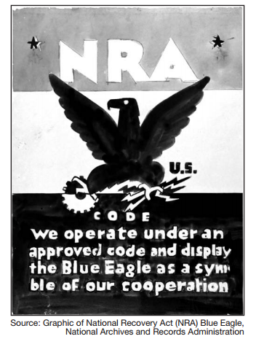

19. The cooperation mentioned in the poster was intended to be between

- business and government C. consumers and producers
- workers and retirees D. socialists and capitalists

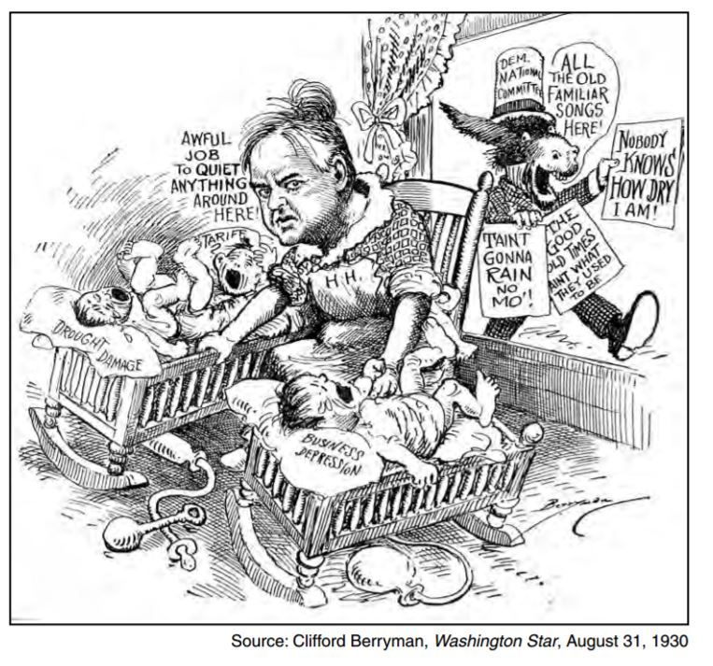

20. This cartoon is portraying a situation that resulted from the

- public rejection of the New Deal C. economic downturn of the late 1920s
- failure of the Civilian Conservation Corps D. opposition to the Treaty of Versailles

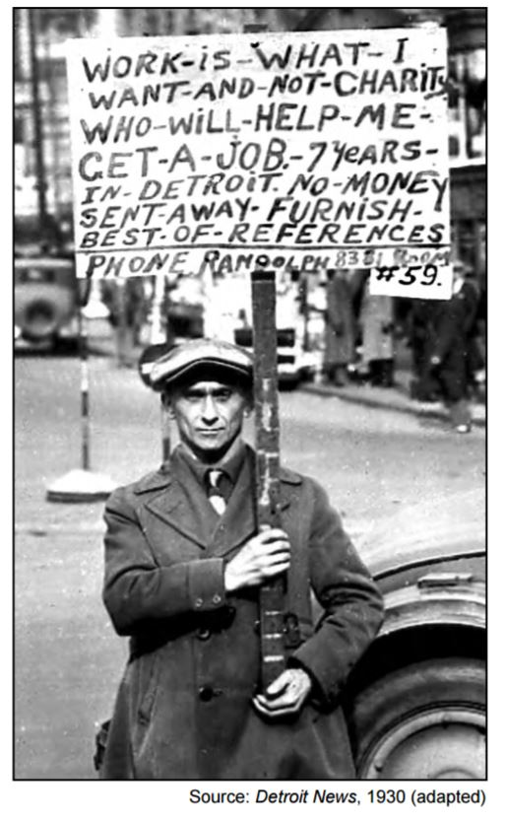

21. Which New Deal agency was created to provide employment for individuals such as the man in the photograph?

- Agricultural Adjustment Administration (AAA) C. Social Security Administration (SSA)
- Works Progress Administration (WPA) D. Federal Deposit Insurance Corporation (FDIC)

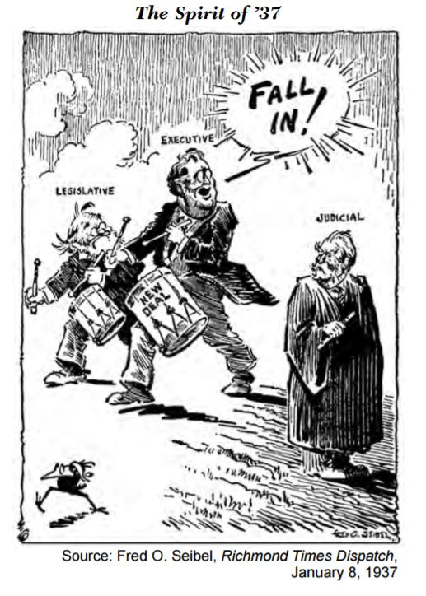
22. What is the main idea of this cartoon?

- President Franklin D. Roosevelt wanted to end Supreme Court opposition to the New Deal
- Congress refused to pass New Deal legislation
- President Franklin D. Roosevelt had not faced any opposition to his New Deal
- Congress voted to increase the size of the Supreme Court

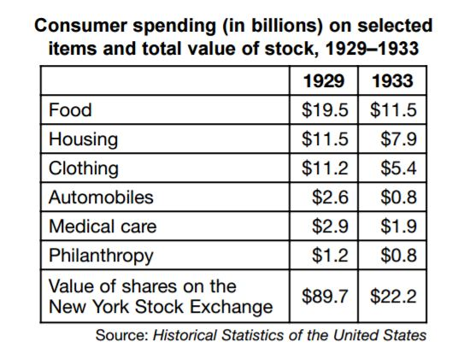
23. Which conclusion is best supported by the information on the chart?

- Business advertising had succeeded in selling more products
- Violence by labor had increased throughout the country
- Economic conditions had become worse
- The stock market had recovered in 1933

24. “… Our whole system of self-government will crumble either if officials elect what laws they will enforce or citizens elect what laws they will support. The worst evil of disregard for some law is that it destroys respect for all law.…” — President Herbert Hoover, 1929

Which issue is President Hoover discussing in this statement?

- national Prohibition C. environmental conservation
- Social Security taxes D. voting rights for women

25. “…We therefore formulate, and for ourselves adopt the following pledge, asking our sisters and brothers of a common danger and a common hope, to make common cause with us, in working its reasonable and helpful precepts [principles] into the practice of everyday life. I hereby solemnly promise, God helping me, to abstain from all distilled, fermented and malt liquors, including wine, beer and cider, and to employ all proper means to discourage the use of and traffic in the same.…”
— National Woman’s Christian Temperance Union, 1908 (adapted)

According to this passage, those who adopted this pledge believed that

- religion had no place in national politics C. Congress should repeal Prohibition
- alcohol consumption was damaging to society D. only the government can solve social problems

26. . . . I see one-third of a nation ill-housed, ill-clad, ill-nourished. It is not in despair that I paint you that picture. I paint it for you in hope—because the Nation, seeing and understanding the injustice in it, proposes to paint it out. We are determined to make every American citizen the subject of his country’s interest and concern; and we will never regard any faithful, law-abiding group within our borders as superfluous. The test of our progress is not whether we add more to the abundance of those who have much; it is whether we provide enough for those who have too little. . . .
—President Franklin D. Roosevelt, Second Inaugural Address, January 20, 1937

President Franklin D. Roosevelt addressed the situation described in this speech by

- reducing the influence of labor unions
- supporting programs to aid the poor and unemployed
- promoting the interests of big business
- adopting the trickle-down economic theory

27. …I pledge you, I pledge myself, to a new deal for the American people. Let us all here assembled constitute ourselves prophets of a new order of competence and of courage. This is more than a political campaign; it is a call to arms. Give me your help, not to win votes alone, but to win in this crusade to restore America to its own people.

—Franklin D. Roosevelt, Acceptance Speech, Democratic National Convention, 1932

In this statement, Franklin D. Roosevelt promised to

- build up the military
- reduce government interference in business
- end an isolationist foreign policy
- provide government assistance to combat the Great Depression

28. ...For the purpose of enabling each State to furnish financial assistance to aged needy individuals, . . . to needy dependent children, . . . promoting the health of mothers and children, especially in rural areas and in areas suffering from severe economic distress . . . services for locating crippled children and for providing medical, surgical, corrective, and other services and care, and facilities for diagnosis, hospitalization, and aftercare,. . . for the protection and care of homeless, dependent, and neglected children, and children in danger of becoming delinquent . .
-Social Security Act, 1935

Which statement is consistent with the increased power of the federal government under the 1935 Social Security Act?
- More citizens were given job opportunities by the federal government.
- Returning veterans and their families were provided with health care, education, and housing.
- Individual citizens who could not provide for themselves were given financial aid by the government
- New housing facilities were built by the government to accommodate citizens who lost their farms in the Dust Bowl.

Economic depression cannot be cured by legislative action or executive pronouncement. Economic wounds must be healed by the action of the cells of the economic body—the producers and consumers themselves.
-Annual Message to the Congress on the State of the Union Herbert Hoover, December 2, 1930

29. How did President Herbert Hoover propose to resolve economic depression in the United States?
- by citizens and businesses working together
- by government providing for the welfare of people
- by government assuming responsibility for employment
- by industry and government collaborating

The Universal Negro Improvement Association has been misrepresented by my enemies. They have tried to make it appear that we are hostile to other races. This is absolutely false. We love all humanity…We believe in the purity of both races…It is cruel and dangerous to promote social equality, as certain black leaders do. The belief that black and white should get together would destroy the racial purity of both. We believe that the black people should have a country of their own where they should be given the fullest opportunity to develop politically, socially, and industrially.
-Autobiography of Marcus Garvey, 1923

30. According to Garvey’s writings above, his beliefs would best be described as part of what US & global movement?
- Civil Disobedience C. Abolition
- Black Nationalism D. Harlem Renaissance

“It is believed that less consumption of alcohol by the community would mean less tuberculosis, less poverty, less dependency, less pressure on our hospitals, asylums, and jails.”
“ Alcohol hurts the tone of the muscles and lessens the product of laborers; it worsens the skill and endurance of artists; it hurts memory, increases industrial accidents, causes diseases of the heart, liver, stomach and kidney, increases the death rate from pneumonia and lessens the body’s natural immunity to disease.”
-Statement read at the 8th Annual Meeting of the National Temperance Council, 1920

31. The main theme of the Temperance Council passage is that the main problem with the consumption of alcohol is
- Increases in violence C. Health impacts
- Community expenses D. Problems within families

When the Bill against the teaching of evolution in public schools was passed, I could not see why more mothers were not thanking the lawmakers. They were protecting our children from on the destructive forces which will destroy our civilization. I for one was grateful that they stood up for what was right. And grateful too, that we have a Christian man for governor who will defend the Word of God against this so-called science.
-Mrs Jesse Sparks letter to the editor of the Nashville Tennessean July 1925

32. Mrs Sparks and her beliefs would fit what movement in American history?
- Racism B. Progressivism C. Populism D. Fundamentalism

The civilization of the past 100 years, with its startling industrial changes, has made life insecure. Young people have come to wonder what will happen to them in old age. The man with a job has wondered how long the job would last. This social security measure gives some protection to 30 million of our citizens who will receive direct benefits through unemployment compensation, through old-age pensions, and through increased services for the protection of children and the prevention of ill health.
-President Franklin Roosevelt’s speech August 1935

33. Which impact of the Great Depression is most related to the services and laws this passage describes?
- Foreclosures B. Farm Prices C. Unemployment D. Budget deficits

For twenty years this little spot on the vast expanses of the Great Plains has been the center of all our thought and hope and effort. And marvelous are the changes that we have seen...The almost unbroken buffalo grass sod has given way to cultivated fields. The old trails have become wide graded highways. Little towns have sprung up with attractive homes, trees, flowers, schools, churches, and hospitals. Automobiles and trucks, tractors and combines have revolutionized methods of farm work and manner of living. The wonderful crop of 1926 when our country alone produced 10,000,000 bushels of wheat - more it was said than any equal in the world - revealed the possibilities of our productive soil under modern methods of farming. It seemed as if at last our dreams were coming true...Yet now our daily torture, confusion or mind and gradual wearing down of courage, seem to make that long continued hope look like a vanishing dream. For we are in the worst of the dust storm area where “dust to eat” is not merely a figure of speech, but the phrasing of a bitter reality…
-Caroline Henderson’s (Oklahoma homesteader) letter to Henry A Wallace (Secretary of Agriculture) in 1935

34. Ms. Henderson lives in what we would term
- New England B. Dust Bowl C. Deep South D. Rust Belt

There had been overgrazing before the coming of the settlers and the invasion of barbed wire, but the death knell of the Plains was sounded and the birth of the Great American Desert was inaugurated with the introduction and rapid improvement of power farming. Tractors and combines made the Great Plains a regions a new wheat empire, but in doing so they disturbed nature’s balance, and nature is taking its revenge.
-Lawrence Svobida “Farming the Dust Bowl: A First-Hand Account from Kansas” published 1940

35. What does Mr. Svobida identify as the cause of desertification of the Great Plains?
- Barbed Wire C. Overgrazing
- Mechanization and machines D. Government supported overpopulation

Answers
      - B
      - C
      - C
      - A
      - A
      - C
      - C
      - D
      - C
      - A
      - C
      - B
      - D
      - B
      - C
      - A
      - C
      - D
      - A
      - C
      - B
      - A
      - C
      - A
      - B
      - B
      - D
      - C
      - A
      - B
      - C
      - D
      - C
      - B
      - B

