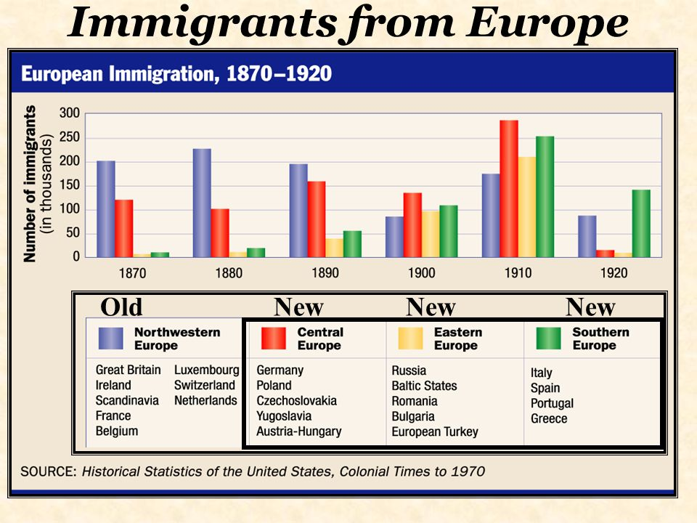

- Which conclusion is best supported by the information above?

- Immigration from the Western Hemisphere declined after 1900
- The percentage of Irish immigrants increased from 1870-1920
- Southern and Eastern European immigration increased from 1870-1910
- Western European immigration remained the largest percentage of immigrants from 1870-1920.

“...you come to us and tell us that the great cities are in favor of the gold standard; we reply that the great cities rest upon our broad and fertile prairies. Burn down your cities and leave our farms, and our cities will spring up again as if by magic; but destroy our farms and the grass will grow in the streets of every city in the country…”
-William Jennings Bryan, 1896

2. In the late 19th century, farmers attempted to address the issue raised by William Jennings Bryan by

- Supporting the Populist Party B. Demanding higher tariffs
C. Providing jobs for the unemployed D. Lobbying Congress to cut income taxes

“Yet after all our years of toil and privation, dangers and hardships, upon the ...frontier, monopoly is taking our homes from us by an infamous system of mortgage foreclosure, the most infamous that has ever disgraced the statutes of a civilized nation...How did it happen? The government, at the bid of Wall Street, repudiated its contracts with the people; the circulating medium was contracted...As senator Plumb [of Kansas] tell us, ‘Our debts were increased, while the means to pay them was decreased’. As grand senator...Stewart [of Nevada] puts it, ‘For twenty years the market value of the dollar has gone up and the market value of labor has gone down, till today the American laborer, in bitterness and wrath, asks which is the worst: the black slavery that has gone or the white slavery that has come?”
-Mary Elizabeth Lease, speech to the Woman’s Christian Temperance Union, 1890

3. People who agreed with the argument made in the speech would most likely have recommended which of the following solutions?

- separate but equal segregated facilities to increase job opportunities for white workers
- reduced government involvement in the economy in order to create more competition
- continuation of the gold standard as the basis for money
- a stronger government role in the economic system

“ [Buffalo hunters] have done more in the last two years, and will do more in the next year, to settle the ...Indian question than the entire regular army has done in the last 30 years...For the sake of peace let them kill, skin, and sell until the buffalo are destroyed.”
-General Phillip Sheridan

4. The quote above refers to which of the following ideas?
- Native Americans were granted land under the Homestead Act
- Many Native Americans moved to Eastern cities to work in factories
- The disappearance of their economic base helped drive Native Americans to the reservations
- Most Native Americans migrated to Canada to find new ways to earn a living

“There have been certain wild & hostile bands of Sioux Indians in Dakota and Montana…These Indians continue to rove at pleasure, attacking scattered settlements, stealing horses and cattle, and murdering peaceful settlers & travelers. The present military operations are not against the Sioux Nation at all, but against certain hostile parts of it that defy the Government…The accidental discovery of gold on the western border on the western border of the Sioux reservation, and the settlement of our people there, have not caused this war. The young Indian warriors love war…The object of these (American) operations was in the interest of the peaceful people of the Sioux nation, and not one of these peaceful Indians have been bothered by the military authorities.”
-Secretary of War JD Cameron report to the President of actions leading up to battle of Little Bighorn, July 8th, 1876

5. According to Cameron, what was the purpose of the US cavalry military actions against the Sioux?

- Secure access to gold for American settlers
- Protect American homesteaders
- Keep peace for the majority of Sioux who were not hostile
- To finalize westward expansion & conquest

‘Early in the winter of 1868, Long Hair {General Custer} and the 7th Cavalry attacked our camp on the Wichita River killing Chief Black Kettle and his band, burning their tipis and destroying all their food and belongings. In the Spring, Long Hair promised peace and moved the Cheyenne to a reservation. When gold was discovered white people came and the Indians were moved again. My brothers and I left for the open plains where our band of Cheyenne was again attacked by the White soldiers in the winter of 1875. We were forced to seek help from a tribe of Sioux. We joined Sitting Bull and the Sioux and decided to travel and hunt together as one strong group. As conditions on the reservations became worse more and more Indians moved West to join our group.’
-Account of Cheyenne Indian Kate Bighead to Dr. Thomas Marquis (Little Bighorn historian) in 1920 interview

6. According to Kate Bighead, why were so many Indians joining the Sioux nation?

- Drawn to the centralized, hierarchical military authority of the Sioux nation
- Conditions on the reservations were so bad they were looking for alternatives for their families
- The Sioux were so successful in fighting and resisting the American cavalry
- All Indians peoples and tribes had similar languages and cultures so it made sense to join together

‘An Italian girl who has lessons in cooking will help her mother to connect the entire family with American food and household habits. That the mother has never baked bread in Italy – only mixed it in her own house and then taken it out to the village oven- makes it all the more valuable her daughter’s understanding of the complicated cooking stove. The same thing is true of the girl who learns to sew, and more than anything else, perhaps, of the girl who receives the first simple instruction in the care of little children – that skillful care which every tenement-house baby requires is he is to live through his second summer…Through civic instruction in the public schools, the Italian woman slowly becomes urbanized…and the habits of her entire family were modified. The public schools in the immigrant neighborhoods deserve all the praise as Americanizing agencies.’
-Jane Addams Twenty Years at Hull House, 1910

7. The excerpt from Twenty Years at Hull House exemplifies a popular American belief in which of the following as keys to assimilation and upward mobility?
- Education B. Land ownership
C. Military superiority D. Suffrage

“We have here in San Francisco tonight to raise our voice to you in warning of a great danger that seems to us imminent, and threatens our almost utter destruction as a prosperous community…Today, every avenue of labor, or every sort is crowded with Chinese slave labor worse than it was 8 years ago. The boot, shoe, and cigar industries are almost entirely in their hands…They monopolize nearly all the farming done to supply the market with all sorts of vegetables.”
-Speech to the workingmen of San Francisco August 16th 1888

8. According to this speech in San Francisco, what is the main concern over Chinese immigrants?
- The spread of epidemic diseases B. Political power of immigrants as voters
C. Job competition D. Challenges to Christian, European culture of the U.S.

‘What but meaningless phrases are "imperialism," "expansion," "free silver," "gold standard," etc., to the wage worker? The large capitalists represented by Mr. McKinley (Republican) and the small capitalists represented by Mr. Bryan (Democrat) are interested in these "issues," but they do not concern the working class. What the workingmen of the country are profoundly interested in is the private ownership of the means of production and distribution, the enslaving and degrading wage system in which they toil for a pittance at the pleasure of their masters and are bludgeoned, jailed or shot when they protest-this is the central, controlling, vital issue of the hour, and neither of the old party platforms has a word or even a hint about it.’
-Eugene V Debs, article in academic journal 1900

9. What are the main concerns for the working class according to Debs?
- The right to challenge the wealthy capitalists and success in making pay and safety improvements for workers
- making sure America pursues expansion to increase markets and material resources
- rights of African Americans to equality and franchise
- the protection of American wages against foreign competition and foreign immigrants

“I’ve been readin’ a book by Lincoln Steffens on The Shame of the Cities. Steffens means well, but like all reformers, he don’t know how to make distinctions. He can’t see no difference between
honest graft and dishonest graft, and, consequently, he gets things all mixed up…For instance, I ain’t no looter. The looter hogs it. I never hogged. I made my money in politics, but at the same time I served the organization and got more big improvements for New York City than any other
livin’ man.
The Irish was born to rule, and they’re the honestest people in the world. Show me the Irishman who would steal a roof off an orphanage! He don’t exist. Of course, if an Irishman had the political pull and the roof was in bad shape, he might get the city authorities to put on a new one and get the contract for himself, and buy the old roof at a bargain-but that’s honest graft.”
-Talk by George Plunkitt, NYC political boss in 1905

10. According to Plunkitt, what positive role do political bosses play?
- Keep big businessmen from dominating politics
- Protect jobs from immigrant workers
- Ensure voting rights are protected
- Provide services for the community

‘Several days before Christmas 1896 one of my Irish playmates suggested that I go with her to a Christmas party at Hull House…I asked her if there would be any Jewish children at the party. She said there were Jewish children at the parties every year and that no one got hurt…At the party, the children of the Hull House Music School sang some songs that I later found out were called “Christmas carols.” I shall never forget the …sweetness of those childish voices. All feelings of religious intolerance and bigotry faded. I could not connect this beautiful party with any hatred or superstition that existed among the people of Poland. As I look back, I know that I became an American at this party. I was with children that had been brought here from all over the world. The fathers and mothers, like my father and mother, had come in search of a free and happy life. And we were all having a good time at a party, as the guest of an American, Jane Addams.’
-Hilda Satt Polacheck I Came a Stranger: The Story of a Hull House Girl 1953

11. This passage exemplifies which characteristic of the United States?
- Personal Liberties B. Melting Pot C. Democracy D. Christianity

‘To-day three-fourths of its people live in the tenements, and the nineteenth century drift of the population to the cities is sending ever-increasing multitudes to crowd them . . . . We know now that there is no way out; that the “system” that was the evil offspring of public neglect and private greed has come to stay . . . . Nothing is left but to make the best of a bad bargain . . . . The greed of capital that wrought the evil must itself undo it . . .’
—Jacob Riis, How the Other Half Lives, 1890

12. Why did Jacob Riis call the tenements “a bad bargain”?

A. Reformers would only help people living in tenements if they agreed to change their lifestyles.
B. Negotiations between labor unions and businesses made small strides in improving the lives of workers, but it was not enough.
C. The lack of laws protecting workers allowed businesses to pay workers so little that the workers had to live in crowded, unsanitary conditions
D. People had more access to entertainment in the cities than in rural areas, but the trade-off was living in smaller and more crowded housing

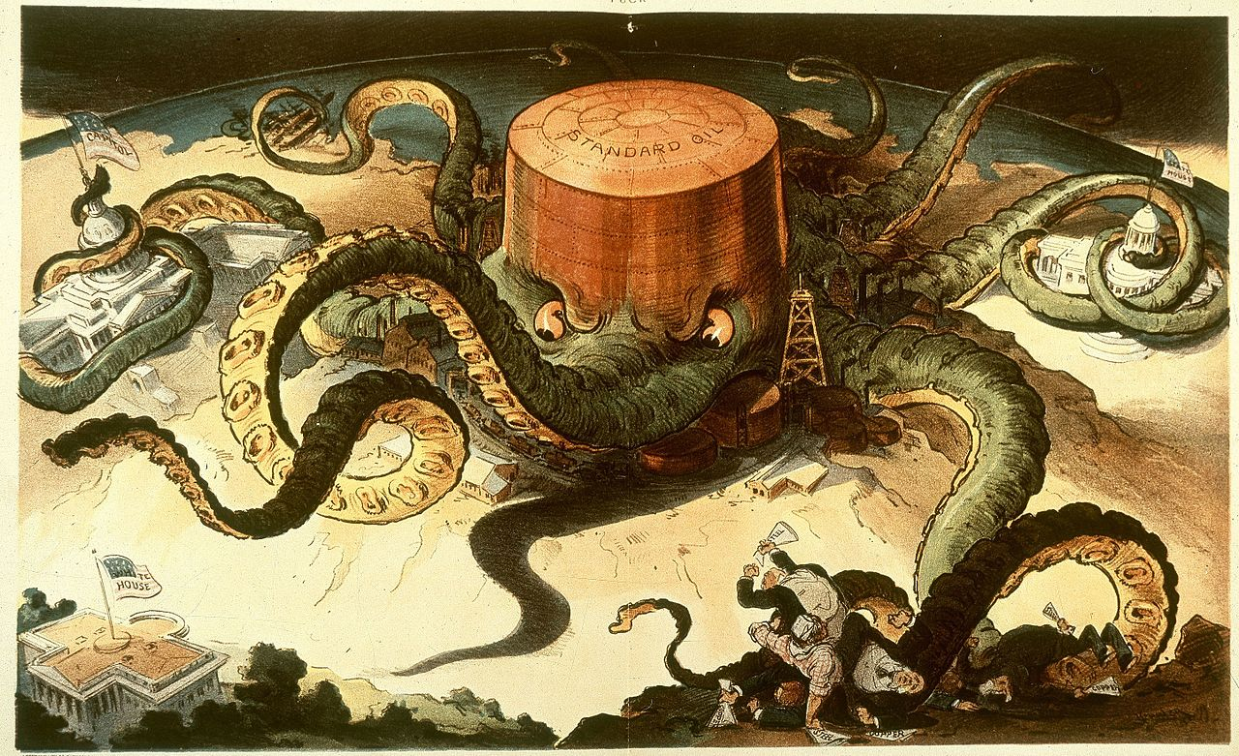

13. Which of the following best sums up the principal message of the cartoon is that the Standard Oil Company?
- it used its size to lower the prices of its products
- it protected the nation from foreign competition
- it used its economic power to influence government decisions
- it employed violence to gain an unfair advantage for its workers

“…We therefore formulate, and for ourselves adopt the following pledge, asking our sisters and brothers of a common danger and a common hope, to make common cause with us, in working its reasonable and helpful precepts [principles] into the practice of everyday life. I hereby solemnly promise, God helping me, to abstain from all distilled, fermented and malt liquors, including wine, beer and cider, and to employ all proper means to discourage the use of and traffic in the same.…”
— National Woman’s Christian Temperance Union, 1908 (adapted)

14. According to this passage, those who adopted this pledge believed that

- religion had no place in national politics
- Congress should repeal Prohibition
- alcohol consumption was damaging to society
- only the government can solve social problems

Base your answers to questions 15 and 16 on the speakers’ statements below and on your knowledge of social studies.

Speaker 1: The best way to prevent corruption in government is to allow citizens a direct role in the legislative process.
Speaker 2: Breaking up trusts and monopolies will increase business competition.
Speaker 3: An important goal of the federal government should be the protection of our natural resources.
Speaker 4: Government will only improve when women are granted full suffrage

15. Which speaker’s statement is most directly related to the political concepts of initiative, referendum, and recall?

- 1 B. 2 C. 3 D. 4

16. Which two speakers’ viewpoints reflect actions taken by Theodore Roosevelt when he was president (1901–1909)?

- 1 and 2 B. 2 and 3 C. 3 and 4 D. 1 and 4

Use the chart below and your knowledge of Social Studies to answer number 23 below:
 | Before | After
 | One worker makes a product from start to finish | One worker makes a component of the product
 | One item is produced at a time | Many items are produced at the same time
 | Cost of item is high | Cost of item is reduced

17. Which event caused these changes?

- An increase in wages B. Development of the Assembly Line
C. A decrease in safety regulations D. The support of labor unions

“Black Codes” were laws and constitutional amendments passed by Southern states after the Civil War. In North Carolina, for example, the code enacted in 1866 allowed a black person to testify in court if the case involved African Americans; if the case involved two white people, then both had to agree to allow a black person to testify. If one black person sold property worth more than ten dollars to another black person, the transaction had to be witnessed by a white person who could read or write.

18. What best explains the reason why codes like this were enacted in Southern states?

- to maintain the control of whites over African Americans
- to guide newly freed slaves as they gained experience as citizens
- to ensure that African Americans had the same legal rights as whites
- to meet federal standards on civil rights required for rejoining the Union

Use the political cartoon below and your knowledge of social studies to answer the following question.

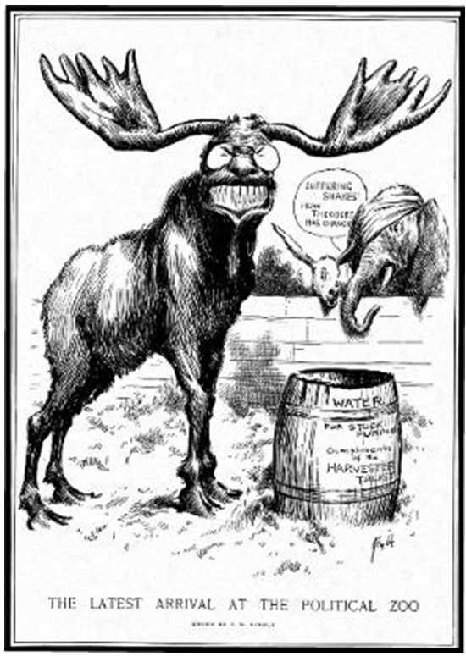
The Latest Arrival at the Political Zoo
Edward Windsor Kemble, Harper's Weekly, July 20, 1912

19. The Democratic donkey and Republican elephant in the background of this cartoon clearly indicate that the animal in the foreground represents a new third party challenger. Which of the following most accurately identifies that challenger and party?

- Henry Wallace, Progressive party B. James B. Weaver, Greenback party
C. Theodore Roosevelt, Bull Moose party D. Millard Fillmore, American or Know Nothing party

“One day several of us met at the office of one of the refiners, who, I felt pretty sure, was being persuaded to go into the scheme which they were talking up. . . . I got pretty excited when I saw how those South Improvement men were pulling the wool over our men’s eyes, and making them believe we were all going to the dogs if there wasn’t an immediate combination to put up the price of refined [oil] and prevent new people [from] coming into the business, and I made a speech which, I guess, was pretty warlike. Well, right in the middle of it John Rockefeller stopped rocking and took down his hands and looked at me. You never saw such eyes. He took me all in, saw just how much fight he could expect from me, and I knew it.”
-Ida Tarbell, The History of the Standard Oil Company, 1904

20. Which unfair practices referred to in the statement were stopped with Anti-Trust laws?

- Donations to controversial charities B. Intimidation
C. Using wealth to gain political office D. Price fixing

“We have been proud of our industrial achievements, but we have not...stopped thoughtfully enough to count the human costs…(Our) great Government that we loved has too often been made use of for private and selfish purposes, and those who used it had forgotten the people.
At last a vision has been (shown to) us of our life as a whole. We see the bad with the good...With this vision we approach new affairs. Our duty is to cleanse, to reconsider, to restore, to correct the evil...to purify and humanize every process of our common life.”
-Woodrow Wilson, First Inaugural Address, March 4, 1913

21. How did President Woodrow Wilson propose to help people achieve their American Dreams?
- By encouraging monopolies to make the nation economically stable
- By encouraging leaders to pursue private business goals so that their prosperity would reduce human costs
- By requiring long working hours to make the nation more profitable and economically powerful
- By using government programs to minimize the human costs of economic success

“Worst of any, however, were the fertilizer men, and those who served in the cooking rooms. These people could not be shown to the visitor—for the odor of a fertilizer man would scare any ordinary visitor at a hundred yards, and as for the other men, who worked in tank rooms full of steam, and in some of which there were open vats near the level of the floor; their peculiar trouble was that they fell into the vats.”
-Upton Sinclair, The Jungle, 1906

22. Why did muckrakers like Upton Sinclair encourage Progressive reforms?

- They wanted the passage of specific bills in Congress
- They sought change in dangerous and illegal practices in American industries
- They tried to get particular candidates voted into office
- They wanted to draw attention to unfair practices in the banking industry

Answers
      - C
      - A
      - D
      - C
      - B
      - B
      - A
      - C
      - A
      - D
      - B
      - C
      - C
      - C
      - A
      - B
      - B
      - A
      - C
      - D
      - D
      - B

