Should the United States have dropped the Atomic Bomb on Japan?
Source # 1: ~~~Public Papers of the Presidents: Harry S Truman, 1945", pg. 212
"Having found the bomb we have used it. We have used it against those who attacked us without warning at Pearl Harbor, against those who have starved and beaten and executed American prisoners of war, against those who have abandoned all pretense of obeying international laws of warfare. We have used it in order to shorten the agony of war, in order to save the lives of thousands and thousands of young Americans."

Source # 2

Secretary of War – Henry Stimson 1947 – Taken from Harper’s Magazine http://harpers.org/archive/1947/02/the-decision-to-use-the-atomic-bomb/

On July 28 the Premier of Japan, Suzuki, rejected the Potsdam ultimatum by announcing that it was “unworthy of public notice.” In the face of this rejection we could only proceed to demonstrate that the ultimatum had meant exactly what it said …

… Had the war continued until the projected invasion on November 1, additional fire
raids of B‑20’s would have been more destructive of life and property than the very limited number of atomic raids which we could have executed in the same period. But the atomic bomb was more than a weapon of terrible destruction; it was a psychological weapon. …

The bomb thus served exactly the purpose we intended. The peace party was able to
take the path of surrender, and the whole weight of the Emperor’s prestige was exerted in favor of peace. When the Emperor ordered surrender, and the small but dangerous group of fanatics who opposed him were brought under control, the Japanese became so subdued that the great undertaking of occupation and disarmament was completed with unprecedented ease.

Source # 3 ~~~~ Dwight Eisenhower from his 1963 book Mandate For Change, pg. 380
"...in [July] 1945... Secretary of War Stimson, visiting my headquarters in Germany, informed me that our government was preparing to drop an atomic bomb on Japan. I was one of those who felt that there were a number of cogent reasons to question the wisdom of such an act. ...the Secretary, upon giving me the news of the successful bomb test in New Mexico, and of the plan for using it, asked for my reaction, apparently expecting a vigorous assent.
"During his recitation of the relevant facts, I had been conscious of a feeling of depression and so I voiced to him my grave misgivings, first on the basis of my belief that Japan was already defeated and that dropping the bomb was completely unnecessary, and secondly because I thought that our country should avoid shocking world opinion by the use of a weapon whose employment was, I thought, no longer mandatory as a measure to save American lives. It was my belief that Japan was, at that very moment, seeking some way to surrender with a minimum loss of 'face'. The Secretary was deeply perturbed by my attitude..."

Source # 4
Notes on Conversation of Linus Pauling with Albert Einstein on 16 November 1954
"I made one great mistake in my life... when I signed the letter to President Roosevelt recommending that atom bombs be made; but there was some justification - the danger that the Germans would make them." ~~~~~~Albert Einstein

Source # 5
Winston Churchill, leader of the Opposition, in a speech to the British House of Commons, August 1945

There were those who considered that the atomic bomb should never have been used at all. I cannot associate myself with such ideas… I am surprised that very worthy people—but people who in most cases had no intention of proceeding to the Japanese front themselves—should adopt a position that rather than throw this bomb we should have sacrificed a million American and a quarter of a million British lives… | ”

Source # 6
After helping to supervise the Manhattan Project and seeing the first atomic bomb tested in New Mexico on July 16, 1945, General Leslie Groves said the following: “The war’s over. One or two of those things and Japan will be finished.”

Source # 7
After helping to supervise the Manhattan Project and seeing the first atomic bomb tested in New Mexico on July 16, 1945, J. Robert Oppenheimer repeated the following quote from a poem: “Now I am become Death, the destroyer of Worlds.”

Source # 8 Nakayama Shiro,Shi no kage The Shadow of Death – Hiroshima survivor
Taken from the website: http://atomicbombmuseum.org/4_survivors.shtml
“I hated for people to stare at me…. Yet, every nerve in my body was attuned to the outside world; and to avoid even the slightest sinister look, I walked with a rigid on-guard posture…. Even so, I secluded myself at home and spent hours before the mirror, looking at my own face. What I saw was ugly hunks of flesh, like lava oozing from a crater wall, covering the left half of my face, with the eyebrow burned off and my eye pulled out of shape. My neck was pulled over to one side, and however much I tried to straighten it out, it wouldn't move back to the normal position.”

Source # 9
A pall of smoke lingers over this scene of destruction in Hiroshima, Japan, on Aug. 7, 1945, a day after the explosion of the atomic bomb. (AP Photo)

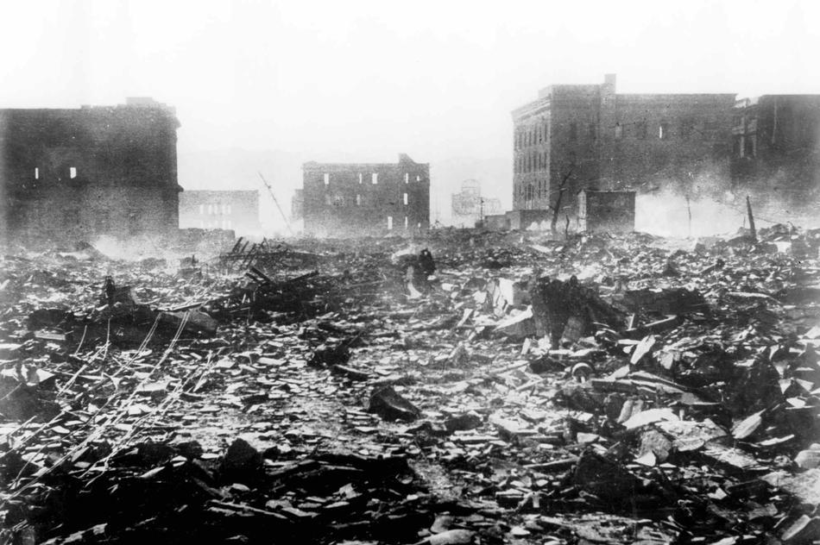

Source # 10

A burn victim, image from http://students.umf.maine.edu/~donoghtp/Hiroshi.aBodyBurnt7-8_3000m.jpg

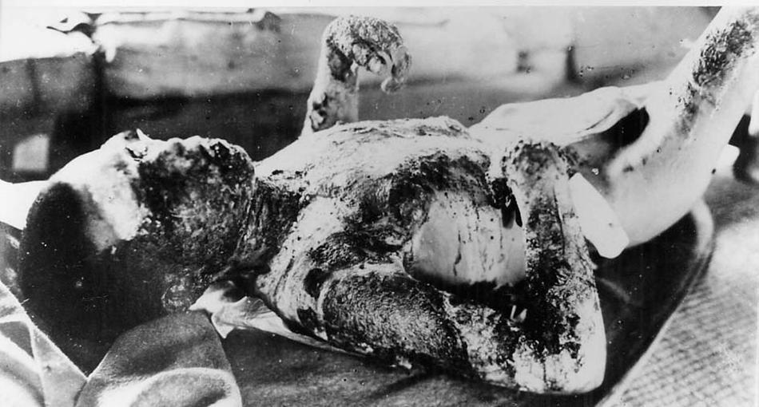

Source # 11
Taken from http://www.greatdreams.com/war/Atomic_cloud_over_Hiroshima.jpg

A massive column of billowing smoke, thousands of feet high, mushrooms over the city of Nagasaki, Japan, after an atomic bomb was dropped by the United States on August 9, 1945. A B-29 plane delivered the blast killing approximately 35,000 people instantly, with thousands dying later of radiation effects. Three days earlier, on August 6, 1945, an atomic bomb was dropped on Hiroshima killing about 60,000 people instantly.

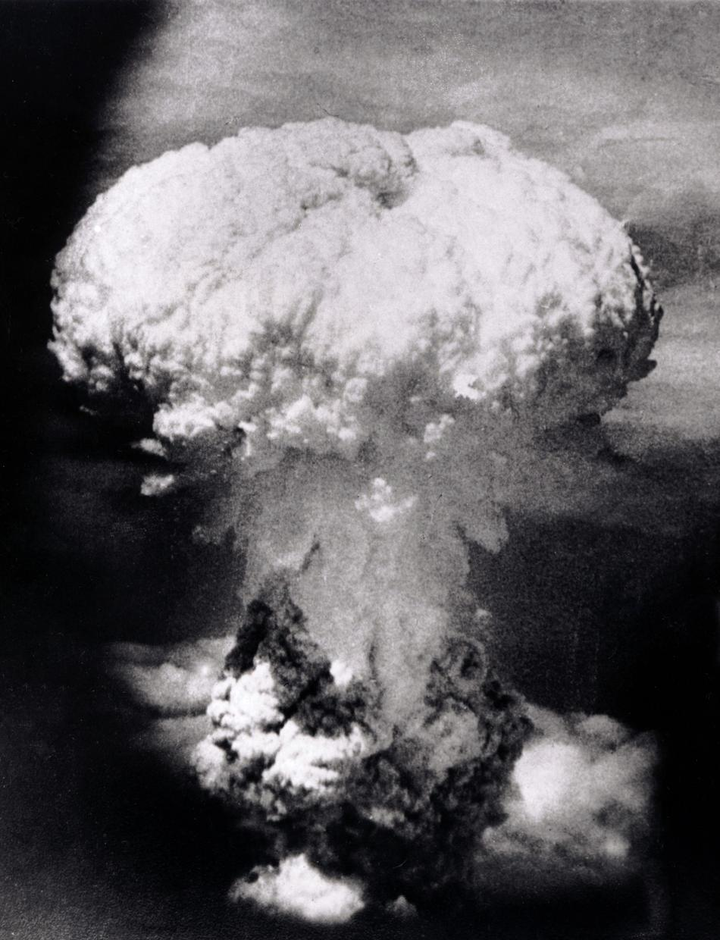

Source # 12

Official United States Navy PhotographGo, December 7, 1941
Taken from learning.blogs.nytimes.com

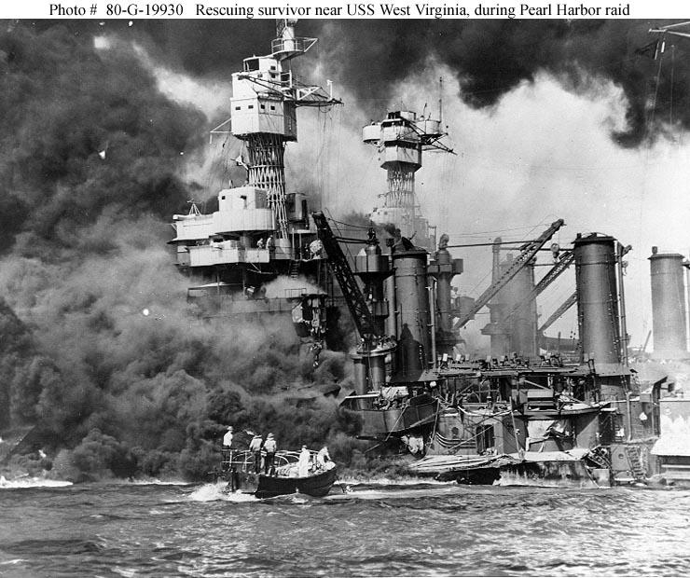

Source # 13

The Rape of Nanking – the Japanese invasion of China
(200,00 Chinese were killed in 1937)
It was taken by H. S. “Newsreel” Wong (Wang Haisheng – 王海升), a Chinese photographer with the Hearst Metronone News and printed in Life Magazine in the United States.

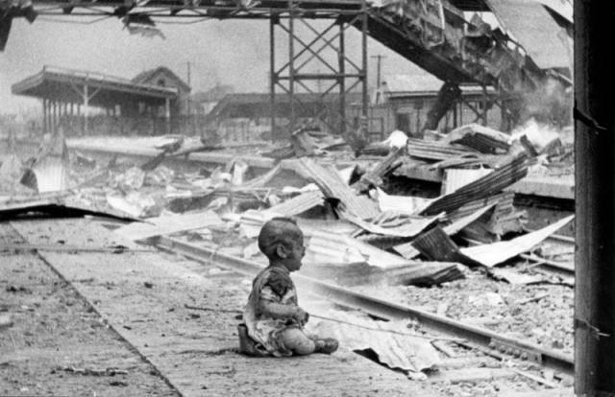

Source # 14

Source An Australian POW captured in New Guinea, Sgt. Leonard Siffleet, about to be beheaded by the Japanese with a shin guntō sword, October, 1943.
Taken from: http://ww2today.com/24th-october-1943-japanese-execute-australian-commando-leonard-siffleet

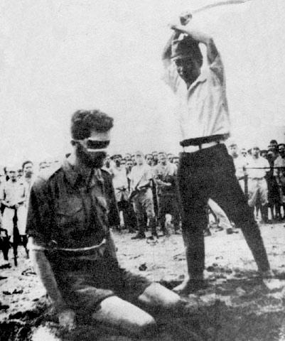

Thought to consider
How could a moral, democratic nation that values life, drop an atomic bomb on two foreign cities knowing the bombs would kill innocent women and children?

Thought to consider
If the US were to have invaded the mainland of Japan, how could President Truman look a mother of a dead US soldier in the eye when he had access to a weapon that could have ended the war, but refused to use it?

Thoughts to consider
Regardless of your position on the dropping of the Atomic Bomb, can you think of other times in US or World History where morally questionable tactics have been used to win a war?

