Should the United States have entered the fighting in Vietnam?

Background:
The Vietnam War was a long, costly and divisive conflict that pitted the communist government of North Vietnam against South Vietnam and its principal ally, the United States. The conflict was intensified by the ongoing Cold War between the United States and the Soviet Union. More than 3 million people (including over 58,000 Americans) were killed in the Vietnam War, and more than half of the dead were Vietnamese civilians. Opposition to the war in the United States bitterly divided Americans, even after President Richard Nixon ordered the withdrawal of U.S. forces in 1973. Communist forces ended the war by seizing control of South Vietnam in 1975, and the country was unified as the Socialist Republic of Vietnam the following year.

Source 1: Map of Vietnam / 1960s - Map courtesy of National Geographic Society

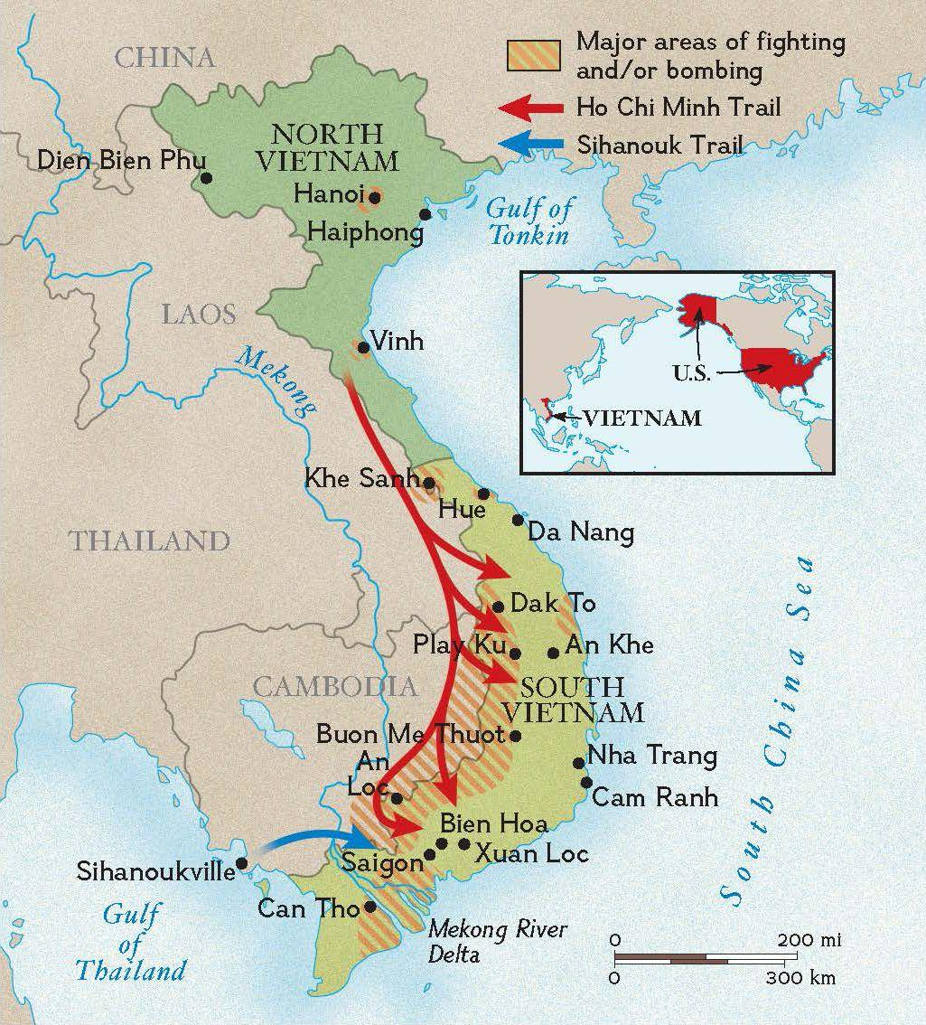

Source 2: CIA Released Document / “CONSEQUENCES TO THE US COMMUNIST DOMINATION OF MAINLAND SOUTHEAST ASIA / September 5, 1950

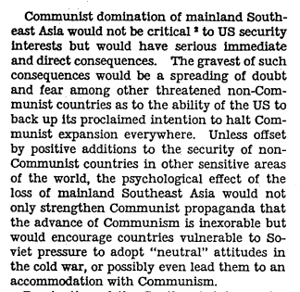
Source 3: Gulf of Tonkin Resolution Congressional Joint Resolution of Congress, August 7, 1964

The North Vietnamese Navy, in violation of the Charter of the United Nations and of international law, have deliberately and repeatedly attacked United States naval vessels lawfully present in international waters, and have thereby created a serious threat to international peace; and
These attacks are part of a deliberate and systematic campaign of aggression that the Communist regime in North Vietnam has been waging against its neighbors and other free the nations; and
The United States is assisting the peoples of Southeast Asia to protect their freedom and has no territorial, military or political ambitions in that area, but desires only that these peoples should be left in peace to work out their own destinies in their own way:
Therefore the Senate and House of Representatives of the United States of America have decided that we approve and support the determination of the President, as Commander in Chief, to take all necessary military actions to combat Communist forces and to prevent further aggression.
The United States is prepared, as the President determines, to take all necessary steps, including the use of armed force, to assist any member of the Southeast Asia Collective Defense Treaty requesting assistance in defense of its freedom.

Source 4: On September 2, 1945, Ho Chi Minh (President of the Democratic Republic of Vietnam) proclaimed the independent Democratic Republic of Vietnam in Hanoi’s Ba Dinh square.

All men are created equal. They are endowed by their Creator with certain inalienable rights, among them are Life, Liberty, and the pursuit of Happiness."
This immortal statement was made in the Declaration of Independence of the United States of America in 1776. In a broader sense, this means: All the peoples on the earth are equal from birth, all the peoples have a right to live, to be happy and free.
Those are undeniable truths.
Nevertheless, for more than eighty years, the French imperialists, abusing the standard of Liberty, Equality, and Fraternity, have violated our Fatherland and oppressed our fellow-citizens. They have acted contrary to the ideals of humanity and justice.
In the field of politics, they have deprived our people of every democratic liberty. To weaken our race they have forced us to use opium and alcohol.
They have enforced inhuman laws; they have set up three distinct political regimes in the North, the Center and the South of Vietnam in order to wreck our national unity and prevent our people from being united.
They have built more prisons than schools. They have mercilessly slain our patriots; they have drowned our uprisings in rivers of blood.
In the field of economics, they have fleeced us to the backbone, impoverished our people, and devastated our land…
...For these reasons, we, members of the Provisional Government, representing the whole Vietnamese people, declare that from now on we break off all relations of a colonial character with France; we repeal all the international obligation that France has so far subscribed to on behalf of Vietnam and we abolish all the special rights the French have unlawfully acquired in our Fatherland.
The whole Vietnamese people, animated by a common purpose, are determined to fight to the bitter end against any attempt by the French colonialists to reconquer their country.
We are convinced that the Allied nations which at Tehran and San Francisco have acknowledged the principles of self-determination and equality of nations, will not refuse to acknowledge the independence of Vietnam.
A people who have courageously opposed French domination for more than eight years, a people who have fought side by side with the Allies against the Fascists during these last years, such a people must be free and independent.
For these reasons, we, members of the Provisional Government of the Democratic Republic of Vietnam, solemnly declare to the world that Vietnam has the right to be a free and independent country—and in fact is so already. The entire Vietnamese people are determined to mobilize all their physical and mental strength, to sacrifice their lives and property in order to safeguard their independence and liberty.

Source 5: President Richard Nixon showing off the supportive Vietnam War telegrams with Barbara Walters and George W. Romney after his famous “Silent Majority” speech.

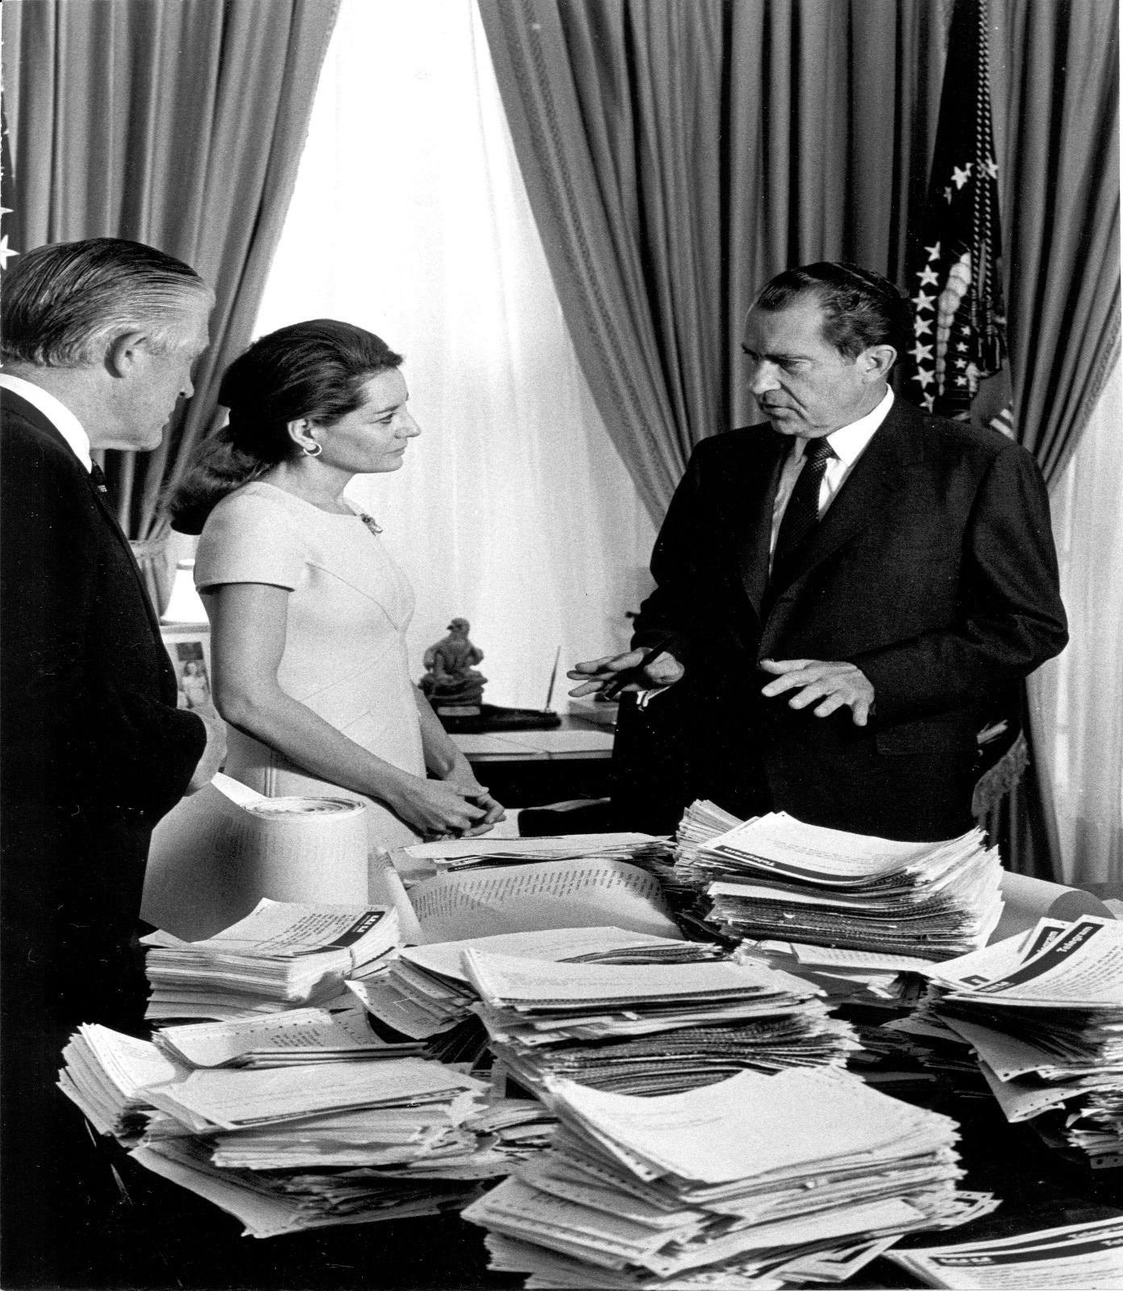

Source 6: Telephone Conversation between President Johnson and the President's Special Assistant for National Security Affairs (Bundy) Washington, May 27, 1964, 11:24 a.m.

Johnson: I will tell you the more, I just stayed awake last night thinking of this thing, and the more that I think of it I don't know what in the hell, it looks like to me that we're getting into another Korea. It just worries the hell out of me. I don't see what we can ever hope to get out of there with once we're committed. . . . I don't think it's worth fighting for and I don't think we can get out. And it's just the biggest damn mess that I ever saw.
Bundy: It is an awful mess.
Johnson: And we just got to think about it. . . I just thought about ordering all those kids in there. And what in the hell am I ordering them out there for? What in the hell is Vietnam worth to me? . . .
Bundy: Yeah, yeah.
Johnson: Of course, if you start running from the Communists, they may just chase you right into your own kitchen.
Bundy: Yeah, that's the trouble. And that is what the rest of that half of the world is going to think if this thing comes apart on us. That's the dilemma, that's exactly the dilemma. . . .
Johnson: But this is a terrible thing that we're getting ready to do.
Bundy:. . . I think, also, Mr. President, you can do, what I think Kennedy did at least once which is to make the threat without having made your own internal decision that you would actually carry it through.

Source 7: Muhammad Ali speaks at an antiwar rally at the University of Chicago on May 11, 1967
Photographer Charles Harrity/Associated Press

Video Link to Ali speech – 3 Minutes: https://www.youtube.com/watch?v=HeFMyrWlZ68&disable_polymer=true

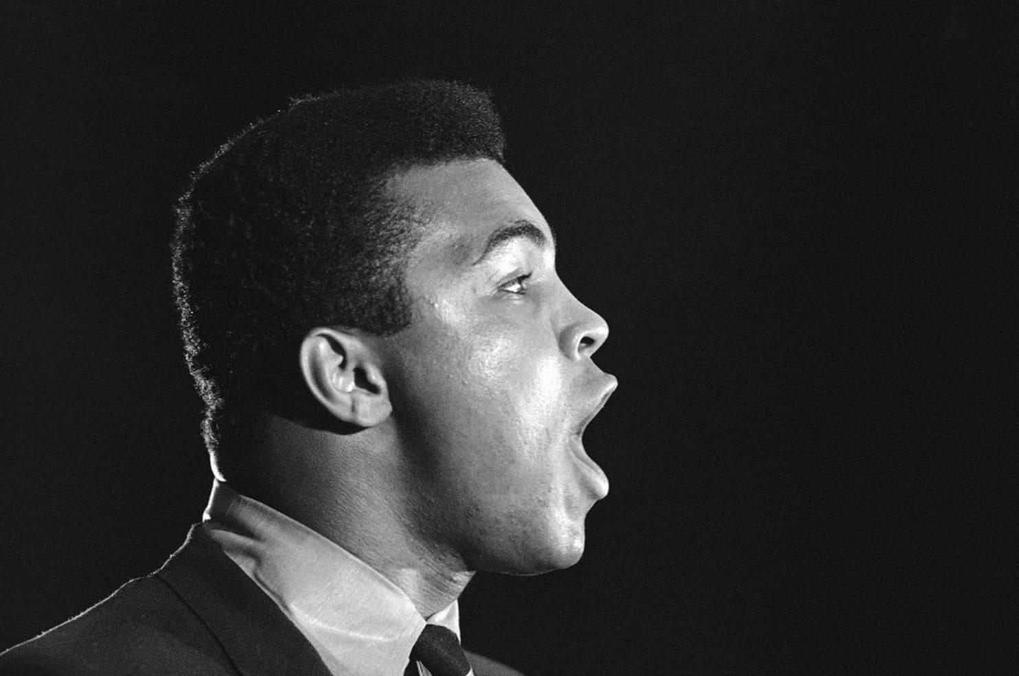

Source 8: “I feel like I’m Fixin’ to Die Rag” / Performed by Country Joe and the Fish / Written by Country Joe McDonald and Barry "The Fish" Melton / 1967

Link to video performance of song: https://www.youtube.com/watch?v=3W7-ngmO_p8

Well, come on all of you, big strong men
Uncle Sam needs your help again
He's got himself in a terrible jam
Way down yonder in Vietnam
So put down your books and pick up a gun
We're gonna have a whole lotta fun
And it's one, two, three
What are we fighting for?
Don't ask me, I don't give a damn
Next stop is Vietnam;
And it's five, six, seven
Open up the pearly gates
Well there ain't no time to wonder why
Whoopee! we're all gonna die
Well, come on generals, let's move fast;
Your big chance has come at last
Now you can go out and get those reds
'Cause the only good commie is the one that's dead
And you know that peace can only be won
When we've blown 'em all to kingdom come
And it's one, two, three
What are we fighting for?
Don't ask me, I don't give a damn
Next stop is Vietnam;
And it's five, six, seven
Open up the pearly gates
Well there ain't no time to wonder why
Whoopee! we're all gonna die

Source 9: Vietnam War – U.S. soldiers carry Vietnamese children to safety. Year unknown.

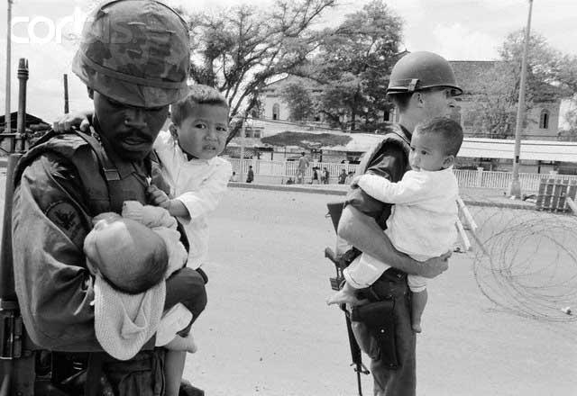

Source 10: South Vietnamese forces follow after terrified children, including 9-year-old Kim Phuc, center, as they run down Route 1 near Trang Bang after an aerial napalm attack on suspected Vietcong hiding places on June 8, 1972. Photographer - Nick Ut—AP

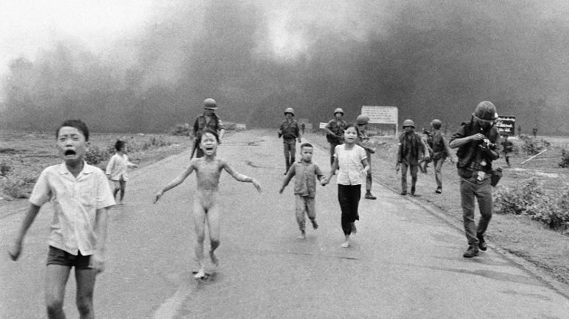

Source 11: Martin Luther King’s speech, “Beyond Vietnam,” delivered April 4, 1967, at a meeting of Clergy and Laity Concerned at Riverside Church in New York City.

Perhaps a more tragic recognition of reality took place when it became clear to me that the war was doing far more than devastating the hopes of the poor at home. . . . We were taking the black young men who had been crippled by our society and sending them eight thousand miles away to guarantee liberties in Southeast Asia which they had not found in southwest Georgia and East Harlem.
So we have been repeatedly faced with the cruel irony of watching Negro and white boys on TV screens as they kill and die together for a nation that has been unable to seat them together in the same schools.. . . As I have walked among the desperate, rejected, and angry young men, I have told them that Molotov cocktails and rifles would not solve their problems. . . .But they asked, and rightly so, "What about Vietnam?" . . . Their questions hit home, and I knew that I could never again raise my voice against the violence of the oppressed in the ghettos without having first spoken clearly to the greatest purveyor [supplier] of violence in the world today: my own government. For the sake of those boys, for the sake of this government, for the sake of the hundreds of thousands trembling under our violence, I cannot be silent.
Somehow this madness must cease. We must stop now. I speak as a child of God and brother to the suffering poor of Vietnam. I speak for those whose land is being laid waste, whose homes are being destroyed, whose culture is being subverted. I speak for the poor of America who are paying the double price of smashed hopes at home, and death and corruption in Vietnam. I speak as a citizen of the world, for the world as it stands aghast at the path we have taken. I speak as one who loves America, to the leaders of our own nation: The great initiative [power to take charge] in this war is ours; the initiative to stop it must be ours.

Source 12: Associated Press Photographer Art Greenspan captured this photo of soldiers aiding wounded comrades. The first sergeant of A Company, 101st Airborne Division, guided a medevac helicopter through the jungle to retrieve casualties near Hue in April 1968.

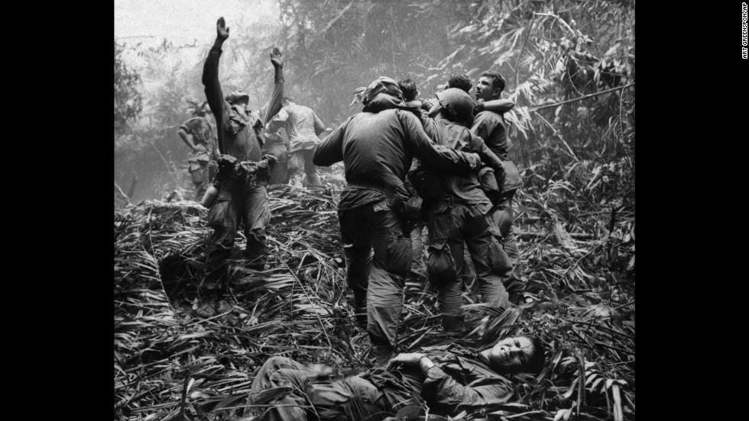

Source 13: In late January, 1968, during the lunar New Year (or “Tet”) holiday, North Vietnamese and communist Viet Cong forces launched a coordinated attack against a number of targets in South Vietnam. The U.S. and South Vietnamese militaries were surprised and suffered casualties before repelling the communist assault and inflicting very heavy casualties on the NVA / VC. The Tet Offensive played an important role in weakening U.S. public support for the war in Vietnam.

1968 Tet Offensive
Forces | Killed in Action | Wounded | Missing in Action
United States | 1,536 | 7,764 | 11
ARVN | 2,788 | 8,299 | 587
NVA / VC | 45,000 | Unknown | Unknown

Source 14: USA. Washington DC. 1967. An American young girl, Jan Rose Kasmir, confronts the American National Guard outside the Pentagon during the 1967 anti-Vietnam march. Photographer Marc Riboud

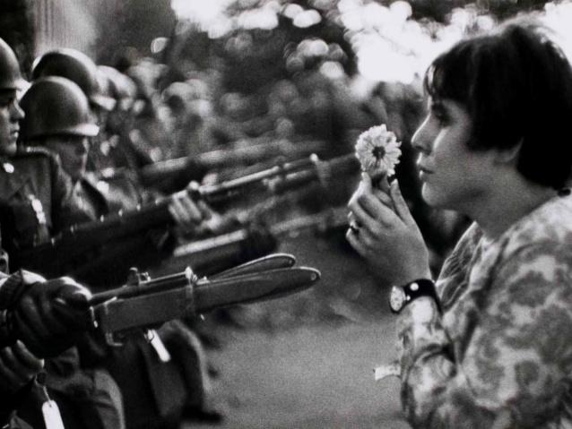

Source 15: John Kerry, testimony to the U.S. Senate Committee on Foreign Relations, April 23, 1971. John Kerry was a veteran who returned from Vietnam in April 1969, having won early transfer out of the conflict because of his three Purple Hearts and Silver Star

I would like to talk on behalf of all those veterans. . . In our opinion and from our experience, there is nothing in South Vietnam which could happen that realistically threatens the United States of America. And to attempt to justify the loss of one American life in Vietnam, Cambodia or Laos by linking such loss to the preservation of freedom. . .is to us the height of criminal hypocrisy, and it is that kind of hypocrisy which we feel has torn this country apart. . .
We found most people didn't even know the difference between communism and democracy. They only wanted to work in rice paddies without helicopters strafing [repeatedly attacking] them and bombs with napalm burning their villages and tearing their country apart. . . .
We rationalized destroying villages in order to save them. . . .We learned the meaning of free fire zones, shooting anything that moves, and we watched while America placed a cheapness on the lives of orientals. . .
Each day . . . someone has to give up his life so that the United States doesn't have to admit something that the entire world already knows, so that we can't say that we have made a mistake. Someone has to die so that President Nixon won't be, and these are his words, "the first President to lose a war."
We are asking Americans to think about that because how do you ask a man to be the last man to die in Vietnam? How do you ask a man to be the last man to die for a mistake?. . .

Source 16: South Vietnamese General Nguyen Ngoc Loan, chief of the National Police, fires his pistol into the head of suspected Viet Cong officer Nguyen Van Lem (also known as Bay Lop) on a Saigon street on February 1, 1968. Photo taken by Eddie Adams – Associated Press

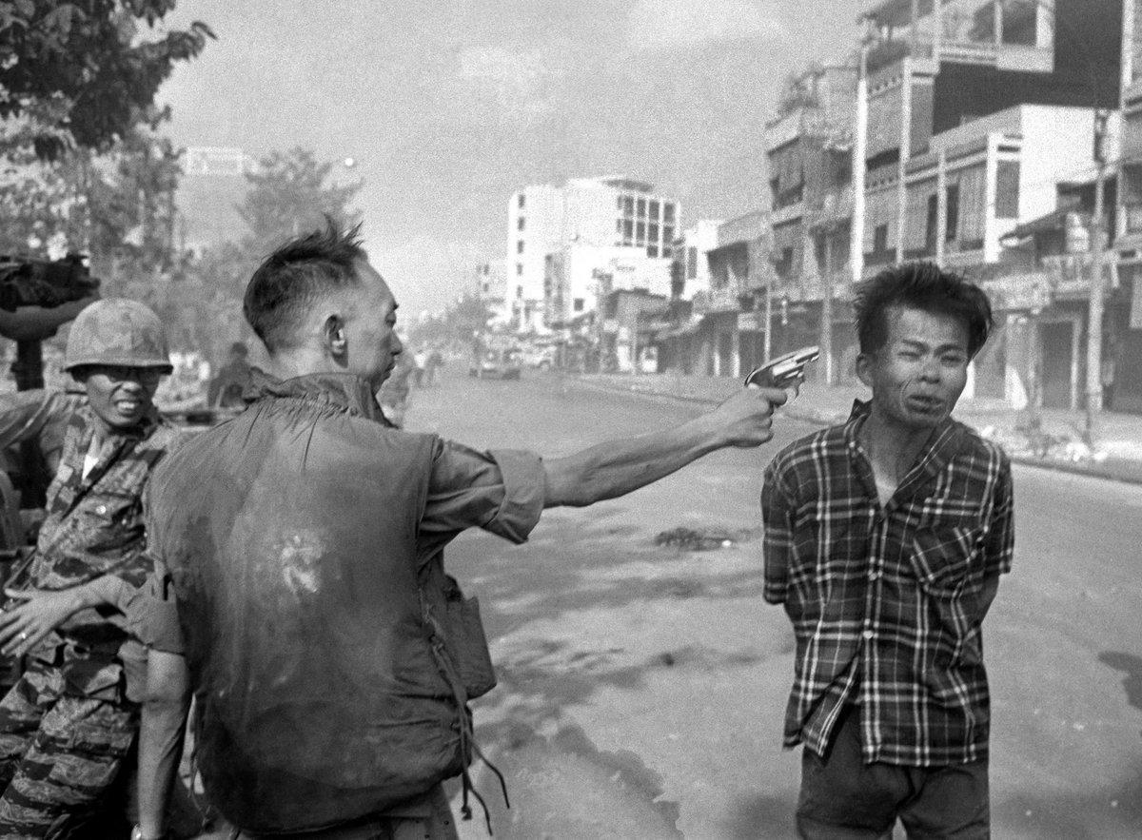

Source 17: “South Vietnamese civilians scale the 14-foot wall of the U.S. Embassy in Saigon, trying to reach evacuation helicopters as the last Americans depart from Vietnam on April 29, 1975.” Associated Press Photo

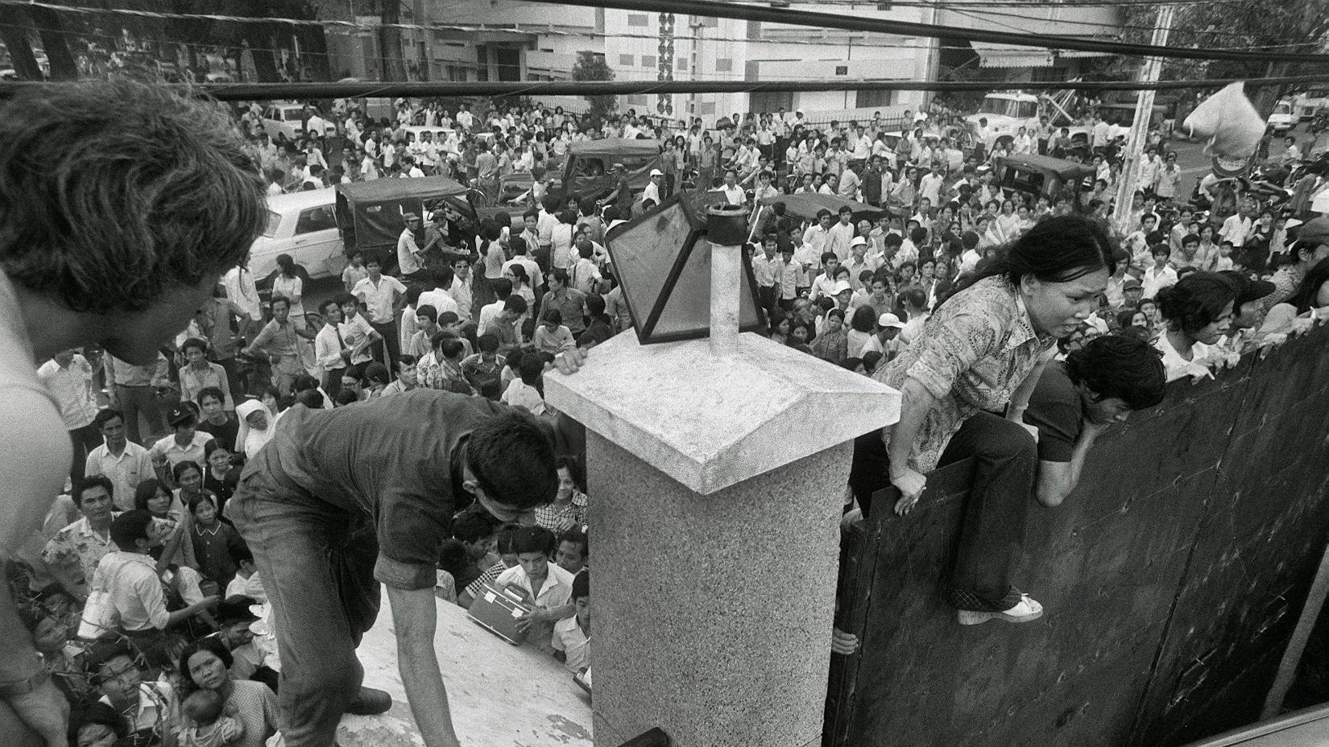

Source 18: Located in Washington, D.C., The Vietnam Veterans Memorial (also known as the Vietnam Wall) honors American soldiers who died in the Vietnam War. The Memorial Wall was designed by American architect Maya Lin and completed in 1982.
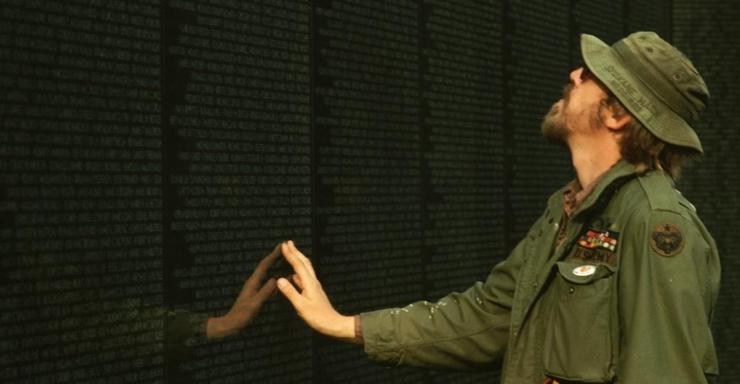

Source 19:
The Three Soldiers (also known as The Three Servicemen) is a bronze statue on the Washington, DC National Mall commemorating the Vietnam War. It was created and designed to complement the Vietnam Veterans Memorial, by adding a more traditional component to the Memorial. Some felt the Vietnam Wall Memorial was too negative.
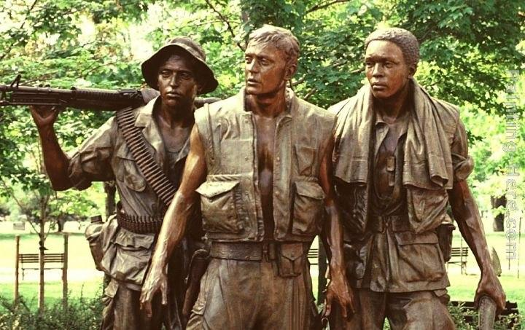
Source or Text | Is this source supportive, critical, or neutral toward U.S. involvement in Vietnam? | How do you know (from box 1)? And, what valid point(s) does the creator of this source make or get you to ponder? | What weaknesses does this source have (what is left out)?
Source 1:
Map of Vietnam

Source 2:
CIA released document - consequences

Source 3:
Gulf of Tonkin Resolution

Source 4:
Ho Chi Minh Declaration of Independence

Source 5:
Richard Nixon Vietnam Support Letters

Source 6:
Taped President Johnson Conversation

Source 7:
Muhammad Ali Protest of Vietnam War

Source 8:
“I feel like I’m Fixin’ to Die Rag” lyrics

Source 9:
U.S. Soldiers Carrying Children

Source 10:
Phan Thi Kim Phuc photo

Source 11:
MLK Speech

Source 12:
Wounded U.S. Soldiers

Source 13:
Tet Offensive Statistics

Source 14:
Flower Child Protest

Source 15:
John Kerry before U.S. Congress

Source 16:
South Vietnamese General Nguyen Ngoc Loan

Source 17:
South Vietnamese citizens trying to evacuate with U.S. Soldiers

Source 18:
The Vietnam Veterans Memorial

Source 19:
The Three Soldiers Memorial

