History Lab: Should Andrew Jackson have been removed from the front of the Twenty Dollar Bill?

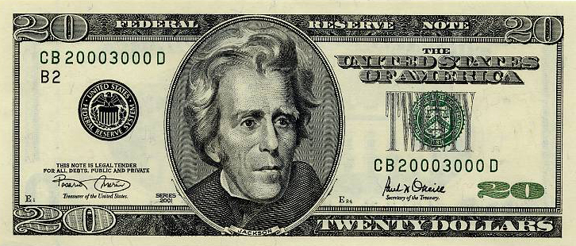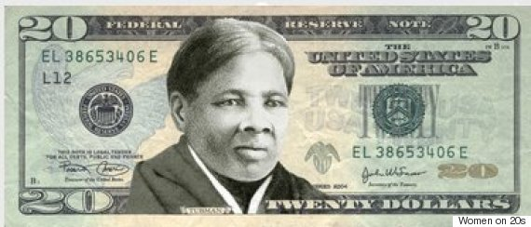

Background
Few, if any, United States Presidents have created more controversy during and after their time in office than Andrew Jackson. Some historians have labeled Jackson a racist and the person most responsible for the extinction of the eastern Native American tribes, while other praise his leadership abilities and credit him for saving the Union during the early 1800s. This history lab will examine many of the controversial aspects of his Presidency.
Born in poverty, Jackson (1767-1845) had become a wealthy Tennessee lawyer and rising young politician by 1812, when war broke out between the United States and Britain. His leadership in that conflict earned Jackson national fame as a military hero, and he would become America’s most influential–and polarizing–political figure during the 1820s and 1830s. After narrowly losing to John Quincy Adams in the contentious 1824 presidential election, Jackson returned four years later to win redemption, soundly defeating Adams and becoming the nation’s seventh president (1829-1837). As America’s political party system developed, Jackson became the leader of the new Democratic Party. A supporter of states’ rights and slavery’s extension into the new western territories, he opposed the Whig Party and Congress on polarizing issues such as the Bank of the United States. For some, his legacy is tarnished by his role in the forced relocation of Native American tribes living east of the Mississippi

Source 1: Table and “The Battle of New Orleans” / Painting - 1910. Edward Percy Moran – courtesy Library of Congress.

 | United States | Great Britain
Date | January 6 – 18, 1815
Commanders | Major General Andrew Jackson | Admiral Alexander Cochrane & General Edward Pakenham
Military Strength | 4, 732 | 14,450
Killed, Wounded, or Missing | 333 | 2,459
Winner | The United States
Significance: | Though a peace treaty had been agreed to by both sides prior to the Battle of New Orleans (word had not gotten back to the Americas), this battle victory prevented the British capture of the important port of New Orleans and increased military pride in the newly established nation. It also thrust General Andrew Jackson into an American hero and helped propel him into the Presidency.

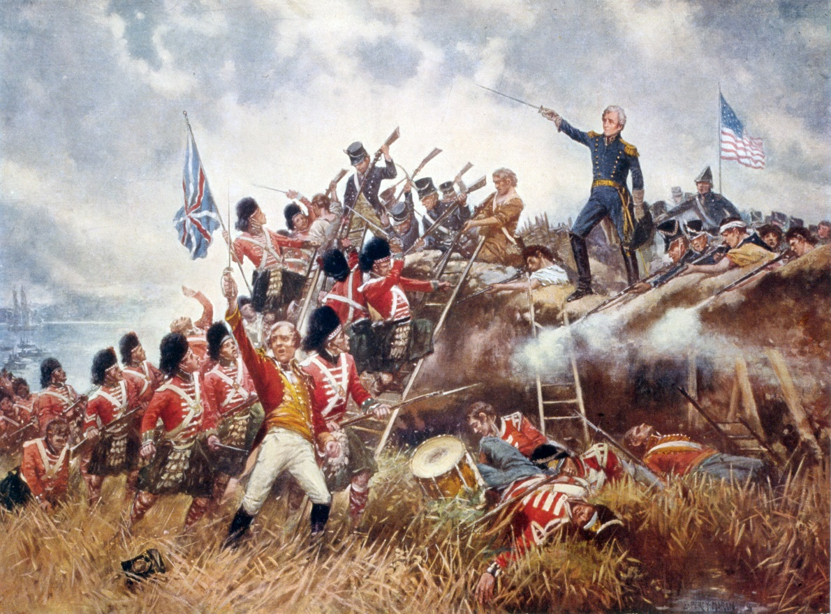

Source 2: Proclamation by Andrew Jackson, President of the United States. December 10, 1832.

I consider then the power to annul a law of the United States, assumed by one State, INCOMPATIBLE WITH THE EXISTENCE OF THE UNION, CONTRADICTED EXPRESSLY BY THE LETTER OF THE CONSTITUTION, UNAUTHORIZED BY ITS SPIRIT, INCONSISTENT WITH EVERY PRINCIPLE ON WHICH IT WAS FOUNDED, AND DESTRUCTIVE OF THE GREAT OBJECT FOR WHICH IT WAS FORMED.... , The law in question was passed under a power expressly given by the Constitution, to lay and collect imposts.... The Constitution has given expressly to Congress the right of raising revenue and of determining the sum the public exigencies will require. The States have no control over the exercise of this right, other than that which results from the power of changing the Representatives who abuse it, and thus procure redress....
The States, severally have not retained their entire sovereignty. It has been shown that in becoming parts of a nation, not members of a league, they surrendered many of their essential parts of sovereignty. The right to make treaties--declare war--levy taxes--exercise exclusive judicial and legislative powers--were all of them functions of sovereign power. The States then, for all these important purposes, were no longer sovereign.
The allegiance of their citizens was transferred in the first instance to the Government of the United States--they became American citizens, and owed obedience to the Constitution of the United States and to laws made in conformity with the powers it vested in Congress.... Treaties and alliances were made in the name of all. Troops were raised for the common defence. How then, with all these proofs that under all changes of our position we had, for designated purposes and with defined powers, created national Governments--how it is, that the most perfect of those several modes of union, should now be considered as a mere league that may be dissolved at pleasure? It is an abuse of terms.... ,
Fellow citizens of my native State! let me not only admonish you, as the first Magistrate of our common country, not to incur the penalty of its laws, but use the influence that a Father would over his children whom he saw rushing to certain ruin.... You are free members of a flourishing and happy union. There is not settled design to oppress you.--You have indeed felt the unequal operation of the laws which may have been unwisely, not constitutionally passed; but that inequality must necessarily removed…
The laws of the United States must be executed. I have no discretionary power on the subject--my duty is emphatically pronounced in the Constitution. Those who told you that you might peaceably prevent their execution, deceived you--they could not have been deceived themselves. They know that a forcible opposition could alone prevent the execution of the laws, and they know that such opposition must be repelled. Their object is disunion: but be not deceived by names: disunion, by armed force, is TREASON....

Source 3: Cartoon drawn during the Nullification Crisis – source unknown

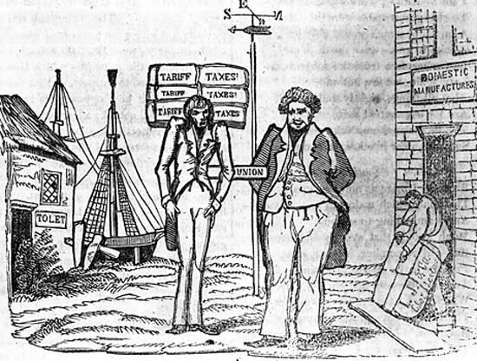
Source 4: President Jackson's Message to Congress "On Indian Removal", December 6, 1830; Records of the United States Senate, 1789‐1990; Record Group 46; Records of the United States Senate, 1789‐1990; National Archives and Records Administration (NARA]

"It gives me pleasure to announce to Congress that the benevolent policy of the Government, steadily pursued for nearly thirty years, in relation to the removal of the Indians beyond the white settlements is approaching to a happy consummation. Two important tribes have accepted the provision made for their removal at the last session of Congress, and it is believed that their example will induce the remaining tribes also to seek the same obvious advantages.”
“The consequences of a speedy removal will be important to the United States, to individual States, and to the Indians themselves. The pecuniary advantages which it promises to the Government are the least of its recommendations. It puts an end to all possible danger of collision between the authorities of the General and State Governments on account of the Indians. It will place a dense and civilized population in large tracts of country now occupied by a few savage hunters. By opening the whole territory between Tennessee on the north and Louisiana on the south to the settlement of the whites it will incalculably strengthen the southwestern frontier and render the adjacent States strong enough to repel future invasions without remote aid. It will relieve the whole State of Mississippi and the western part of Alabama of Indian occupancy, and enable those States to advance rapidly in population, wealth, and power. It will separate the Indians from immediate contact with settlements of whites; free them from the power of the States; enable them to pursue happiness in their own way and under their own rude institutions; will retard the progress of decay, which is lessening their numbers, and perhaps cause them gradually, under the protection of the Government and through the influence of good counsels, to cast off their savage habits and become an interesting, civilized, and Christian community. “

Source 5: “Andrew Jackson as the Great Father.” 1835. Native American History at the Clements Library. William L. Clements Library. University of Michigan, Ann Arbor.

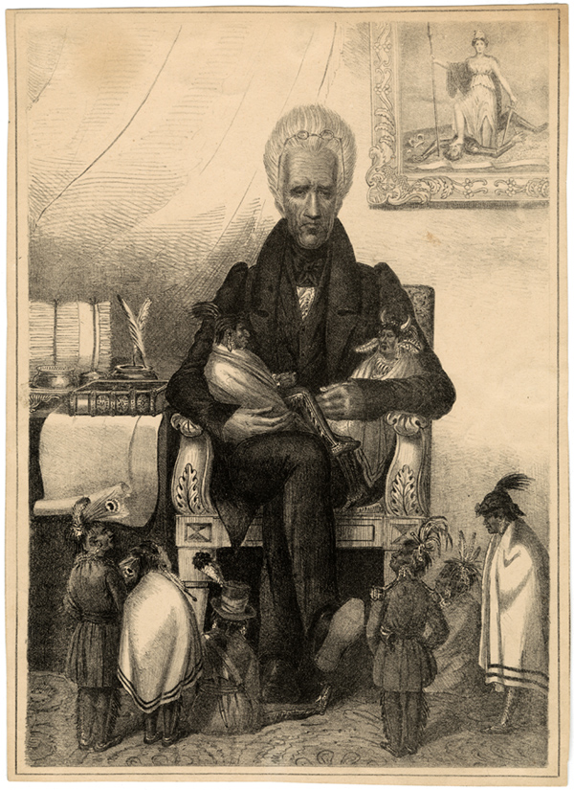

Source 6: Andrew Jackson’s Veto Message Against the Re-chartering of the Bank of the United States, July 10, 1832

“It is to be regretted that the rich and powerful too often bend the acts of government to their selfish purposes. Distinctions in society will always exist under every just government. Equality of talents, of education, or of wealth cannot be produced by human institutions. In the full enjoyment of the gifts of Heaven and the fruits of superior industry, economy, and virtue, every man is equally entitled to protection by law; but when the laws undertake to add to these natural and just advantages artificial distinctions, to grant titles, gratuities, and exclusive privileges, to make the rich richer and the potent more powerful, the humble members of society--the farmers, mechanics, and laborers--who have neither the time nor the means of securing like favors to themselves, have a right to complain of the injustice of their government. There are no necessary evils in government. Its evils exist only in its abuses. If it would confine itself to equal protection, and, as Heaven does its rains, shower its favors alike on the high and the low, the rich and the poor, it would be an unqualified blessing.”

Source 7: The Reply of Senator Daniel Webster, July 11, 1832

I will not conceal my opinion that the affairs of the country are approaching an important and dangerous crisis. At the very moment of almost unparalleled general prosperity, there appears an unaccountable disposition to destroy the most useful and most approved institutions of the government. Indeed, it seems to be in the midst of all this national happiness that some are found openly to question the advantages of the Constitution itself; and many more ready to embarrass the exercise of its just power, weaken its authority, and undermine its foundations. How far these notions may be carried, it is impossible to say. We have before us the practical result of one of them. The bank has fallen, or is to fall.…
The responsibility justly lies with [the President], and there it ought to remain. A great majority of the people are satisfied with the bank as it is, and desirous that it should be continued….The strength of this public sentiment has carried the bill through Congress, against all the influence of the administration, and all the power of organized party. But the President has undertaken, on his own responsibility, to arrest the measure, by refusing his assent to the bill. He is answerable for the consequences, therefore, which necessarily follow the change which the expiration of the bank charter may produce; and if these consequences shall prove disastrous, they can fairly be ascribed to his policy only, and the policy of his administration.
…Congress passed the bill, not as a bounty or a favor to the present stockholders, not to comply with any demand of right on their part, but to promote great public interest, for great public objects. Every bank must have some stockholders…and if the stockholders, whoever they may be, conduct the affairs of the bank prudently, the expectation is always, of course, that they will make it profitable to themselves, as well as useful to the public. If a bank charter is not to be granted because it may be profitable, either in a small or great degree, to the stockholders, no charter can be granted. The objection lies against all banks…

Source 8: “To the Victor goes the Spoils” / Thomas Nast / Harper's Weekly, April 28, 1877.

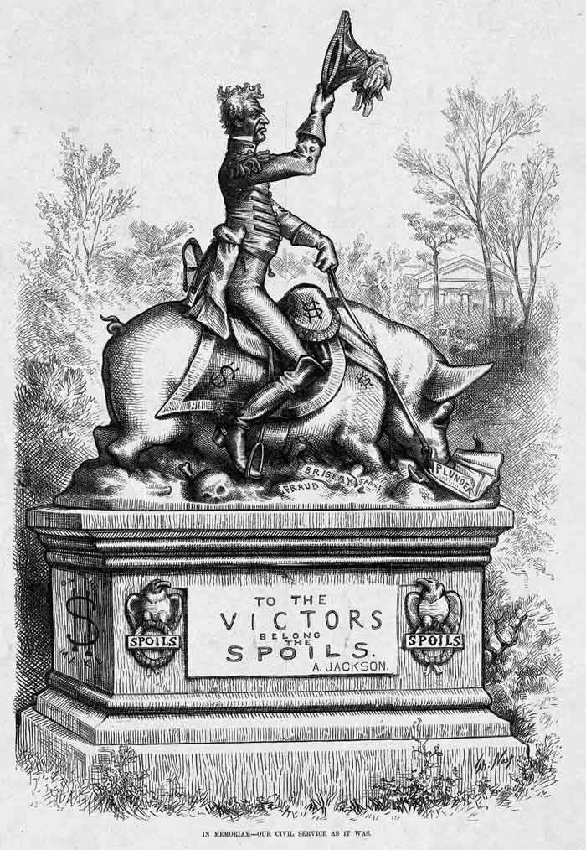

Source 9: Jackson Announces His Policy of Rotation in Office. (1829)

In a country where offices are created solely for the benefit of the people no one man has any more intrinsic right to official station than another. Offices were not established to give support to particular men at the public expense. No individual wrong is, therefore, done by removal, since neither appointment to nor continuance in office is a matter of right. The incumbent became an officer with a view to public benefits, and when these require his removal they are not to be sacrificed to private interests. It is the people, and they alone, who have a right to complain when a bad officer is substituted for a good one.

Source 10: “King Andrew the First” / 1833 / Library of Congress Prints and Photographs Division Washington, D.C. 20540 USA http://hdl.loc.gov/loc.pnp/pp.print

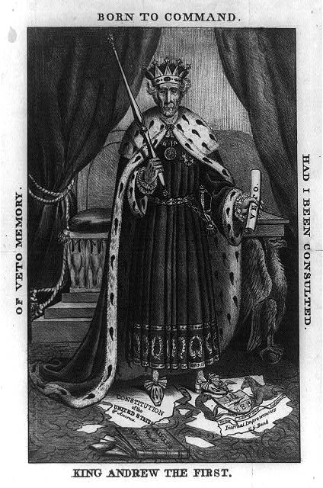

Source or Text | Is this source supportive, critical, or neutral toward Andrew Jackson? | What good points does the author or creator make with this source? | What weaknesses does this source have (what is left out)?
Source 1:
Battle of New Orleans

Source 2:
Jackson Proclamation

Source 3:
Nullification Cartoon

Source 4:
Jackson on Indian Removal

Source 5:
Jackson the Great Father

Source 6:
Andrew Jackson Veto of Bank

Source 7:
Reply of Daniel Webster

Source 8:
To the Victor Goes the Spoils

Source 9:
Policy of Rotation

Source 10:
King Andrew the First

