- The Louisiana Purchase Timeline (Background):
1763: France gave Louisiana to Spain.

March 1801: Napoleon wanted a French empire in North America. So, under pressure, Spain returned Louisiana to France. Federalists in the United States were alarmed that France now owned Louisiana. They wanted to use force against France. But Jefferson (a Democratic-Republican) sent Robert R. Livingston, the U.S. minister to France to attempt to buy New Orleans.

January 1803: U.S. sent James Monroe to join Livingston and try to buy New Orleans and West Florida from France.

April 1803: Napoleon gave up his dream of an American empire because he was overwhelmed by the slave revolt in Haiti and also wanted to go to war with Britain. The French offered Livingston and Monroe all of Louisiana (not just New Orleans). Livingston and Monroe signed a treaty. For roughly $15 million, the U.S. acquired some 828,000 square miles of land, doubling the national territory of the United States.

October 1803: The Senate ratified the treaty and in December the United States acquired the Louisiana Purchase.

- Map Activity:
1: Label the following states that were part of the United States in 1803
Delaware Pennsylvania New Jersey
Georgia Connecticut Massachusetts Maryland
South Carolina New Hampshire Virginia New York
North Carolina Rhode Island Vermont Kentucky
Tennessee Ohio

2: Color the territory gained through the Louisiana Purchase and label the present day states that were created,
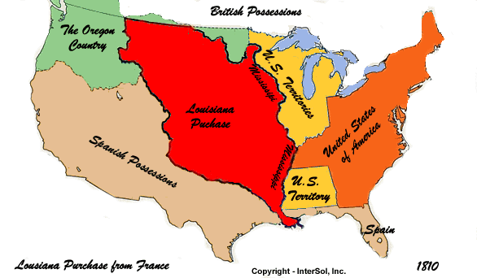

- Opposition:
Document A: Alexander Hamilton (Modified)
The purchase of New Orleans is essential to the peace and prosperity of our Western country, and opens a free and valuable market to our commercial states. This purchase will probably make it seem like Mr. Jefferson is brilliant. Any man, however, who possesses any amount of intelligence, will easily see that the purchase is the result of lucky coincidences and unexpected circumstances and not the result of any wise or thoughtful actions on the part of Jefferson’s administration. As to the vast region west of the Mississippi, it is a wilderness with numerous tribes of Indians. And when we consider the present territory of the United States, and that not one-sixteenth is yet under occupation, the possibility that this new purchase will be a place of actual settlement seems unlikely. If our own citizens do eventually settle this new land, it would weaken our country and central government. On the whole, we can honestly say that this purchase is at best extremely problematic.

Document B: Letters by Federalists (Modified) Rufus King to Timothy Pickering, November 4, 1803
According to the Constitution, Congress may admit new states. But can the President sign treaties forcing Congress to do so? According to the Louisiana Treaty, the territory must be formed into states and admitted into the Union. Will Congress be allowed to set any rules for their admission? Since slavery is legal and exists in Louisiana, and the treaty states that we must protect the property of the inhabitants, won’t we be forced to admit the new states as slave states? Doing so will worsen the problem of unequal representation from slave and free states.
Timothy Pickering to Rufus King. March 4, 1804 I am disgusted with the men who now rule us. The coward at the head [Jefferson] is like a French revolutionary. While he talks about humanity, he enjoys the utter destruction of his opponents. We have too long witnessed his general wickedness—his cruel removals of faithful officers and the substitution of corruption and immorality for honesty. Source: The two letters above are written between two Federalists. Rufus King was a Senator from New York and Timothy Pickering was a Senator from Massachusetts.

- Lewis and Clark
http://www.history.com/topics/lewis-and-clark

http://espn.go.com/blog/pac12/post/_/id/92554/latest-oregon-uniforms-include-nods-to-lewis-clark-oregon-trail

