Artifact A

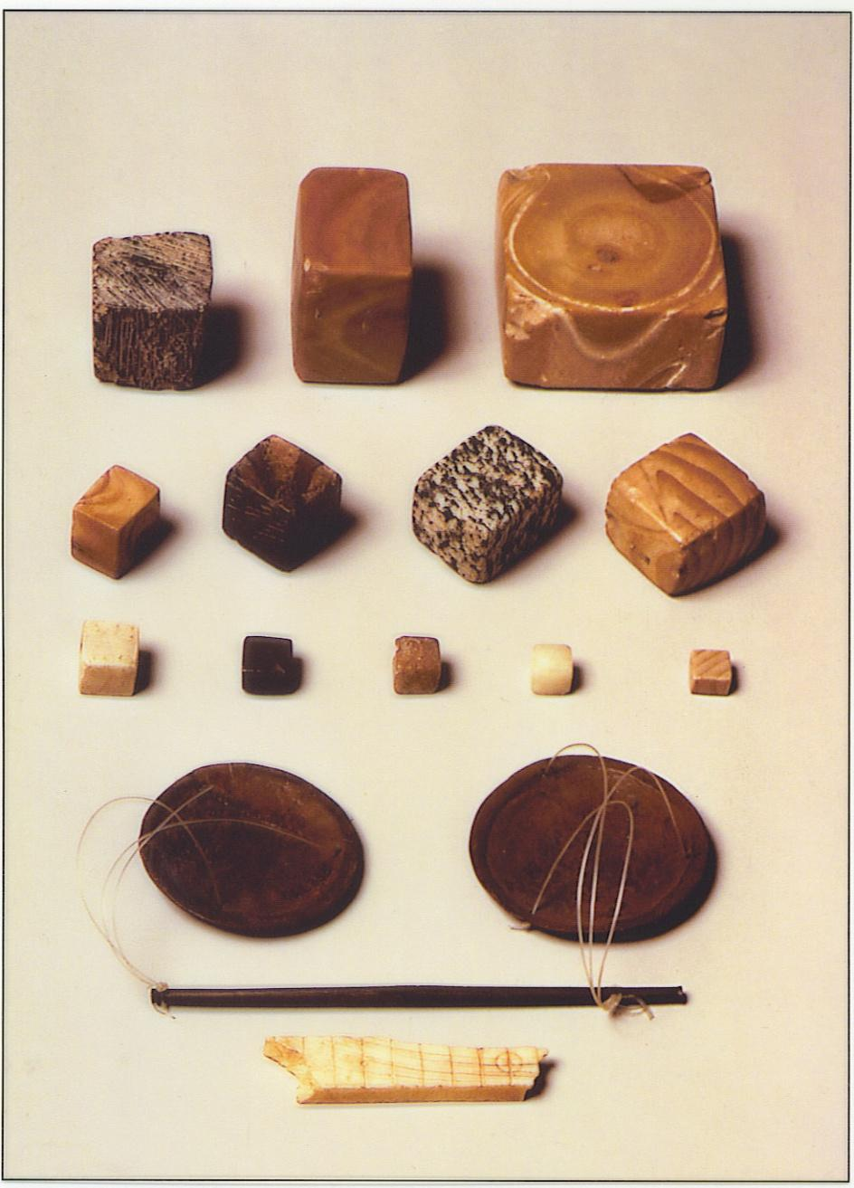
Question: What might people of Mohenjo-Daro have used these objects for?

Artifact B
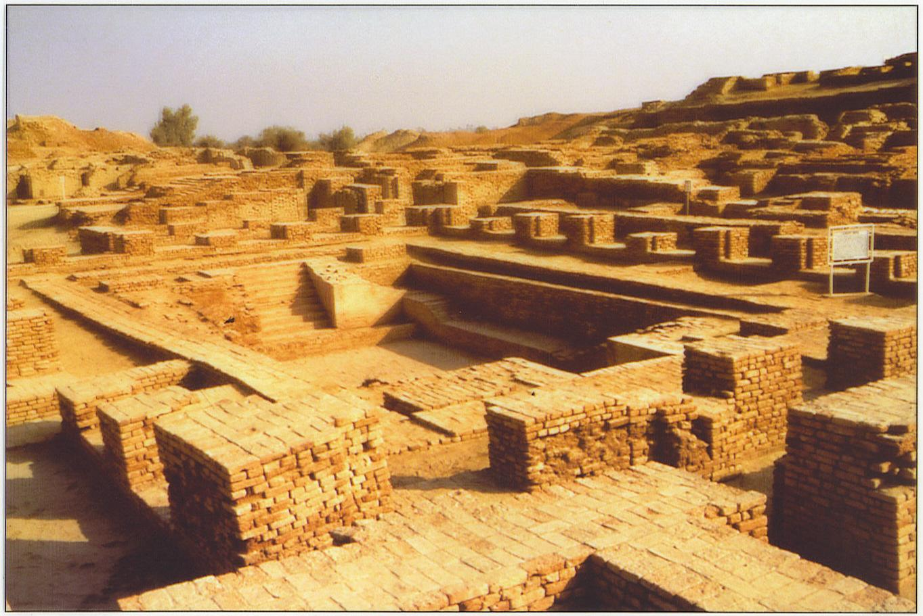
Question: What might the people of Mohenjo-Daro have used this structure for?

Artifact C
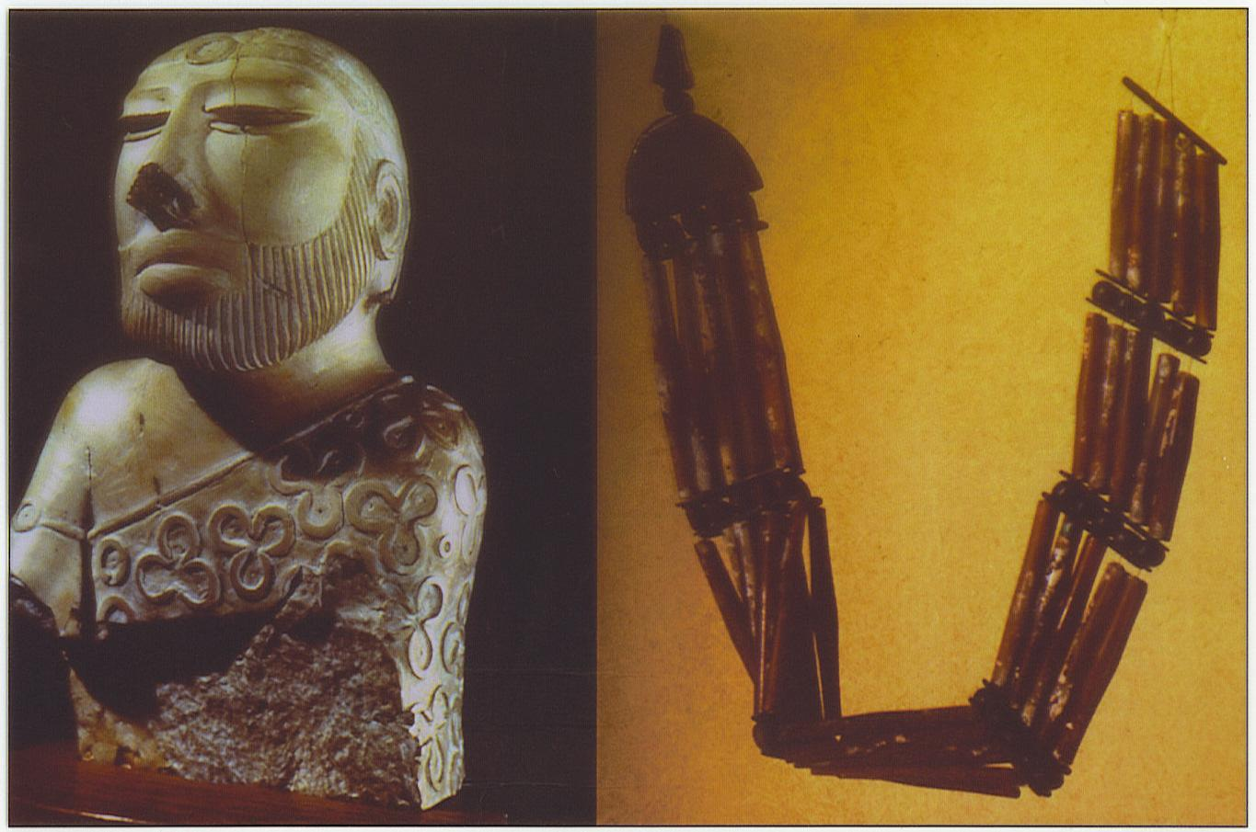
Question: What do these objects tell you about the personal appearance of people of Mohenjo-Daro?

Artifact D
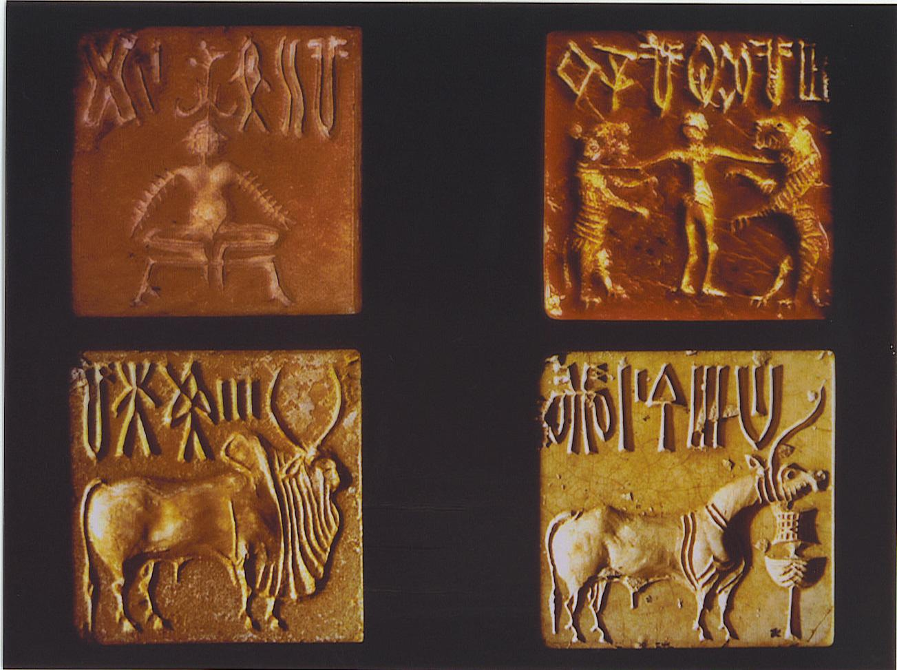
Question: What might the people of Mohenjo-Daro have used these seals for?

Artifact E
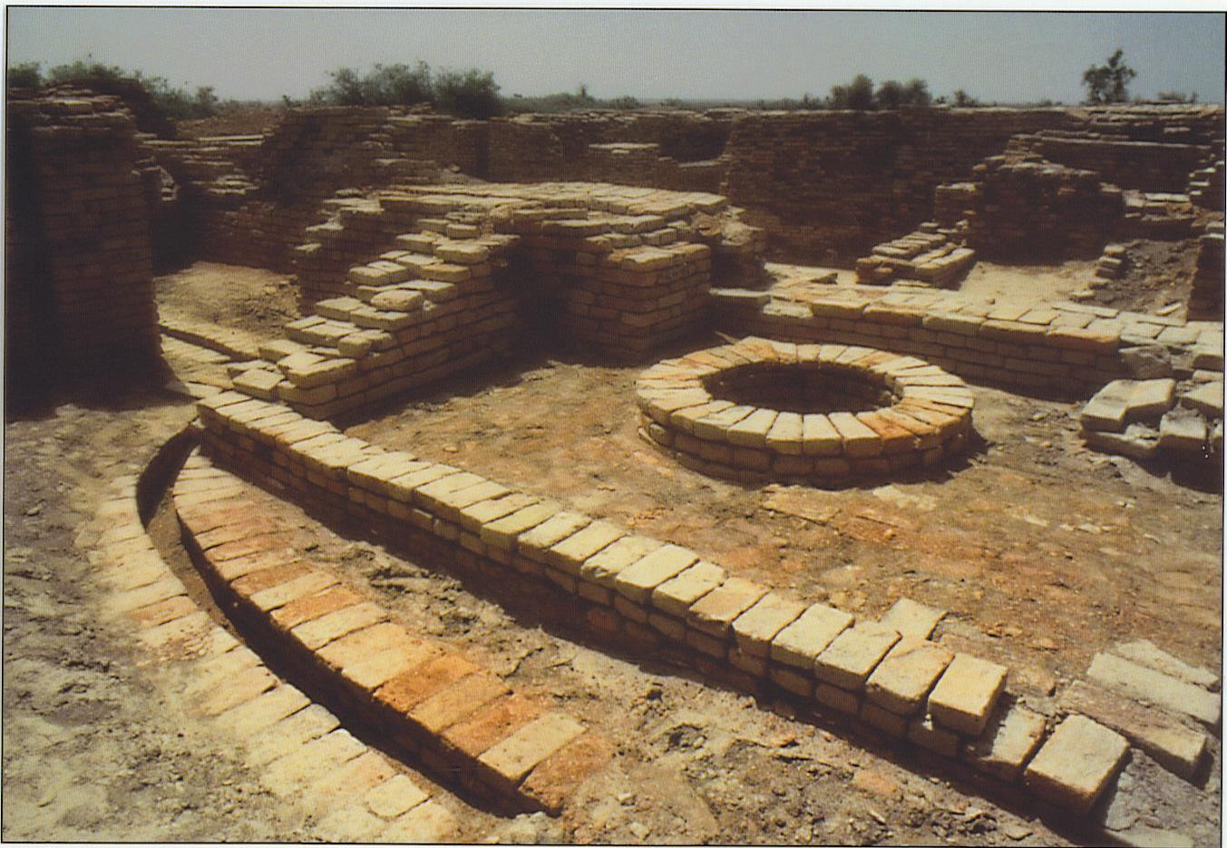
Question: What might the people of Mohenjo-Daro have used these structures for?

Artifact F
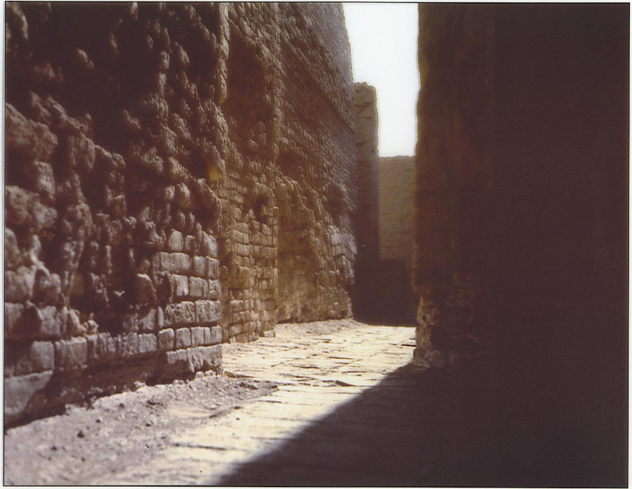
Question: what might the people of Mohenjo-Daro have used these structures for?

Artifact G
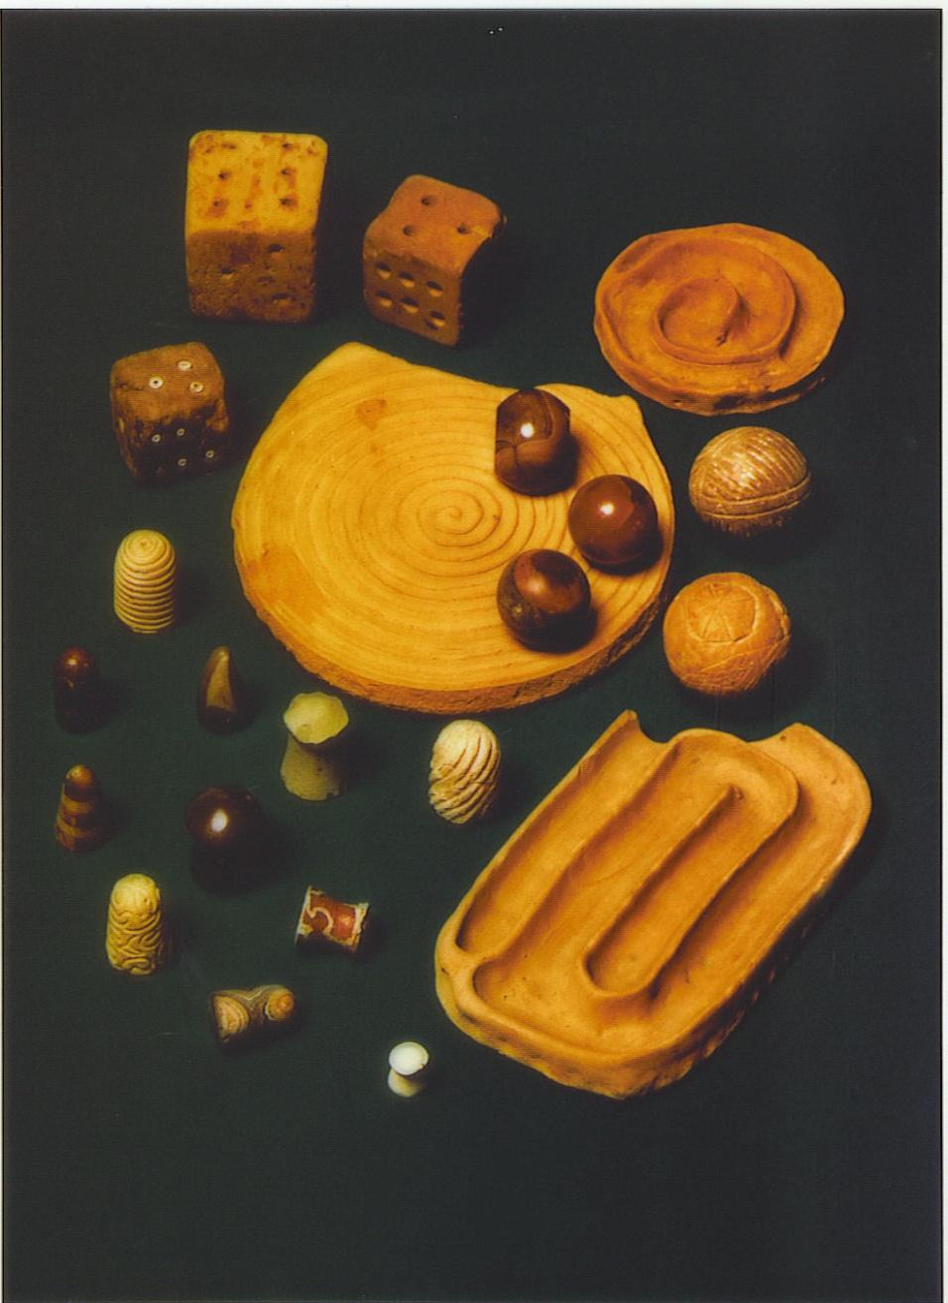
Question: What might the people of Mohenjo-Daro have used these objects for?

Artifact H

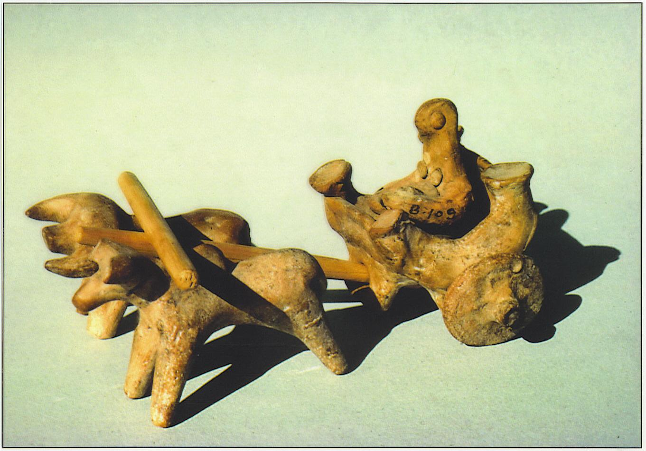
Question: What might this object reveal about daily life in Mohenjo-Daro?

