History Lab: Was the Industrial Revolution ultimately good or bad for society?

Background: The Industrial Revolution
Source: ReadWorks - 2014

From about 1750 to around 1830, a revolution started in England and spread to other parts of the world. The revolution had nothing to do with war or revolting1 against an unjust ruler. Instead, it was a revolution of ideas and industry. The invention of machines instantly changed the way people made goods. It also changed the way people lived and thought. This time of rapid change is known as the Industrial Revolution.
Before the Industrial Revolution, most items people needed were made by hand. Things like clothes, dishes or furniture, were handcrafted one by one. This took a lot of time and skill. Most craftsmen worked out of their homes. Many lived in the countryside. Towards the end of the 18th century all of this began to change. Machines took the place of skilled labor done by craftsmen. Factories were created to bring together machines and the workers needed to operate them.
One of the most important machines invented during the Industrial Revolution was the steam engine. This machine used steam to power its work. Steam was cheap and much more powerful than horses. It revolutionized transportation and industry. Steam engine trains made it possible to ship products quickly across the country. Machines powered by steam also made goods quickly. All this reduced the price of products. It became cheaper for people to buy the things they needed to live.
But industrialization also had a negative side. Large factories sprung up in cities. Many people left their farms and rural homes to work in the factories. This movement from the countryside to the cities is called urbanization. Industrial cities grew very quickly. In some cases, the population more than doubled. They often didn’t have homes for all the new people. Some workers crowded into little shacks near the factories. The quarters1 were cramped and unsanitary. Diseases spread easily from one person to another.
Workers suffered in other ways, too. Skilled craftsmen who lost their jobs to machines weren’t always able to find a new factory job. When they did, they worked long hours and weren’t paid well. Women and children were even paid less. They worked up to 14 hours a day, six days a week for pennies a day. There was barely ever time to rest. Factory machines never stopped running. Often, the machines were unsafe. Many workers were crippled and desperately poor. As time went by, however, workers organized into unions. 2 They fought back and forced their employers to improve working conditions and pay
The Industrial Revolution was a major turning point in history. As it spread to other areas of the world, life in the countryside was replaced by life in new industrial cities. As industry grew and more goods were produced, people’s standard of living improved. Today, workers earn more and live longer than before the revolution. But industrialization also caused new problems. Factories have polluted the air, land, and water. Most industrialized nations will face these challenges for years to come.

Source 1: Testimony of Dr. Michael Ward before a British Governmental Committee

Source: House of Lords Committee (Interviewer) & Michael, W. (Interviewee). (1819).
Excerpt from Minutes of Evidence taken before the Lords Committees appointed to enquire into the State and Condition of the Children employed in the Cotton Manufactories of the United Kingdom. House of Lords Sessional Papers (1806-1859).

Question (House of Lords Committee): Give the committee information on your knowledge of the health of workers in cotton-factories.
Answer (Dr. Ward): I have had frequent opportunities of seeing people coming out from the factories and occasionally attending as patients. Last summer I visited three cotton factories with Dr. Clough of Preston and Mr. Barker of Manchester and we could not remain ten minutes in the factory without gasping for breath. How it is possible for those who are doomed to remain there twelve or fifteen hours to endure it? If we take into account the heated temperature of the air, and the contamination of the air, it is a matter of astonishment to my mind, how the work people can bear the confinement for so great a length of time.

Question: What was your opinion of the relative state of health between cotton-factory children and children in other employments?
Answer: The state of the health of the cotton-factory children is much worse than that of children employed in other manufactories.

Question: Have you any further information to give to the committee?
Answer: Cotton factories are highly unfavorable, both to the health and morals of those employed in them. They are really nurseries of disease and vice.

Question: Have you observed that children in the factories have particular accidents?
Answer: When I was a surgeon in the infirmary, accidents were very often admitted to the infirmary, through the children's hands and arms having being caught in the machinery; in many instances the muscles, and the skin is stripped down to the bone, and in some instances a finger or two might be lost. Last summer I visited Lever Street School. The number of children at that time in the school, who were employed in factories, was 106. The number of children who had received injuries from the machinery amounted to very nearly one half. There were forty-seven injured in this way

Souce 2 : Testimony of Dr. Holmes before a British Governmental Committee

Source: House of Lords Committee (Interviewer) & Holmes, E. (Interviewee). (1818).
Excerpt from Minutes of Evidence taken before the Lords Committees to who was referred The Bill entituled 'Act to amend and extend an Act made in the Forty-second Year of His present Majesty, for the Preservation of the Health and Morals of Apprentices, and others, employed in Cotton and other Mills, and Cotton and other Factories.' House of Lords Sessional Papers (1806-1859).

Question: How long have you practised as a physician in Manchester?

Answer: Twenty-four years.

Question: Have you, in Manchester, occasion to visit any public establishments?

Answer: I am physician to the principal medical establishments. The medical establishments with which I am connected, and have been for twenty-four years are, the Manchester Infirmary, Dispensary, Lunatic Hospital and Asylum, and the House of Recovery.

Question: Has that given you opportunities of observing the state of the children who are ordinarily employed in the cotton-factories.

Answer: It has.

Question: In what state of health did you find the persons employed?

Answer: They were in good health generally. I can give you particulars, if desired, of Mr. Pooley's factory. He employs 401 persons; and, of the persons examined in 1796, 22 were found to be of delicate appearances, 2 were entered as sickly, 3 in bad health, one subject to convulsions, 8 cases of scrofula: in good health, 363.

Question: Am I to understand you, from your investigations in 1796, you formed rather a favourable opinion of the health of persons employed in cotton-factories.

Answer: Yes.

Question: Have you had any occasion to change that opinion since?

Answer: None whatever. They are as healthy as any other part of the working classes of the community.

Question: If children were overworked for a long period, would it, in your opinion as a medical man, affect their health so as to be visible in some way?

Answer: Unquestionably; if a child was overworked a single day, it would incapacitate him in a great measure for performing his work the next day; and if the practice was continued for a longer period, it would in a certain time destroy his health altogether.

Question: Then you are to be understood, that, from the general health among the children in the cotton-factories, you should form an opinion that they were not worked beyond their physical powers?

Answer: Certainly not.

Question: The result of your observation did not indicate any check of growth arising from their employment.

Answer: It did not.

Question: Would you permit a child of eight years old, for instance, to be kept standing for twelve hours a day?

Answer: I did not come here to answer what I would do if I had children of my own.

Question: Would it be injurious to a child, in your judgement as a medical man, if at the time he got his meals he was still kept engaged in the employment he was about?

Answer: These are questions which I find a great difficulty in answering.

Question: Who applied to you to undertake the examining of these children in Mr. Pooley's factory?

Answer: Mr. Pooley.

Question: Suppose I put this question to you. If children were employed twelve, thirteen, fourteen, fifteen hours out of twenty-four, should you think that conducive to the health of a delicate child?

Answer: My conclusion would be this: the children I saw were all in health; if they were employed during those ten, twelve, or fourteen hours, and had the appearance of health, I should still say it was not injurious to their health.

Source 3: Breaker boys, Woodward Coal Mines, Kingston, Pa. Date: around 1900

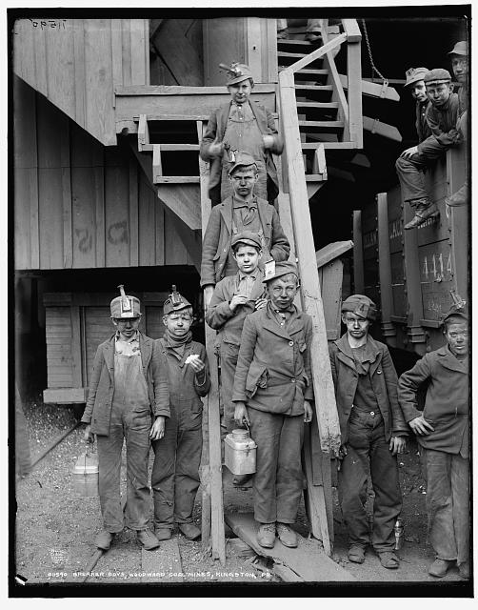

Source 4: Changes in England due to Industrial Revolution
California Department of Education – Around 2010

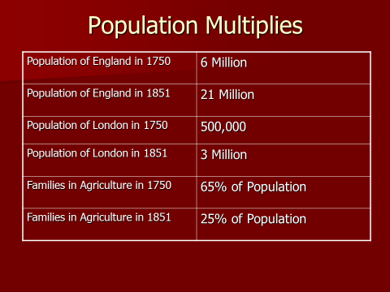
Source 5: World Population – Developing vs Industrialized Nations - From The Atlantic - 2014

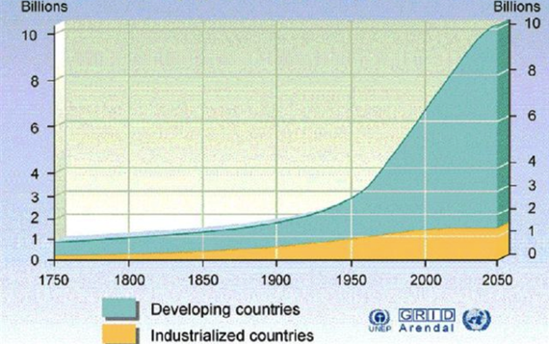

Source 6 : Image and Quote: Carbon dioxide (PPM), methane (PPB), and nitrous oxide (PPM) in the atmosphere since 1750. From The Atlantic - 2014

“When we take these trajectories into consideration, the Industrial Revolution starts to look like something less than an “undivided blessing.” It begins to look like, at best, a mixed blessing—one that resulted in technologies that have allowed many people to live longer, safer lives, but that has, simultaneously, destroyed global ecosystems, caused the extinction of many living species, facilitated rampant population growth, and wreaked havoc on climate systems, the effects of which will be an increase in droughts, floods, storms, and erratic weather patterns that threaten most global societies.”

Source 7 : Two Passages in Favor of Industrial Revolution

“[The Industrial Revolution] has also resulted in modern technological innovations that generations of people have grown accustomed to—such as steam engines, railroads, cars, modern appliances, and computers. Average life expectancy has more than doubled in industrialized nations, while average incomes have increased even more… Global GDP per capita—the most common measurement of national wealth—has increased 800% over the past 200 years in 1990 dollars (“The Contours of World Development”). Most people in the world experience better education than they did 200 years ago. 90% of United Nation member countries in 2011 had a literacy rate well above 50%, and just about half of the countries in the world had a literacy rate above 90% (“Literacy Rate of Countries”). In contrast, the large majority of Europeans before 1850 were illiterate. Healthcare also certainly improved. Some diseases that decimated populations in the past have now essentially been defeated through scientific and technological advances made possible by the Industrial and Scientific Revolutions.
Source: Great Britian Modern World Textbook - http://webs.bcp.org/sites/vcleary/ModernWorldHistoryTextbook/index.html

“Perhaps the only way to fully appreciate the impact of the industrial revolution is to look at those in the modern world who have yet to undergo industrialization. The fate of the hungry and disease-ridden peasants in such areas as Africa and India is perhaps the most forceful and convincing argument in favor of capitalism’s industrial revolution.”
From the Freedom For Economic Education: John Majewski is an economics major at the University of Texas at Austin. He is currently serving as a summer intern with the Institute for Humane Studies.

Source 8: Political Cartoon - “The Protectors of Our Industries” 1883
Created by Gillam, Bernhard, 1856-1896, artist

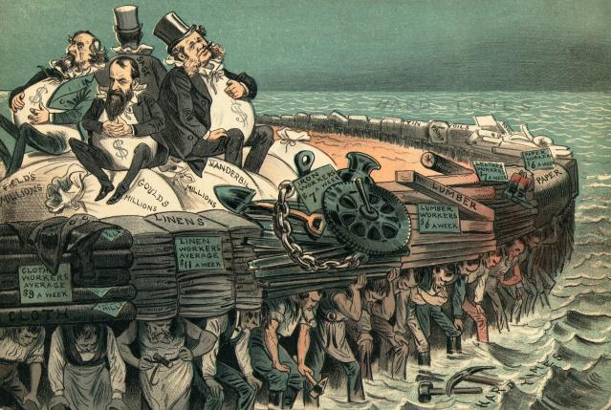

Source 9 : “Technology over true family engagement?” Google Images – 2015

Document Source Analysis Sheet
Source or Text | What do you see (what did you see at first and what do you see after reading or viewing this source again)? | What message do you think the creator was trying to send? | Support or Challenge the belief that the Industrial Revolution was good for society?
Source 1:
House of Lords Committee (Interviewer) & Michael, W. (Interviewee)

Source 2:
Testimony of Dr. Holmes before a British Governmental Committee

Source 3:
Breaker boys, Woodward Coal Mines, Kingston, Pa.

Source 4:
Changes in England due to Industrial Revolution

Source 5:
World Population – Developing vs Industrialized Nations

Source 6:
Image and Quote: Carbon dioxide (PPM), methane (PPB), and nitrous oxide (PPM) in the atmosphere since 1750

Source 7:
Two Passages in Favor of Industrial Revolution

Source 8:
Political Cartoon - “The Protectors of Our Industries”

Source 9:
Image: “Technology over true family engagement?”

