History Lab: How Should George Washington Be Judged On The Issue of Slavery?
- A man uncomfortable with slavery, but committed to keeping all 13 original states together in one union.
or
- A willing participant in the institution of slavery that should have done more to help abolish the practice.

Background Information:
George Washington and Slavery Background - Maryland Department of Education
George Washington lived during a time when slavery was an “accepted” practice for most Americans. His father’s death made him an owner of 10 slaves when he was only 11 years old. Like most people of the Virginia gentry, he believed that the only way to be successful was to own land.

Owning that land, however, was not enough. That land had to be cultivated and made useful. In order to do that, Washington and his peers turned to enslaved Africans for their labor force. Washington possessed approximately 75 slaves between 1743 and 1775. Some he inherited from his father; his 1759 marriage to Martha Custis provided him with access to 25 more. He used their labor to establish successful farming operations at Mount Vernon and his other farms. By the time of his death, his estate included 317 enslaved people, 124 of whom were his property outright, 153 who were Martha Washington’s dower slaves, and 40 whom he had leased from a neighbor.
Washington’s landholdings were vast. In addition to Mount Vernon, he owned and operated four additional farms. Since each farm was a separate entity, the slave labor force on each had to be diversified in order to make the operations successful. Because 132 of his 317 enslaved laborers were either too old or too young to work, Washington’s five farms were actually staffed by only 184 people. Of those 184, 52 were considered skilled artisans or domestic workers. The work of skilled artisans such as coopers, blacksmiths, bricklayers, carpenters, and distillers were essential to the everyday operation of plantations. Domestic workers included butlers, maids, cooks, and waiters. Most of Washington’s enslaved population, however, were field workers.

Like many of the Founding Fathers, Washington had conflicting feelings over the institution of slavery. Despite never having made a public stand on the issue during his lifetime, he left behind a will that served as an example of his changed beliefs. In his 1799 will, he made provisions for the emancipation of all of his slaves. Washington gave immediate freedom to his body servant, Billy Lee. He was one of Washington’s close and loyal personal servants. The remaining slaves were to be emancipated after his wife’s death.

Source: http://marylandpublicschools.org/NR/rdonlyres/F68E8866-61CB-4AF5-8AE6-F9275A9CEE9C/31536/Washington_Changing_Views_Emancipation_02062012_.pdf

Teacher Background Information:
George Washington and Slavery Background - Maryland Department of Education
George Washington lived during a time when slavery was an “accepted” practice for most Americans. His father’s death made him an owner of 10 slaves when he was only 11 years old. Like most people of the Virginia gentry, he believed that the only way to be successful was to own land.

Owning that land, however, was not enough. That land had to be cultivated and made useful. In order to do that, Washington and his peers turned to enslaved Africans for their labor force. Washington possessed approximately 75 slaves between 1743 and 1775. Some he inherited from his father; his 1759 marriage to Martha Custis provided him with access to 25 more. He used their labor to establish successful farming operations at Mount Vernon and his other farms. By the time of his death, his estate included 317 enslaved people, 124 of whom were his property outright, 153 who were Martha Washington’s dower slaves, and 40 whom he had leased from a neighbor.
Washington’s landholdings were vast. In addition to Mount Vernon, he owned and operated four additional farms. Since each farm was a separate entity, the slave labor force on each had to be diversified in order to make the operations successful. Because 132 of his 317 enslaved laborers were either too old or too young to work, Washington’s five farms were actually staffed by only 184 people. Of those 184, 52 were considered skilled artisans or domestic workers. The work of skilled artisans such as coopers, blacksmiths, bricklayers, carpenters, and distillers were essential to the everyday operation of plantations. Domestic workers included butlers, maids, cooks, and waiters. Most of Washington’s enslaved population, however, were field workers.

Like many of the Founding Fathers, Washington had conflicting feelings over the institution of slavery. Despite never having made a public stand on the issue during his lifetime, he left behind a will that served as an example of his changed beliefs. In his 1799 will, he made provisions for the emancipation of all of his slaves. Washington gave immediate freedom to his body servant, Billy Lee. He was one of Washington’s close and loyal personal servants. The remaining slaves were to be emancipated after his wife’s death.

Source: http://marylandpublicschools.org/NR/rdonlyres/F68E8866-61CB-4AF5-8AE6-F9275A9CEE9C/31536/Washington_Changing_Views_Emancipation_02062012_.pdf

History Lab Introduction:

George Washington did some incredible things. He was a successful farmer, businessman and husband. He also kept the United States Army together in the country’s quest to win their independence from Great Britain. In addition, he served as the President of the Constitutional Convention and the first President of the United States of America – most historians rank him as one of the top five best presidents in our nation’s history. However, George Washington was also a slave owner. Though the practice was legal at the time, Washington used slavery to make his Mount Vernon plantation a very profitable place. It was clear Washington was uneasy about slavery, but he still very much participated in the practice. General and President Andrew Jackson, also a slave owner, was recently taken off the $20.00 dollar bill and replaced by Harriet Tubman. A new question has emerged: Should George Washington be taken off the $1.00 dollar bill due being a slave owner?

Source 1: George Washington Dollar Bill

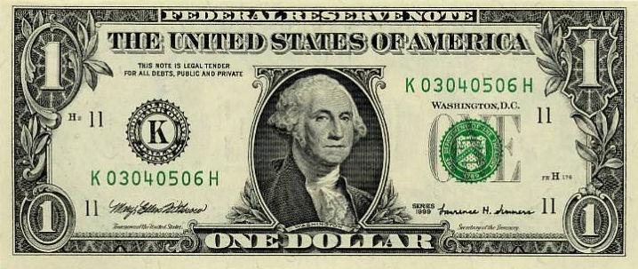

Source 2: 2014 ReadWorks article on George Washington

George Washington is regarded as the Father of Our Country. He guided America and helped it evolve2 into the nation that it is today. Before becoming president, Washington led the Continental Army to victory, winning American independence from Britain during the Revolutionary War. After the war ended, he was a key player at the convention3 that drafted the United States Constitution. Finally, as president, Washington’s leadership solved many problems. It showed people that the Constitution could work to govern a new nation.
America was a very different place back in Washington’s time. The nation was small and weak. There were only 11 states in the U.S. when Washington took office. When he left after two terms there were 16. The country only stretched as far as the Mississippi River. Most people farmed and struggled to make a living. Many children never went to school. Most adults could not read or write. Communication and transportation were slow and difficult. It took days for Washington to travel the distance covered in a couple of hours by car today.
Most Americans loved Washington for the way he handled hardship. As a general, he lost many battles and suffered greatly. Washington never gave up, even during the bitter winters when he and his troops had barely enough food or supplies to survive. Washington’s officers admired his loyalty and strength so much that they wanted to make him king. Washington refused.
Today, George Washington is honored in many ways. His face adorns America’s dollar bill and its quarter. Both Washington state and our nation’s capital, Washington, D.C., are named after the first president. The bridge that stretches across the Hudson River from New Jersey to New York is named the George Washington Bridge. It is located exactly where Washington crossed the Hudson with his troops to defeat British forces. Perhaps one of Washington’s officers expressed America’s feelings about Washington best: “He was first in war, first in peace, and first in the hearts of his countrymen.”
Source: 3 “Farmer at Mount Vernon” painted by Junius Brutus Stearns
Junius Brutus Stearns is best known for his five part “Washington Series,” 1847-1856, in which he tries to capture George Washington‘s life as farmer at his plantation; citizen at his wedding; soldier at Monongahela; Christian on his deathbed, and statesman at the Founding. This particular painting was completed in 1851 and resides in the Virginia Museum of Fine Arts.

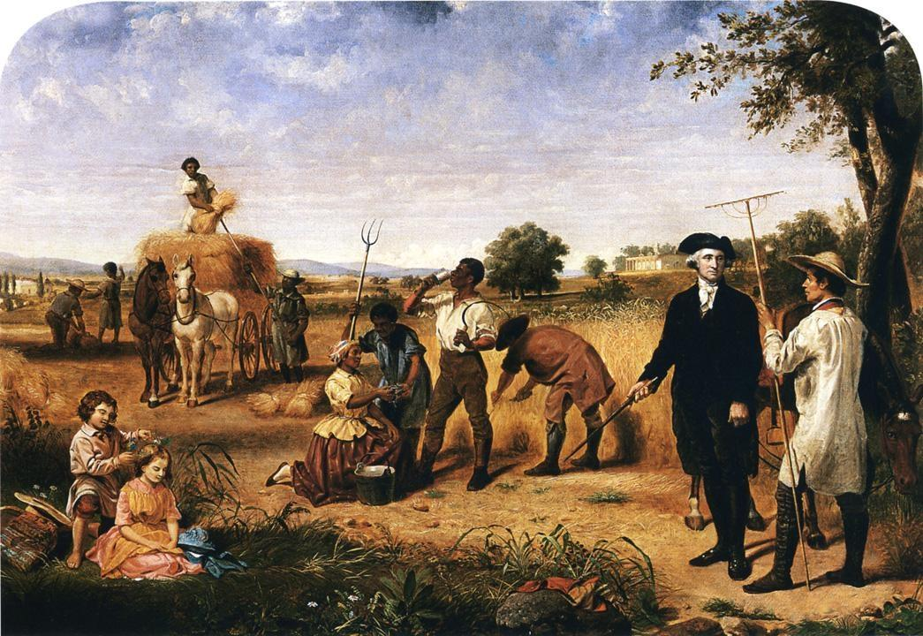

Source 4: A slave family standing next to baskets of recently-picked cotton near Savannah, Georgia in the 1860s.

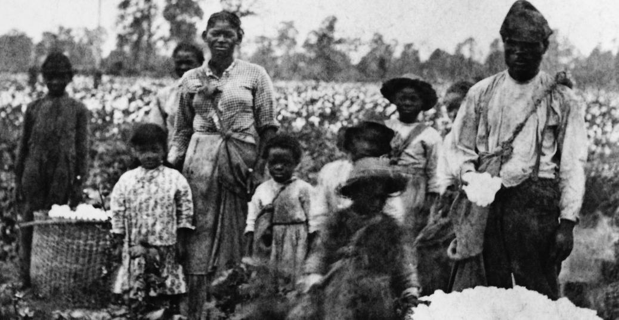

Source 5: Letters from George Washington

Letter from George Washington to John Francis Mercer – September 9, 1786
Mercer served in the Revolutionary War and was a member of Continental Congress. He attended the Constitutional Convention, served in various state political posts (for Virginia and then Maryland), and was Governor of Maryland 1801-1803.
“With respect to the first. I never mean (unless some particular circumstances should compel me to it) to possess another slave by purchase; it being among my first wishes to see some plan adopted by, [the Legislature] which slavery in this Country may be abolished [ended] by slow, sure, & imperceptible [gradual] degrees.”

Source: 6 Three-minute lecture from conservative historian Burt Folsom (Hillsdale College) on George Washington’s stance and actions on the issue of slavery. Filmed on June 15, 2011. https://www.youtube.com/watch?v=KAU-0IGiPq4

Source 7: Letter from George Washington to his personal secretary Tobias Lear. Within this letter, he talks about a plan to get around the Pennsylvania state law that frees any slave that has been in the state for 6 consecutive months.

[Letter below is paraphrased) Actual Letter: http://founders.archives.gov/documents/Washington/05-08-02-0062

April 12, 1791

Mr. Lear,
I would like to discuss with you the situation regarding my slaves and the Pennsylvania state law known as the Gradual Abolition Act. According to this law, any slave staying six consecutive months in the state of Pennsylvania is supposed to be set free. As you know, I am planning on taking a handful of my slaves with me to Philadelphia [acting capital] and I do not want to lose their services. Besides, I doubt that complete freedom would do them much good, but there will be a small amount of citizens in Philadelphia that might try and entice them to run away to seek emancipation.
In order to get around this law, I think I have devised a successful plan. I will have my wife Martha Washington transport slaves back and forth between Virginia and Philadelphia before any of my slaves have six consecutive months in Pennsylvania. Again, I think this can work and at the same time avoid public scrutiny.
Please keep this plan just between you, me, and Ms. Washington.

Sincerely,
George Washington

Source 8: George Washington left instructions in his will for the emancipation of his slaves upon the death of his wife.

Source: Mount Vernon National Historic Site Webpage / http://www.mountvernon.org/george-washington/slavery/ten-facts-about-washington-slavery/

Washington wrote his will several months before his death in December 1799. In the document, Washington left directions for the eventual emancipation [freedom] of his slaves after the passing of Martha Washington. Of the 318 slaves at Mount Vernon in 1799, 123 of the individuals were owned by George Washington and were eligible to be freed as per the terms of the will.
However, these conditions did not apply to all slaves at Mount Vernon. By law, neither George nor Martha Washington could free the Custis dower slaves [slave given to them in a will]. Upon Martha Washington’s death in 1802, these individuals became property once again of the Custis estate, and were divided among the grandchildren. By 1799, 153 slaves at Mount Vernon were part of this dower property [and not eligible for the freedom granted in Washington’s will].

Primary Source Analysis Sheet
Source or Text | When was this source created? What was the creator of this source trying to communicate? | What information does this source provide? | Does this source make George Washington look moral or immoral on the issue of slavery?
Source 1:
George Washington on the $1.00 Dollar Bill

Source 2:
ReadWorks article on George Washington
Source 3:
“Farmer at Mount Vernon” Painting

Source 4:
Image of slaves in field

Source or Text | What do you see or what did you learn? | What do you think? | Does this source make George Washington look moral or immoral on the issue of slavery?
Source 5
Letter from George Washington to John Francis Mercer

Source 6
Three-minute lecture from conservative historian Burt Folsom

Source 7:
Letter from George Washington to his personal secretary Tobias Lear

Source 8:
Washington’s Will

