Source 1: - 1961 – Library of Congress

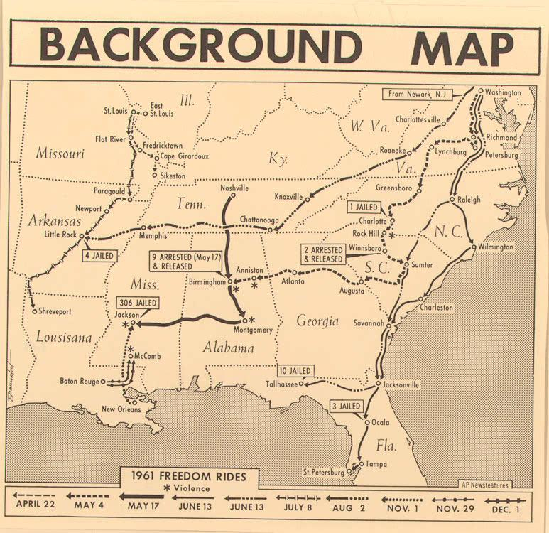
Source 2: Video Clip: In this video segment adapted from American Experience: "Freedom Riders," watch newsreel footage, archival photos, and interviews to explore how Freedom Riders made efforts to end the segregation of African Americans in the Southern United States.
http://www.pbslearningmedia.org/resource/fr11.soc.civil.tactics.frgoals/freedom-riders-freedom-riders-challenge-segregation/

Source 3: Letter written by a father to his son John Dolan. Dolan was a student at the University of California at Berkeley and was involved in the Freedom Rides.
Source: John Dolan, August 2006. Also online at: http://www.freedomridersfoundation.com/photos.articles.and.artifacts.html

John,
It is now 1:30 a.m., but I have been unable to sleep so will kill the time by writing you.
Upon my return home this evening I found your note, together with your drums and other items. I will put your things in the front room and take good care of them for you in the hope that someday your sanity will return.

Your group has received excellent publicity in all bay area newspapers, so any attempt to keep this episode quiet is utterly impossible. The men in the band were all studiously polite to me today, but I learned that nearly all of them had read the account in one paper or another.

It seems incredible that a man with a brilliant mind and all the opportunities that you have had should choose to pursue such a ridiculous course. One of the men in the band who is a student at Cal told Bob Hanson that you had the reputation of being "a crazy mixed-up kid." I wonder if psychiatric help would be of any value, and I write this in all seriousness. I wish you would give the matter serious though.

If I had any religious convictions I could pray, but without faith of any kind in the supernatural I can only hope, and at present it doesn't seem that hope is of any great value.

In the years ahead your actions will prove a severe handicap in many fields, particularly in any government positions and also in teaching if you decide to make that your career.
In the past three years I have tried every system that I could think of. Arguments, threats, cajolery, humor and bribery with no effect whatsoever. Presumably as a parent I have been a miserable failure.
When you first advised me of your decision, I characteristically blew my top, and was quite bitter. This feeling is now modified into one of deep disappointment and an aching void.

I should type this, but I just do not have the ambition. Hope you will be able to decipher the major portion of it.

Sorry I can't wish you "Bon Voyage," but with all my failings, no one has ever called me a hypocrite.

Your Father,

Dr. J.W. Dolan

Source 4: Image from Freedom Riders Bus - Anniston, AL / May 14, 1961
Birmingham Public Library, Freedom Bus. May 14, 1961.
Retrieved from: http://biology.clc.uc.edu/fankhauser/Society/freedom_rides/Freedom_Ride_DBF.htm (Dr. David Fankhauser)

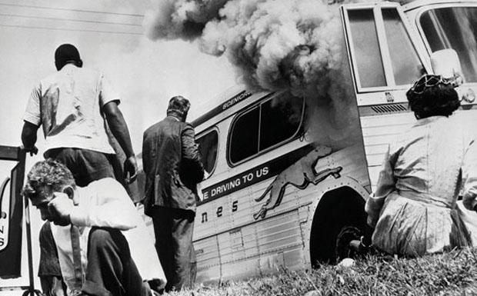

Source 5: Interview with Hank Thomas – an African American Freedom Rider participant

October 20, 2014 Interview – WCYB Link; http://www.wcyb.com/news/freedom-rider-remembers-civil-rights-movement/29247076

It's been 50 years since President Lyndon B. Johnson signed the Civil Rights Act into law. One of the people who played a role in making that happen spoke at ETSU on Monday. When Hank Thomas stood up to speak, he started singing songs of freedom.

"Things are wonderful in this country now that I can truly say 'My Country, 'Tis Of Thee' and 'God Bless America'," he said. In May of 1961, however, there was a much different tone."I may be in this university but I certainly would not be welcomed," said Thomas. "The law of the land as far as the South was concerned, every time I got aboard a bus, whether a municipal bus or an interstate bus, I was supposed to go to the back of the bus."
Thomas decided to board a bus in Washington D.C. that was headed to Louisiana to fight for desegregation. He was only 19-years-old and a sophomore at Howard University. Thomas became one of seven "Freedom Riders" on board that bus.
When the bus got to the Alabama border, a mob was waiting. Thomas told us the crowd disabled the bus by slashing the tires. "The bus driver could not drive the bus any further and all the windows of the bus were broken out," said Thomas. "The bus driver got off the bus and really ran for his life but we were able to lock the door so they could not get in."
The mob decided to set the bus on fire. "When they set it afire, they held the door so we could not get out," said Thomas. "The bus is burning, we're all trying to get out of the front door of the bus. Luckily for us, as we were about to be overcome by the toxic smoke inside the bus, the fire reached the fuel tank."
He told us the tank blew out and the men holding the doors fled, allowing Thomas and the others to get off the bus. "The mob followed us to the hospital and threatened to burn the hospital down if the personnel there did not set us out," said Thomas. "That's how bloodthirsty that mob was."
Despite the threat to his life, Thomas re-joined a new bus continuing the ride to Louisiana. He was arrested when they got to their destination and was sent to prison. The Freedom Riders were released after 30 days following a Supreme Court decision. Thomas said he remained active in the civil rights movement and ended up being arrested 22 times.
Now decades later, he is recognizing all that they were able to achieve. "The country today is light years away in terms of changes to what it was yesterday," said Thomas. After the Freedom Rides, Thomas went on to serve in Vietnam from 1965 to 1966, where he earned a Purple Heart.
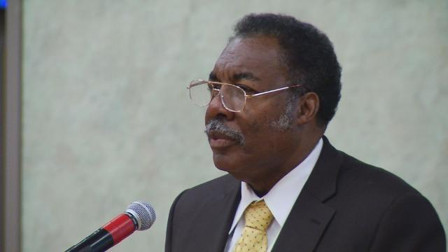
Source 6: White Freedom Rider Jim Peck briefly interviews former United States President Harry S. Truman From: The Crisis – June/July 1961

…I decided to approach former President Harry Truman during his early morning walk on June 5 to take issue with a statement he had made on his walk a couple of days earlier that "Northerners who go south as Freedom Riders are meddlesome intruders (who) ... should stay at home and attend to their own business."
When I introduced myself as "a Freedom Rider from the north," Truman interrupted with: "Better stay up north, then." I went on to express the view that "ending racial segregation in the U.S. is the business of all conscientious citizens, north, south, east and west." I added that: "Racial segregation- more than any other single factor-besmirches the U.S. in the world's eyes and aids the Communist propaganda machine."
Truman then interrupted again with: "That's just what you're doing: helping the Communists!" I tried to get in a final sentence, but Truman cut it short with: "I'm not going to say any more." However, I continued to walk with him- along with eight reporters- and after they had asked him some questions on other matters, I addressed him again to express regret that he would not discuss the CORE Freedom Rides in a more serious manner in view of the fact that many prominent Americans view them favorably. "Just trouble-making," was his final comment on the Freedom Rides.
Reporters told me it was the first time that Truman on his walks had been confronted with a key social issue of this kind. The confrontation, which received considerable publicity, was worthwhile, I feel. Truman's unintelligent responses and his rudeness of attitude certainly lent no dignity to his position. The nature of his remarks recalled to me his comment a year ago on the sit-ins. Asked his opinion of them, he stated that if he had a business and an unwelcome customer refused to leave the premises, he would kick them out. Shortly thereafter, he tried unsuccessfully to smear the sit-in movement as Communist.

