Documents: Mandate of Heaven
The Classic of Odes (also known as the “Book of Songs”) was compiled around 600 BCE from an oral tradition going back perhaps as long as four centuries earlier. The Odes include court poetry and popular songs and poems. The Ode entitled “King Wen” celebrates the founding king of the Zhou dynasty and the Zhou’s subsequent conquest of the territory of the Shang dynasty in about 1045/40 BCE. The poem refers to a Zhou deity (tian, translated here as “Heaven”) and a Shang deity (di or Shangdi, translated here as “God”). Selection from the Classic of Odes: King Wen (Ode 235)

King Wen is on high,
Oh, he shines in Heaven!
Zhou is an old people,
but its Mandate is new.
The leaders of Zhou became illustrious,
was not God’s Mandate timely given?
King Wen ascends and descends
on the left and right of God.

August was King Wen,
continuously bright and reverent.
Great, indeed, was the Mandate of Heaven.
There were Shang’s grandsons and sons,
Shang’s grandsons and sons.
Was their number not a hundred thousand?

But the High God gave his Mandate,
and they bowed down to Zhou.
The Mandate is not easy to keep;
may it not end in your persons.
Display and make bright your good fame,
and consider what Yin had received from Heaven.
The doings of high Heaven have no sound, no smell.
Make King Wen your pattern,
and all the states will trust in you.

1. _______ This passage’s focus on the Mandate
of Heaven set a precedent for over 2,000 years
of
a. Democracy in China
b. Communism in China
c. Dynastic Cycle in China
d. Confucianism in China

2. _______ According to this passage, what did
the people of the Shang dynasty do?
a. Bow to the Zhou
b. Get the Mandate
c. Fight a civil war
d. Refocus on filial piety and Confucianism

Documents: Filial Piety
“The Classic of Filiality” (Xiaojing, also translated as “Classic of Filial Piety”) was written during the Former or Western Han dynasty (206 BCE-8 CE). Although it is not a classic in the sense of being a document dating from the Zhou period, “The Classic of Filiality” has been a popular and highly respected text throughout East Asia up through the twentieth century. The text is cast in the form of a conversation between Confucius and Zengzi, one of his students. In the text, “Confucius” explains the concept of filiality, or filial piety, and its central importance in family, community, and spiritual and political life. From Sources of Chinese Tradition, compiled by
Wm. Theodore de Bary and Irene Bloom, 2nd ed., vol. 1 (New York: Columbia University Press, 1999), 326-329. © 1999 Columbia University Press. Reproduced with the permission of the publisher. A

Our body, skin, and hair are all received from our parents; we dare not injure them. This is the first
priority in filial duty. To establish oneself in the world and practice the Way; to uphold one’s
good name for posterity and give glory to one’s father and mother -- this is the completion of filial
duty. Thus filiality begins with service to parents, continues in service to the ruler, and ends with
establishing oneself in the world [and becoming an exemplary person]...
As one serves one’s father, one serves one’s mother, drawing on the same love. As one serves one’s
father, one serves one’s prince, drawing on the same reverence. The mother draws upon one’s love,
the prince on one’s reverence. Therefore, if one serves one’s prince with the filiality one shows to
one’s father, it becomes the virtue of fidelity (loyalty). If one serves one’s superiors with brotherly
submission it becomes the virtue of obedience. Never failing in fidelity and obedience, this is
how one serves superiors. Thus one may preserve one’s rank and office and continue one’s family
sacrifices. This is the filiality of the scholar-official.

1. __________ According to this explanation of filial piety, people should do what to honor their parents?
a. Serve their country in the military
b. Live a life of personal honor and accomplishment
c. Financially support their family’s elders
d. Women must be subordinate to the men

2. __________ Filial piety is important beyond the individual family because it
a. Models and applies to a subjects respect and treatment of the ruler
b. Maintained the caste system
c. Established trade networks
d. Challenged the dominance of Buddhism

3. __________ Filial Piety, along with Confucianism, was a major way the Chinese provided
a. Spiritual meaning
b. Cultural and artistic expression
c. Economic opportunity
d. Stability and order

Documents: Spread of Islam
During the conquest period the granting of gifts, which had been practiced by Muhammad, became more
regularized and eventually institutionalized. In the first place, there was established a system of stipends or
direct salary payments ('ata-') to warriors serving in the Islamic armies. . . . Tribesmen in the Islamic armies
who rebelled against the regime now did so at the cost of losing the stipends that the regime provided.
Similarly, stipends were granted to some Persian or Aramean nobles (dihqans) who cooperated with the
Muslims in Iraq. In most cases, it appears that these individuals were required to embrace Islam in order to
receive their stipend.
Fred Donner historian at University of Chicago, 1981

1. ______ According to Professor Donner, what was 1 major reason that many converted to Islam in the
early days of the religion and caliphate?
a. Military conquest
b. Financial incentive
c. Spiritual conversion
d. Trade rights

2. ______ What does it mean when it states that the ...”granting of gifted, which had been practiced by Muhammad, became more regularized and eventually institutionalized.”?
a. That only the military provided financial incentive for conversion
b. That financial incentives were distributed by individuals and were given as gifts
c. That the governments have formal programs in place to incentivize conversion
d. Only Muhammad could determine who got the incentives

Documents: Umayyad Empire

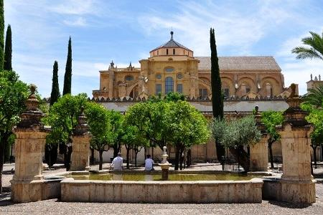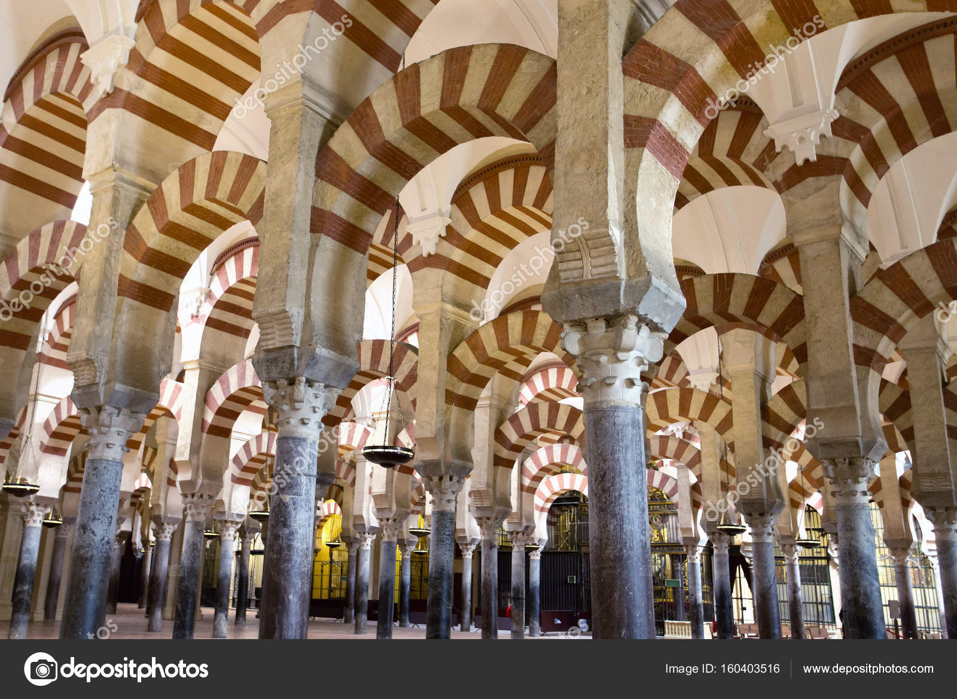

Grand Mosque of Cordoba, built 784 on site of previous Christian & Muslim shared house of worship. 1236 it
returned to Christian roots with the Reconquista, Spanish take over of the Muslim territory on Iberian peninsula.

‘Cordoba is made up of fine continuous cities, each surrounded by walls that divide it from the rest, and
possessing enough markets, hostelries, baths, and buildings for the different professions. From east to west the city covers a distance of five kilometers (three miles). From the Gate of the Jews in the north to the Gate of the Bridge in the south is a little over one and a half kilometers (just under one mile).’
Al-Idraisi (1100-1165) the great medieval geographer

1. ______ Using the images and primary text on Cordoba, what could you determine about the city of Cordoba?
a. It was very small and an outpost of the Muslim Empire
b. It was controlled by a Muslim empire and government but it was not impacted by Muslim
religion and culture
c. It was a large, cosmopolitan city
d. It did not need to prepare for military threats

2. ______ Why would the city have gates and walls?
a. For defense
b. To promote trade
c. To keep different ethnic and religious groups separate
d. To maintain the caste system

3. ______ The architecture and design of the Mosque is a great example of
a. Scientific and technological superiority of the Umayyad
b. Blending of cultures in southern Spain
c. The complete change in Spain from Christian to Muslim culture
d. The maintenance of European and Christian culture, with no influence of Islamic culture

Documents: Mansa Musa’s Pilgrimage

From the beginning of my coming to stay in Egypt I heard talk of the arrival of this sultan Musa on his Pilgrimage and found the people of Cairo eager to tell what they had seen of the Africans’ extravagant spending. I asked the emir Abu and he told me of the opulence, manly virtues, and piety of his sultan. ... I tried to persuade him to go up to the Citadel to meet the sultan of Cairo, but he refused persistently saying: ‘I came for the Pilgrimage and nothing else. I do not wish to mix anything else with my Pilgrimage.’” Mansa Musa
flooded Cairo with his gifts. He left no emir or holder of a royal office without the gift of a load of gold. The people of Cairo made incalculable profits out of him and his caravan in buying and selling and giving and taking. They traded away gold until they depressed its value in Egypt and caused its price to fall. This has been the state of affairs for about twelve years until this day by reason of the large amount of gold which they brought into Egypt and spent there.
Al-Umari, Arab historian from Damascus who visited Cairo a few years after Mansa Musa’s visit

1. ______ What most impressed the people of Cairo about Mansa Musa?
a. His religious beliefs
b. The Camels and elephants
c. His wealth
d. His physical presence

2. ______ Why was Mansa Musa in Cairo?
a. Trade
b. Pilgrimage
c. Military invasion
d. Scientific exploration

3. ______ What was the lasting impact of Mansa Musa’s visit to Cairo?
a. Inflation
b. Mass conversions to Islam
c. 100+ years as Mali colony
d. New artistic movement inspired by African art

Documents: Justinian

In our own age there has been born the Emperor Justinian, who, taking over the State when it was harassed by
disorder, has not only made it greater in extent, but also much more illustrious, by expelling from it those
barbarians who had from of old pressed hard upon it.. But this Sovereign does not lack the skill to produce
completely transformed states — witness the way he has already added to the Roman domain many states which in his own times had belonged to others, and has created countless cities which did not exist before...Moreover,finding the laws obscure because they had become far more numerous than they should be, and in obvious confusion because they disagreed with each other, he preserved them by cleansing them of the mass of their verbal trickery, and by controlling their discrepancies with the greatest firmness; ... he wedded the whole State to a life of prosperity. Furthermore, he strengthened the Roman domain, which everywhere lay exposed to the barbarians, by a multitude of soldiers, and by constructing strongholds he built a wall along all its remote frontiers. The writings of Procopius are the primary source of information for the rule of the Roman emperor Justinian. Procopius was the author of a history in eight books of the wars fought by Justinian I and a panegyric ( speech like a eulogy, praise) on Justinian's public works throughout the empire.

1. _________ Which of the following is not a listed accomplishment of Justinian?
a. Unifying the Christian Church
b. Codifying the laws
c. Establishing cities
d. Expanded defenses against invaders

Documents: Fealty Oaths

When a Freeman shall do Homage to his Lord of whom he holds in Chief, he shall hold his hands together between the hands of his Lord, and shall say thus: "I become your Man from this day forth, for life, for member, and for worldly honor, and shall [owe] you Faith for the Lands that I hold of you; saving the Faith that I owe unto our Lord the King, and to [mine other Lords.] When a Freeman shall do fealty to his Lord, he shall hold his Right Hand upon a book, and shall say thus "Hear you my Lord R. that I, P. shall be to you both faithful and true, and shall owe my Fidelity unto you, for the Land that I hold of you, and lawfully shall do such Customs and Services, as my Duty is to you, at the times assigned. So help me God and all his Saints.
From: A. Luders, ed., The Statutes of the Realm: Printed by Command of His Majesty King George the Third, in Pursuance of an Address of the House of Commons of Great Britain, From Original Records and Authentic
Manuscripts, 11 vols., (London: Record Commission, 1810- 1828), Vol. I, pp. 227-228.

1. _________ When a Freeman gives his oath of loyalty and service, what does he get in return?
a. Use of land
b. Economic stability
c. Chance to be a knight
d. Representation in Parliament

2. _________ By reading both oaths, it is clear that
a. These oaths were only among the most elite in society
b. The Church would oversee and conduct all contracts and oaths
c. A freeman could have loyalty and ties to more than one lord
d. Oaths were purely financial arrangement

3. _________ The oath makes clear that there are limitations on the loyalty and service based on
a. A set number of weeks per year in service
b. The size of a family and fertility of the land
c. Higher loyalty to God and king
d. Strict social class divisions

Documents: Guilds

The Citizens of Brunswick: Grant of a Goldsmiths’ Gild, 1231

The advocate, consuls, and burgesses in Brunswick to all our successors....

We, the burgesses[an inhabitant of a town or borough with full rights of citizenship] of the ancient city, of our free will, and with common consent, have given the right to form a craft to those goldsmiths who wish to work in the ancient city; and we have granted that they shall possess the right forever that no one may presume against their will, and without permission, to put himself to work at their craft, except he previously pay to them at their wish the fee which they have decreed....

1. _____ What must someone do to legally become a goldsmith in Brunswick, England?
a. Pass a certification exam and get a license
b. Petition the king for permission
c. Pay a fee and get permission from the local guild
d. Get written permission from the lord of the manor

2. _____ The issues addressed by this document and similar organizations are met today in various ways by all of the following EXCEPT
a. Government regulations & licensing programs
b. Unions
c. Economic division of the Catholic Church
d. Interest Groups

Southampton Guild Organization, 14th Century A common provision of early town charters was the privilege of possessing a "gild merchant" and dates from the 14th century.

1. In the first place, there shall be elected from the gild merchant, and established, an alderman, a steward, a chaplain, four skevins, and an usher. And it is to be known that whosoever shall be alderman shall receive from each one entering into the gild fourpence; the steward, twopence; the chaplain, twopence; and the usher, one penny. And the gild shall meet twice a year: that is to say, on the Sunday next after St. John the Baptist's day, and on the Sunday next after St. Mary's day.

7. And when a gildsman dies, all those who are of the gild and are in the city shall attend the service of the dead, and the gildsmen shall bear the body and bring it to the place of burial. And whoever will not do this shall pay according to his oath, two pence, to be given to the poor. And those of the ward where the dead man shall be ought to find a man to watch over the body the night that the dead shall lie in his house. And so long as the service of the dead shall last, that is to say the vigil and the mass, there ought to burn four candles of the gild, each candle of two pounds weight or more, until the body is buried. And these four candles shall remain in the
keeping of the steward of the gild.

19. And no one of the city of Southampton shall buy anything to sell again in the same city, unless he is of the gild merchant or of the franchise. And if anyone shall do so and is convicted of it, all which he has so bought shall be forfeited to the king; and no one shall be quit of custom unless he proves that he is in the gild or in the franchise, and this from year to year.

1. _____ One main conclusion a historian could draw from Rule #1 is that
a. The fact that this guild had paid leadership positions implies a formal structure and complex organization
b. It was REALLY expensive to be par to fa guild
c. The chaplain is clearly the most important position and this reflects the significant role of the Church in guilds
d. The fact that the organization met on Sundays is evidence the Church and Sabbath were not important influences in the guild

2. _____ One main conclusion a historian could draw from Rule #7 is that
a. Guild membership is passed down within the family after a death of a member
b. Guild members had little obligation to the guild beyond fees and quality inspections
c. The connections of the guild were strictly limited to economic interactions and agreements
d. The connections of the guild went beyond purely academic and were social as well

3. _____ Rule #19 describes a component of guilds that often have people describing them as functioning as
a. A democracy c. A monopoly
b. A mercantile economy d. Feudalism

Documents: Monastic Donations

From the tenth century there were successive waves of monastic reform - Cluniac, Cistercian, Mendicant and so forth. The founding of the abbey of Cluny in 910 marked the onset of this period. As well as providing some basis for Cluny's later power and independence, the charter is an example of why donations were made to the Church.
To all right thinkers it is clear that the providence of God has so provided for certain rich men that, by means of their transitory [not permanent] possessions, if they use them well, they may be able to merit everlasting rewards. As to which thing, indeed, the divine word, showing it to be possible and altogether advising it, says: “The riches of a man are the redemption of his soul.” (Prov. Xiii.) I, William, count and duke by the grace of God, diligently pondering this, and desiring to provide for my own safety while I am still able, have considered it advisable – nay, most necessary, that from the temporal [worldly as opposed to spiritual] goods which have been conferred upon me I should give some little portion for the gain of my soul. I do this indeed in order that I who have thus increased in wealth may not, per chance, at the last be accused of have having spent all in caring for my body, but rather may rejoice, when fate at last shall snatch all things away, in having reserved something for myself. Which end, indeed, seems attainable by no more suitable means than that, following the precept of Christ "I will make his poor my friends" (Luke xvi. 9), and making the act not a temporary but a lasting one, I should support at my own expense a congregation of monks. ... I hand over from my own rule to the holy apostles, Peter, namely, and Paul, the possessions over which I hold sway, the town of Cluny, namely, with the court and demesne [land attached to manor] manor, and the church in honour of St. Mary the mother of God and of St. Peter the prince of the apostles, together with all the things pertaining to it, the vills, indeed, the chapels, the serfs of both sexes, the vines, the fields, the meadows, the woods, the waters and their outlets, the mills, the incomes and revenues, what is cultivated and what is not, all in their entirety... I give, moreover, all these things to the aforesaid apostles - I William and my wife Ingelberga - first for the love of God; then for the soul. Of my lord king Odo, or my father and mother; for myself and my wife - for the salvation, namely, of our souls and bodies...; for the souls of our brothers and sisters and nephews, and of all our relatives of both sexes; for our faithful ones who adhere to our service; for the advancement, also, and integrity of the catholic religion...I give these things, moreover, with this understanding, that in Cluny a regular monastery shall be constructed in honour of the holy apostles Peter and Paul, and that there the monks shall
congregate and live according to the rule of St. Benedict, and that they shall possess, hold, have and order these same things unto all time.... But the validity of this deed of gift, endowed with all authority, shall always remain inviolate and unshaken, together with the stipulation subjoined. Done publicly in the city of Bourges. I William, commanded this to made and drawn up and confirmed it with my own hand.
(Signed by Ingelberga and a number of bishops and nobles)
from the edition of A. Bruel in "Recueil des Chartes de L'Abbaye de Cluny". Paris, 1876, trans in Ernest F. Henderson, Select Historical Documents of the Middle Ages, (London: George Bell and Sons, 1910),

1. _______ What does Lord William want done with the donation of his manor and wealth?
a. A museum dedicated to the preservation of Christian texts and relics
b. A memorial honoring him and his family
c. A cathedral and new cathedral school
d. A Benedictine monastery

2. _______ What does Lord William hope to gain through the donation of his wealth?
a. Spiritual gains in the afterlife for himself and his family
b. Positions of power within the Church for his sons
c. Financial benefit from the increased travel and trade to his land
d. The support of the king

3. _______ A historian studying this document could argue that the nobility
a. Made many donations to the Church but mostly gave gold and kept their manors
b. Had less concern over their souls and spirituality than the common men
c. Had sincere concern over spirituality and the afterlife
d. Worked hand in hand with the Church for power and wealth

Documents: Malleus Maleficarum

Malleus Maleficarum: How to Torture a Witch Jacob Sprenger and Heinrich Kramer (1486)

The method of beginning an examination by torture is as follows: First, the jailers prepare the implements of torture, then they strip the prisoner (if it be a woman, she has already been stripped by other women, upright and of good report... And when the implements of torture have been prepared, the judge, both in person and through other good men zealous in the faith, tries to persuade the prisoner to confess the truth freely; but, if he will not confess, he bids attendants make the prisoner fast to the strappado or some other implement of torture... Then, at the prayer of some of those present, the prisoner is loosed again and is taken aside and once more persuaded to confess, being led to believe that he will in that case not be put to death.

Here it may be asked whether the judge, in the case of a prisoner much defamed, convicted both by witnesses and by proofs, nothing being lacking but his own confession, can properly lead him to hope that his life will be spared–when, even if he confess his crime, he will be punished with death. It must be answered that opinions vary. Some hold that even a witch of very ill repute, against whom the evidence justifies violent suspicion, and who, as a ringleader of the witches, is accounted very dangerous, may be assured her life, and condemned instead to perpetual imprisonment on bread and water, in case she will give sure and convincing testimony against other witches; .. Others hold, as to this point, that for a time the promise made to the witch sentenced to imprisonment is to be kept, but that after a time she should be burned. A third view is, that the judge may safely promise witches to spare their lives, if only he will later excuse himself from pronouncing the sentence and will let another do this in his place. ...

1. _______ What are the judges hoping to gain from torturing the accused?
a. Confession for themselves and identifying others
b. Explanation of the methods and techniques of the devil
c. Performance of spells for the judges benefit
d. Evidence for the jury

2. _______ Along with “proofs”, what else was used to convinced judges of a “witches” guilt?
a. DNA evidence
b. Physical features identified as witch like a long nose and warts
c. Witness testimony
d. The word of the king or local ruler

3. _______ In addition to torture, judges were encouraged to use ____ to encourage confession.
a. Threats to their family & friends
b. Deception
c. Sermons & prayer
d. Magic

