Document F: The Rise of Universities
Beginning in the early 11th century, universities were founded throughout Europe. Below is a list of the 10 oldest European universities in Europe. Attendance at these universities was limited to a small percentage of the population. However, universities introduced a new system of education, eventually replacing the monastery and church schools.
Year (approximately)
Source: “List of Oldest Universities in Continuous Operation,” Wikipedia. http://en.wikipedia.org/wiki/List_of_oldest_universities_in_continuous_operation
Current location Name
1088 Bologna, Italy University of Bologna
1150 Paris, France University of Paris
1167 (1254) Oxford, UK University of Oxford
1209 (1231) Cambridge, UK University of Cambridge
1218 Salamanca, Spain University of Salamanca
1222 Padua, Italy University of Padua
1224 Naples, Italy University of Naples Federico II
1229 Toulouse, France University of Toulouse
1240 Siena, Italy University of Siena
1241 Valladolid, Spain University of Valladolid
Source: View of Notre Dame from the front, http://commons.wikimedia.org/wiki/File:Facade-notre- dame-paris-ciel-bleu.JPG

Document G:
Gothic Cathedrals Cathédrale Notre Dame de Paris, or Our Lady of Paris Cathedral, is one of the most famous gothic cathedrals in Europe. The gothic style of architecture was common in the late Middle Ages. Common features of gothic cathedrals included architectural innovations, including: large columns, high celings with ribbed vaults, flying buttresses, and large stained glass windows. Gothic cathedrals were usually the tallest and largest buildings in a city. Notre Dame is 420 ft. long, 226 ft. wide, and its two towers are 226 ft. high. Construction on the cathedral began in 1163 and was completed in 1345.
Source: View of Notre Dame from the River Seine,
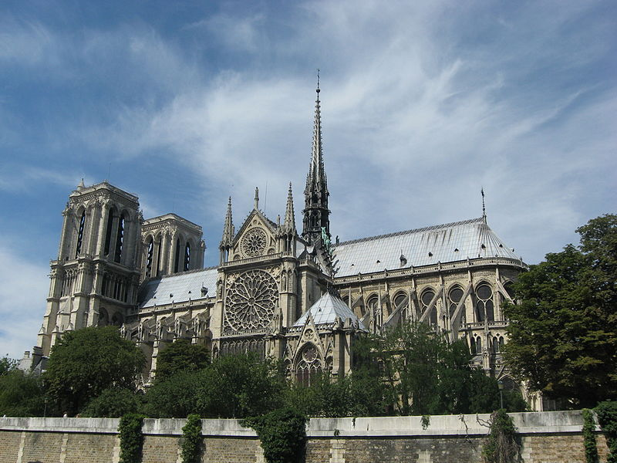

Flying buttress
Source: View of Notre Dame’s South Rose Window, http://commons.wikimedia.org/wiki/File:GothicRayonnantRose003. jpg
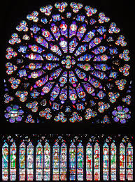
Guiding Questions

Round Three
Document F and G: European Universities and Notre Dame Cathedral
1. In what century were the oldest European universities founded and the
construction of Notre Dame Cathedral begun?

2. Does the founding of universities and construction of Notre Dame conflict with or
match the textbook accounts of the Middle Ages? Explain.

3. Is Wikipedia a reliable source? Why or why not?

Claims Organizer Was the time period between 400 AD and 1400 AD a “Dark Age” for Europe? Was this a time of cultural decay and decline?
Third Claim
List 4-5 pieces of evidence from these documents that support your claim
1)
2)
3)
4)
5)

