Cleopatra Timeline
Cleopatra was a queen of Egypt, but she was not Egyptian. She was the last of the Macedonian Greek dynasty that ruled Egypt from the time of Alexander the Great’s death in 323 BCE to about 30 BCE. She was a talented and resourceful individual of great charm but ruthless when she thought she had to be.
69 BCE: Cleopatra is born in Egypt. Cleopatra is a descendant of Ptolemy, who was put in charge of Egypt in 323 BCE, after Alexander the Great conquered it.
47 BCE: Cleopatra becomes Caesar’s mistress, and Caesar uses his army to defeat and destroy Cleopatra’s rival for power in Egypt, her brother/husband Ptolemy XIII. Caesar establishes Cleopatra as ruler of Egypt. Caesar returns to Rome.
46 BCE: Cleopatra gives birth to Caesar’s child, a boy who is named Ptolemy Caesar and called Caesarion.
44 BCE: Caesar achieves total victory over the armies of his rivals and seizes tremendous political control in Rome. His enemies assassinate him. Civil war breaks out between those who support Caesar and those who support his enemies.
42 BCE: Mark Antony defeats Caesar’s enemies and emerges as the leader. He becomes involved with Cleopatra and joins her in Alexandria.
40 BCE: Mark Antony leaves Alexandria to go to Italy to sign a treaty with Octavian, Julius Caesar’s adopted son. Octavian is Mark Antony’s major rival for the command of the Romans. An agreement is reached, and part of the arrangement is that Mark Antony marry the sister of Octavian, Octavia.
Cleopatra bears Antony’s children. They were twins, a boy named Alexander Helios and a girl named Cleopatra Selene.
37 BCE: Mark Antony decides that he and Octavian can never work together. He marries Cleopatra. Not only was this illegal under Roman law, it was a betrayal of
Octavia, his legal wife and the sister of Octavian. This makes a war between Octavian and Mark Antony inevitable.
34 BCE: Mark Antony defeats the Parthians and celebrates in Alexandria. The celebration of a triumph in Alexandria was a serious offense to Romans. Such celebrations were only supposed to take place in Rome, the capital of the empire.
Back in Rome, Octavian obtains Mark Antony’s will and publicizes its contents. Mark Antony’s will made provision for turning parts of the Roman Empire over to Cleopatra. Worse yet Mark Antony’s will called for moving the Empire’s capital from Rome to Alexandria. The Roman citizens are outraged.
32-­‐31 BCE: Mark Antony and Cleopatra live together in Greece.
31 BCE: Mark Antony’s forces alone are not strong enough to match those of Octavian. His army surrenders to Octavian.
Cleopatra has a message sent to Mark Antony saying that she had killed herself. Upon hearing that his loved one was dead he falls upon his sword.
Document A
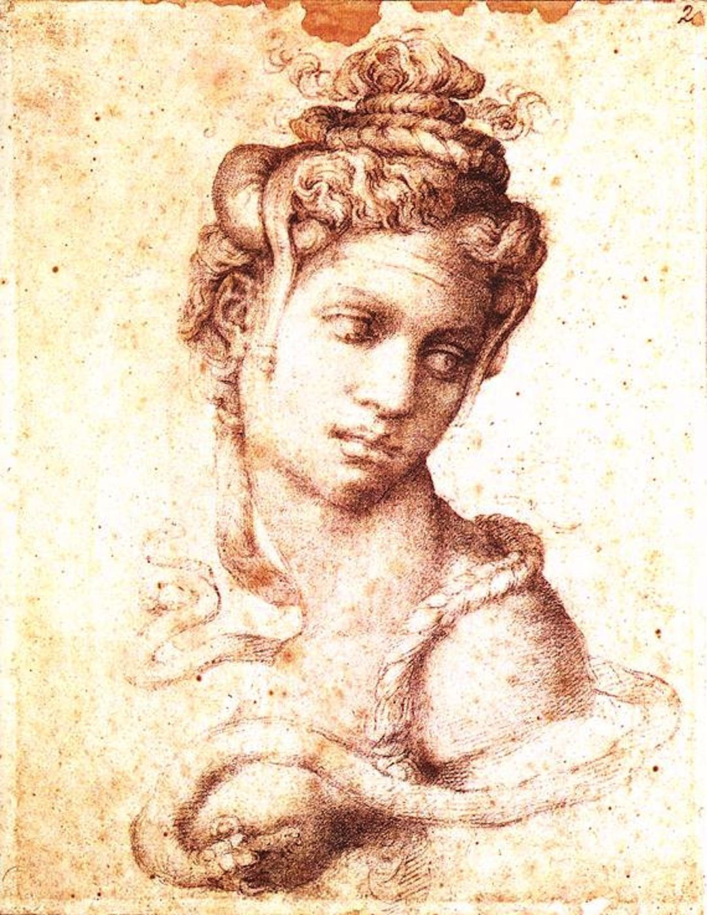
Cleopatra by Michelangelo, 1534

Document B: Shakespeare Play, Antony and Cleopatra

CLEOPATRA
To an asp, which she applies to her breast
With thy sharp teeth this knot intrinsicate Of life at once untie: poor venomous fool Be angry, and dispatch. O, couldst thou speak, That I might hear thee call great Caesar ass Unpolicied!

CHARMIAN
O eastern star!

CLEOPATRA
Peace, peace! Dost thou not see my baby at my breast, That sucks the nurse asleep?

CHARMIAN
O, break! O, break!

CLEOPATRA
As sweet as balm, as soft as air, as gentle,-- O Antony!—Nay, I will take thee too.
Applying another asp to her arm
What should I stay—
Dies

Source: Antony and Cleopatra, a tragedy by William Shakespeare, first printed in 1623.

Vocabulary
asp: a small snake

Cleopatra Graphic Organizer Did Cleopatra Die by Snakebite?

Round One
 | Source: Who made this source? When? Is it reliable? Explain. | According to this source, did Cleopatra die by snakebite? Explain.
Doc A

Doc B

Based on Documents A and B, did Cleopatra die by snakebite?

Document C: Plutarch, Life of Antony (Modified)
Plutarch was a Greek historian who lived approximately between 50 CE – 120 CE. He was a wealthy aristocrat who wrote about famous Greeks and Romans. His biographies focused on people’s moral strengths and weaknesses. Here is an excerpt from his biography of Mark Antony.
There came a man from the country carrying a basket; and when the guards asked him what he was bringing there, he opened the basket, took away the leaves, and showed them that the dish inside was full of figs. The guards were amazed at the great size and beauty of the figs. The man smiled and asked them to take some; so they felt no mistrust.
It is said that a snake was brought with those figs and leaves and lay hidden beneath them. When she took away some of the figs and saw it, she held her arm out for the bite. But the truth of the matter no one knows; for it was also said that she carried about poison in a comb hidden in her hair; and yet neither spot nor other sign of poison broke out upon her body.
Some also say that Cleopatra’s arm was seen to have two slight and indistinct punctures; and this Octavian also seems to have believed. An image of Cleopatra herself with the snake clinging to her was carried in his victory parade.
Document D: Cassius Dio (Modified)
Cassius Dio lived approximately between 164 CE and 230 CE. He was a wealthy Greek who was consul twice and also held important governorships. He wrote eighty books on Roman History, and his position is often sympathetic with emperors, though he is sometimes critical of Octavian. Here is an excerpt from his book Roman History.
Octavian, however, feared that she might kill herself. He did not remove any of her servants and asked that they take special care of her, that she might add brilliance to his triumph. But as soon as the others neglected to keep a careful watch, she prepared to die as painlessly as possible. She put on her most beautiful clothing, took in her hands all the symbols of royalty, and so died.
No one knows clearly in what way she perished, for the only marks on her body were slight pricks on the arm. Some say she hid a poisonous snake in a water-jar, or perhaps it hidden in some flowers. Others declare that she had smeared a pin, with which she fastened her hair, with a poison that if came into contact with even a drop of blood would destroy the body very quietly and painlessly. In this or in some very similar way she perished, and her two handmaidens with her. When Octavian heard of Cleopatra’s death, he was astounded, and not only viewed her body but also tried to revive her. But when he could not in any way resuscitate Cleopatra, felt both admiration and pity for her, and was excessively grieved on his own account, as if he had been deprived of all the glory of his victory.
Document E: Scholarly Journal (Modified)
The excerpt below is from an article on Cleopatra’s death published in 2005 in Acta Theologica, a South African journal that publishes articles on religion and theology.
One scholar has argued convincingly that the snakebite theory is unlikely. Various North African snakes could have been used. However, in the case of each of these species the area surrounding the bite is characterized by severe pain, swelling and bleeding. Cleopatra had no significant bite marks. On the other hand, if the snake were a cobra, a small bite could swiftly lead to paralysis and death. However, in order to bring about the speedy deaths of three adults, the cobra would have had to be at least 5 to 6.5 feet in length.
Another scholar thinks the snakebite theory could have originated as a result of popular misunderstanding at the time of Octavian’s victory parade through Rome. An image of Cleopatra was displayed in the procession, wearing the robes of Isis and with the goddess’s traditional armlet (a coiled snake) on her forearm. Roman spectators ignorant of Egyptian religious symbolism might have interpreted this as suggesting that her death had been caused by a snake.
There is also a possibility that Cleopatra and her handmaidens could have died of poison hidden in a hollow hairpin. A very deadly poison, taken first by Cleopatra and then by Charmian and Iras, could then explain how they died so swiftly and without any wounds. In many ways this simpler explanation is more acceptable than the exotic theories concerning snakebite. The Egyptian royal house was probably well-informed about the effects of various poisons. Roman authors claimed that Cleopatra had a superior knowledge of poison and its effect on human victims.
Round Two
 | Source: Who made this source? When? Is it reliable? Explain. | According to this source, did Cleopatra die by snakebite? Explain.
Doc C

Doc D

Doc E

Based on Documents C-E, did Cleopatra die by snakebite?

Questions for discussion:
• Why might we give more weight to Documents C and D than to Documents A and B? (Although all of the documents were written long after Cleopatra’s death, Documents C and D are histories, and therefore aspire to some degree of accuracy.)

• Do you think Cleopatra was killed by a snakebite?

• Why has the snake been such a lasting image surrounding Cleopatra’s death?

• Why else do we learn about Cleopatra from these stories?

• Victors write history. What can we learn about Octavian from these stories?

