Artifact Analysis!
Directions: Examine each artifact and read the archaeologist’s notes below. Then, determine which characteristics of civilization are represented and support your answer.
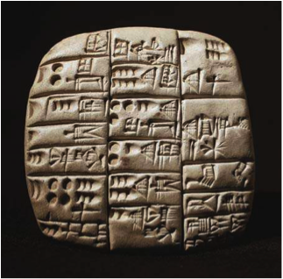  Archaeologist’s Notes: On this clay tablet, scribes from the Temple of Bau recorded the amount of barley (a type of grain) that each of the workers and their families will receive. | 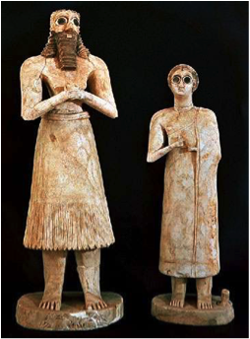  Archaeologist’s Notes: These statues of a married couple were found in the rubble of a shrine. They were probably left at the shrine as a gift to the gods. The size of these statues illustrates that the man was more powerful than the woman. Likewise, a beard shows that this was a powerful man.
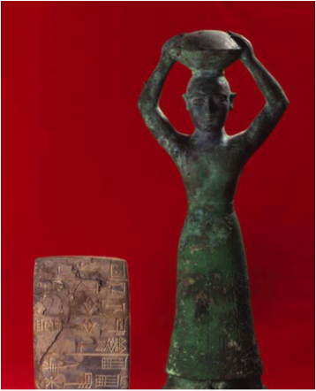  Archaeologist’s Notes: This bronze statue shows King Ur-Nammu carrying a basket of bricks on his head. This probably represents the fact that one of the king’s main responsibilities was to build and maintain the temples, even though he didn’t actually do the work himself. | 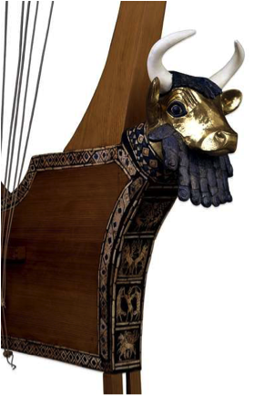  Archaeologist’s Notes: this lyre – a stringed musical instrument – was decorated with gold and semiprecious stones. It was found in a tomb of a Sumerian Queen. Royal musicians may have played this instrument to entertain the queen and her court.

